NAME:…………………………………… ……….………….. CLASS:…………. ADM NO…………….

BIOLOGY FORM 2 JANUARY 2023 TERM 1 OPENER EXAM
TIME: 2 ½ Hours

INSTRUCTIONS TO CANDIDATES
- Write your name, Admission number and name of your school in the spaces provided above
- Answer all the questions in the spaces provided.
Candidates should check to ascertain that all pages are printed as indicated and that no questions are missing.

- Distinguish between botany and zoology. (2mks)

- Some form one students wanted to collect the following animals for study in the laboratory. State the suitable apparatus they should use.
- Housefly (1mk)

- Scorpion (1mk)

- Ants (1mk)

- State the name given to the study of (2mks)
- Parasites

- Classification of living organisms.

- Explain what happens to red blood cells when placed in distilled water for 20 minutes. (3mks)

- a) State one role of active transport in animals. (1mk)

b) Explain how Cyanide as an enzyme inhibitor lowers the rate of active transport. (2mks)

- Name part of the light microscope involved in the following functions.
- Anchors or supports microscope firmly on the bench. (1mk)

- Receive and directs/reflect light towards the diaphragm. (1mk)

- Holds and position the objective lenses. (1mk)

- Define the following terms.
- A cell. (1mk)

- Organelle. (1mk)

- A microscope. (1mk)

- A medical student using a light microscope observed a blood tissue. Across the field of view were 25 red blood cells. The diameter of field of view was about 2.5 millimeters. Indicating the formula, calculate the diameter of a red blood cell in micrometers. (3mks)

- Name a cell that is involved in performing the following functions.
- Control the opening and closing of the stomata. (1mk)

- Defend human body against disease causing micro-organism. (1mk)

- Absorbing water and mineral salts from the soil. (1mk)

- An investigation was set up as shown in the diagram below.
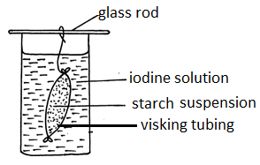
After 30 minutes, starch suspension had turned blue-black while iodine solution retained its colour.
- Name the physiological process that was being investigated in the experiment. (1mk)

- Account for the results observed after 30 minutes. (3mks)

- Distinguish between the following cell organelles.
- A nucleolus and nucleus. (2mks)
Nucleolus | Nucleus

- Cell wall and cell membrane. (2mks)
Cell wall | Cell membrane

- Below is a diagram of part of microscope, use it to answer the questions that follow.
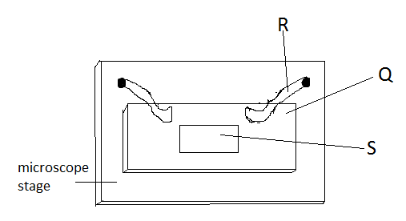
- Label the parts labelled Q and R. (2mks)
Q –

R –

- State the function of part labelled S (1mk)

- Name one organ systems in a maize plant. (1mk)

- Name the products of light stage of photosynthesis that are used in the dark stage. (2mks)

- State three adaptations of the leaf for absorption of carbon (IV) oxide used in photosynthesis. (3mks)

- Study the diagram below and answer the questions that follow.

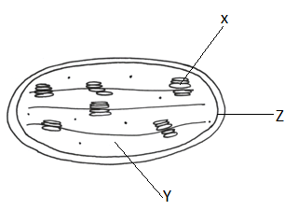
- Identify the organelle. (1mk)

- State the function of the organelle above. (1mk)

- Name the parts labeled X, Y and Z. (3mks)
X -
Y -
Z -
- State two adaptations of the organelle to its function. (2mks)

- Complete the table below. (2mks)
Tissue | Function
Blood
 | Hold and keep organs in position in an organism;

- The following organs perform the same functions despite being found in different organisms. Name the organism in which they are found. (2mks)
Organ | Organism
Lung
Gill
leaf

- Study the organelle below and answer the questions that follow.
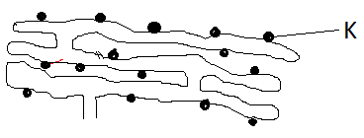
- Name the organelle. (1mk)

- What is the function of organelle K. (1mk)

- State the two guidelines that should be followed when typing scientific names. (2mks)

- Use the equation below to answer questions that follow.
Process X
(a). Glucose + Glucose water and maltose
Enzyme Y
(b). Maltose +water glucose + glucose
Process P

- Name enzyme Y (lmk)

- Process X. (lmk)

- Process P. (lmk)

- The dental formula below was written by a student after observing a skull of an animal;
i $\frac{0}{2}$ c$\frac{0}{0}$ pm $\frac{3}{3}$ m$\frac{3}{3}$
i) How many teeth does the animal have? (1mk)

ii) State the mode of feeding of the animal. (1mk)

iii) Give two reasons for your answer in (ii) above. (2mks)

- The two cells shown below are obtained from two different potato cylinders which were immersed in two different solutions P and Q.
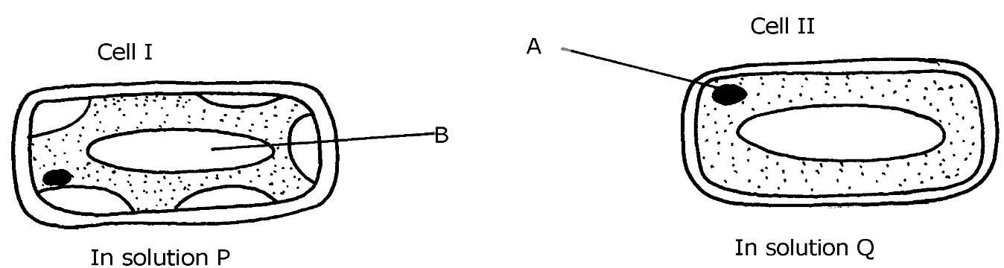

- i) Name the structure labelled A. (1mk)

ii) State one function of structure B. (1mk)

- Suggest the identity of the solution Q. (1mk)

- Account for the change in cell I above. (3mks)

c) State any one importance of the physiological process being demonstrated above in animals. (1mk)

- In an experiment to investigate a factor affecting photosynthesis, a leaf of a potted plant which had been kept in the dark overnight was covered with aluminium foil as shown in the diagram below.
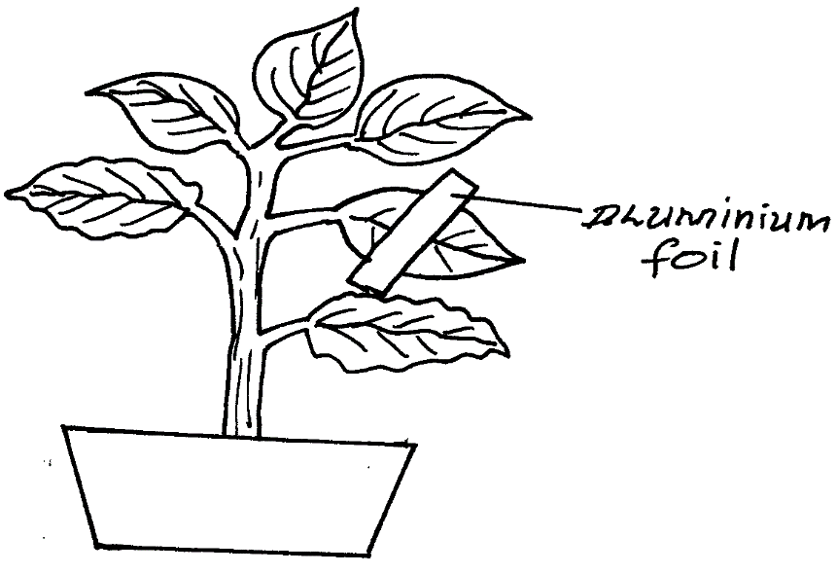

The set up was kept in sunlight for three hours after which a food test was carried out on the leaf.
a) Which factor was being investigated in the experiment? (lmk)

b) What food test was carried out? (lmk)

c) (i) State the results of the food test. (2mks)

ii. Account for the results in c (i) above (3mks)

d) Why was it necessary to keep the plant in darkness before the experiment? (lmk)

- a) State any three differences between Monosaccharides and Polysaccharides. (3mks)

MONOSACCHARIDES | POLYSACCHARIDES

b) Explain four biological functions of lipids to living organisms. (8mks)

c) Describe the laboratory test for proteins using biurets test. (3mks)

d) Describe the role of the following in mammalian digestive system.
i. Pepsin. (1mk)

ii. Bile (3mks)

iii. Hydrochloric acid - (3mks)

LAST PRINTED PAGE

