NAME:…………………………………………….………………………….………….. CLASS:…………. ADM NO…………….

231
BIOLOGY
FORM 3 JANUARY 2023 TERM 1 OPENER EXAM
TIME: 2$\frac{1}{2}$ Hours

FORM 2
INSTRUCTIONS TO CANDIDATES
- Write your name, Admission number in the spaces provided above
- Answer all the questions in the spaces provided.
- Candidates should check to ascertain that all pages are printed as indicated and that no questions are missing.

- What do the following branches of Biology deal with? (2mks)
(a) Physiology

(b) Morphology.

- a) What is a species? (1mks)

b) Give two characteristics that distinguish scientific names of organisms from the ordinary names.
(2mks)

- List down two functions of the endoplasmic reticulum. (2mks)

- Write down the formula used to calculate the diameter of a cell when using a microscope.(1mk)

- Write any two properties of cell wall. (2mks)

- (i) An epidermal cell was found to have a diameter of 300 micrometers. Convert that diameter into
Centimeters. (3mks)

(ii) Identify the cells drawn below and state its functions

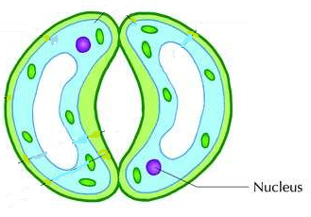

Identity (1mk)

Functions (2mks)

- (i) Name parts of a light microscope that raises and lowers the body tube. (2mks)

(ii) Name the part of microscope that hold the microscope slide firmly on stage. (1mk)

(iii) Why should a microscope not be placed near the edge of a working bench? (1mk)

- Illustrated below is the movement of material in a certain physiological process
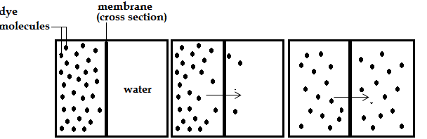

- (i) Name the physiological process illustrated above (1mk)

ii) Give two examples of applicability of the process named in (a) (i) above in plants. (2mks)

- State two ways by which the movement of the dye molecules would be slowed down. (2mks)

- (a) Explain the role of oxygen in Active transport. (1mk)

- Name two processes that depend on Active transport in animals. (2mks)

- How does a sunken stomata help a plant avoid excessive water loss during transpiration? (3mks)

- Name the blood vessel that supplies blood to the
(a) Brain (1mk)

(b) Cardiac muscle (1mk)

- Name the valve which opens during:
i) Systole. (1mk)

ii) Diastole. (1mk)

- A student was found to have blood group B+. Name the antibody present in his plasma? (1mk)

- The diagram below shows the tracheal system of an insect.

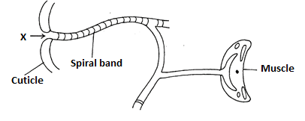

a. Name structure X (1mk)

b. State the role of the spiral band on the trachea. (1mk)

c. How is ventilation maintained in the tracheal system? (1mk)

- (a) state the use of the following excretory products in plants
(4mks)

Excretory product | Economic use
Caffeine
Papain
Gum arabica
tannin

(b) Name any two plant wastes that are recycled/reused by the same plant.. (2mks)

- a) Apart from the kidney and skin name any other organ in human body involved in excretion. (1mk)

- Name two hormones involved in glucose level regulation in man and the structure that secrete
them. (3mks)
Hormones –

Structure that secretes them -

(c) Through which processes do poikilotherms obtain heat from their surrounding? (2mks)

- An experiment was set up to investigate a certain process as shown in the diagram below.
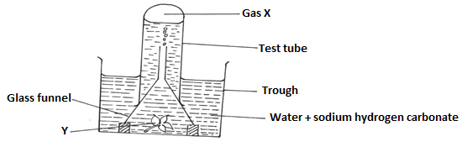

The set-up above was left in bright sunlight for 4 hours.

- State the aim of the experiment. (1mk)

(b) Name X and Y (2mks)
X -
Y -
(c) Other than sunlight name three factors that would affect the experiment. (3mks)

(d) State how the identity of X could be confirmed. (1mk)

(e) Explain why only submerged water plants was used in this experiment. (1mk)

- (a) What prevents blood in veins from flowing backwards? (1 mk)

- The photograph below shows red blood cells that have been put in different solutions. Examine them and answer the questions that follow.
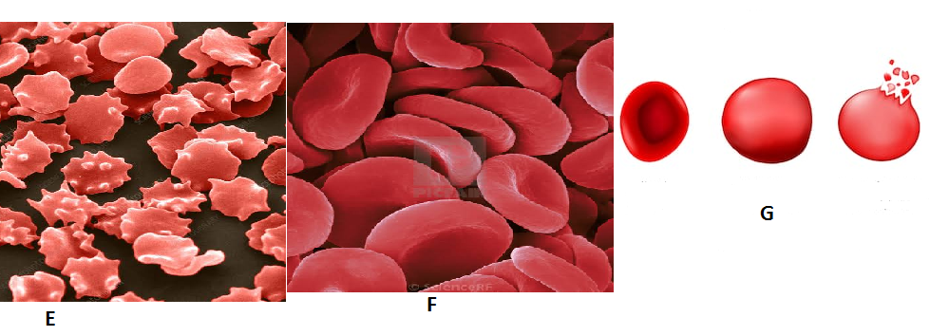
- Identify the type of solution in which cells F placed . (1mk)

- State the process which the red blood cells underwent in illustration E. (1mk)

- Account for the appearance the red blood cells underwent in illustration G. (3mks)

- Explain what would happen if plant cells are placed in the solution, in which the cells G were immersed. (2mks)

- The diagram below shows part of the mammalian digestive system
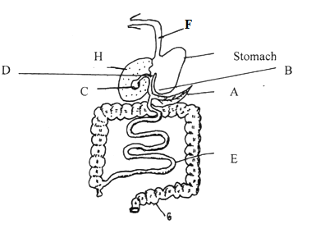

a) Name the parts labeled A, D and F (3mks)
A
B
D

b) State the functions of the parts labeled C and E (2mks)

C
E

c) What are the adaptations of the stomach to its function (2mks)

d) Name a deficiency disease resulting from lack of proteins in the diet (1mk)

- a) Study the diagram below to enable you answer the questions that follow.

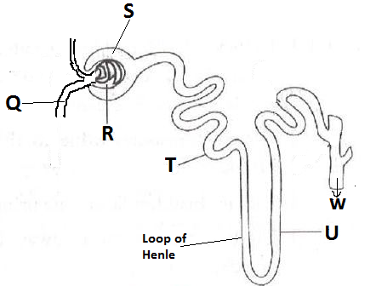

- Above is the functional unit of kidney, on part labelled Q indicate using an arrow the direction of blood flow. (1mk)
- Name the process that take place in parts labelled : (3mks)

R –

S –

T –

- Name a hormone that stimulate part U to enhance reabsorption of salts back into the blood.
(1mk)

- A thirsty patient drinks a glass full of water. Name a hormone that stimulates Loop of Henle
to reabsorb water back into the blood stream to restore water level. (1mk)

- Fluid W flowing out into the pelvis was tested and found to contain glucose molecules. Which part of the functional unit was faulty? (1mk)

- Explain the functions of parts of the mammalian skin. (20mks)

LAST PRINTED PAGE

