NAME………………………………………….. ADM NO………....... CANDIDATE’S SIGN……………… DATE……..….…………

231/2
BIOLOGY FORM 4
PAPER 1
(THEORY)
FORM 3 JANUARY 2023 TERM 1 OPENER EXAMTIME: 2 HOURS
INSTRUCTIONS TO CANDIDATES:
- Write your name and index number in the spaces provided above.
- Sign and write the date of examination in the spaces provided above.
- Check to ascertain that all pages are printed and that no questions are missing.
- FOR EXAMINER’S USE ONLY:
 | Maximum  Score | Candidate’s  Score
Total Score | 80

1. State the functions of the followings apparatus in collecting and observing specimens. (3mks)
a) Pooter:

b) A bait trap:

c) Pit fall trap:

2. Name two kingdoms whose members reproduce by means of spores. (2 marks)

3. How does nutrition as a characteristic of living organisms differ in plants and animals? (2 marks)

4.Use the following figure to answer the questions that follow:

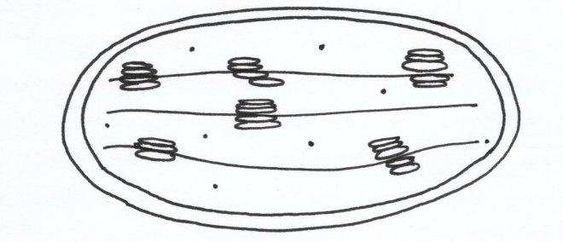

a) State the role of the organelle. (1mk)

b) Give two ways in which the organelle is adapted to its functions. (2mks)

5. Explain the role of the following features in xerophytes.
i. Succulent stem and leaves. 2mks)

ii. Short life cycle

6. State three control measures of bilharzia. (3 Marks)

7. State the role of the following in a nitrogen cycle:
a) Nitrogen fixing bacteria. (1mk)

b) Nitrifying bacteria. (1mk)

8. State three characteristics that make alveolus and buccal cavity suitable for gaseous exchange. (3 Marks)

9. State the changes that take place during inhalation in mammals in the following structures.
a) Rib Cage (1mk)

b) Diaphragm. (1mk)

10. Name two types of valves in the heart. (2 mks)

11. A teacher set-up the apparatus below to investigate a certain phenomenon. The cobalt (II) chloride paper was placed on the upper and lower surfaces of the leaf as shown.

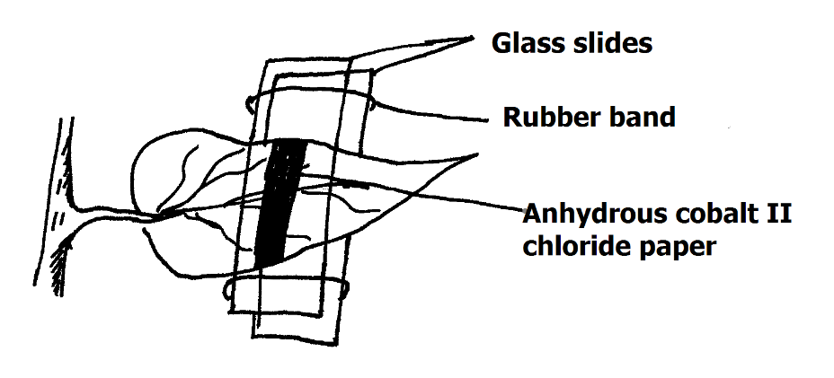
i) What was the aim of the experiment? (1mk)

ii) What observations were made after 2hrs? (2mks)

12.a) Explain two roles of diffusion in human beings. (2mks)

(b) What is meant by each of the following terms?
(i) Crenated cell. (1mk)

(ii) Flaccid cell. (1mk)

13.(a) Define seed dormancy. (1mk)

b) Name a growth inhibitor in seed. (1mk)

c) Differentiate between hypogeal and epigeal germination in seeds (1mk)
epigeal | hypogeal

(d) State one cause of seed dormancy. (1mks)

14. (a) State two characteristics of living organisms that are specific to plants.(2mks)

(b) State the name given to the study of;
- Structure of tissues. (1mk)

- Internal structure of living organism (1mk)

15. Why is a change in dry mass of an organism the best indicator of growth? (2mks)

16. (a) State two advantages of complete metamorphosis to the life cycle of an insect. (2mks)

17(a) what is meant by the term wilting? (1mk)

(b) Explain how an increase in temperature affects the rate of active transport.(2mks)

18. The diagram below represents a certain organism collected by a student at the seashore.
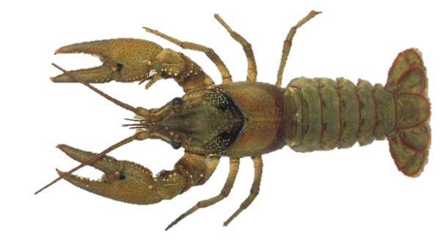

- Name the class to which the organism belongs. (1mks)

(b) Give three reasons for your answer in (a) above (3mks)

-

19. Differentiate between primary and secondary growth. (2mks)

20.A form four student was walking around the school compound and saw leaves from Nandi flame tree on the ground.
(a) Name the hormone responsible for this phenomenon. (1mk)

(b) State the significance of the above phenomenon to the tree. (2mks)

21. a) Guard cells are specialized epidermal cells. State two structural features that suit
them to their functions. (2mks)

-
b) Apart from gaseous exchange, give one other function of the stomata. (1mk)

22. (i) Distinguish between excretion and egestion (2mks)

(ii) Name any one substance in animals that may be secreted by either a cell or gland (1mk)

23(a) Outline three main functions of the mammalian skin (3mks)

(b) Which layer of human skin would be thickest from a person working in a quarry? (1mk)

24. Study the diagram below and answer the questions that follow.
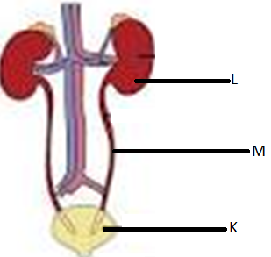

- Label the parts labelled (2mk)
K

L
- Name any two components of the fluid passing through tube M in healthy human being. (2mks)

25. List down two processes through which plants excrete their wastes and for each give one example of waste excreted. (4mks)

process | Waste excreted

26.(a) Why should a microscope not be cleaned using a wet cloth? (1mk)

(b)What’s the other alternative name/s of a cell membrane? (1mk)

- Name two processes that lead to multiplication of cells. (2mks)

27.The diagram below represents an experimental set up. The set up was left for two hours.The level of the solution in the funnel increased while the red dye was seen in the beaker.
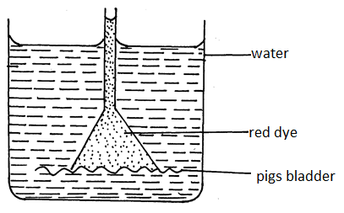
Beaker
Water
Concentrated Nacl in Red dye
Pig’s bladder

a. Identify the process that led to;
i. Increase in the solution level in the funnel. (lmk)

ii. Appearance of red dye in the beaker. (lmk)

b. State the role of the pig’s bladder. (lmk)

c) Name
i) A synthetic material that can be used in place of pig’s bladder (lmk)

ii) A structure in plant cell that is semipermeable. (lmk)

LAST PRINTED PAGE

