NAME…………………………………….. ADM NO…………… CANDIDATE’S SIGN………… DATE………….…………

231/2
BIOLOGY FORM 3
PAPER 2
(THEORY)
November 2022
TIME: 2 HOURS
INSTRUCTIONS TO CANDIDATES:
- Write your name and index number in the spaces provided above.
- Sign and write the date of examination in the spaces provided above.
- This paper consists of Two Sections; A and B.
- Answer all the questions in Section A in the spaces provided.
- Answer question 6 in Section B (Compulsory) and either question
7 or 8 in the spaces provided after question 8.
- Check to ascertain that all pages are printed and that no questions are missing.

FOR EXAMINER’S USE ONLY:
Section | Question | Maximum  Score | Candidate’s  Score
A | 1 | 8
 | 2 | 8
 | 3 | 8
 | 4 | 8
 | 5 | 8
B | 6 | 20
 | 7 | 20
 | 8 | 20
Total Score |  | 80

- The diagram below shows the results obtained in an experiment on growth of a bean seedling.

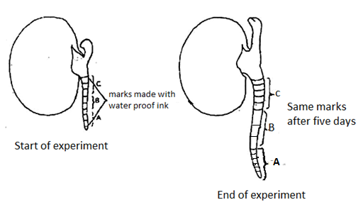

- Suggest the aim of the experiment. (1 mk)

- State the processes that occur in each of the regions marked A, B and C. (3mks)
A
B
C
- Account for the observations made in the regions A and C. (4 marks)

- The diagram below represents part of a gaseous system in a grasshopper.
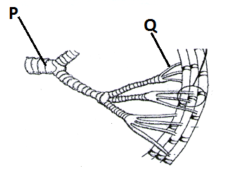
- Name the structures labeled P and Q.
P 1 Mark)
Q (1 Mark)
- State the function of the part labeled P. (1 Mark)

- Describe the path taken by Carbon (IV) Oxide from the tissues of the insects to the atmosphere.
(3 Marks)

d) How is part labelled Q adapted to its functions? (2mks)

3. The relative rates of photosynthesis in a certain plant were determined at different temperature. The results are shown below.
Temperature ºC | Relative rate of photosynthesis mg/hr
25 | 26
30 | 37
35 | 45
40 | 25

a) Account for the rate of photosynthesis at;
i) 35ºC (2 Marks)

ii) 40ºC (2 Marks)

b) Explain what happens during dark reaction in photosynthesis. (2 Marks)

c) In an experiment to show that Oxygen gas is a by-product of photosynthesis a water plant is used. Give two reasons why a terrestrial plant is not used. (2mks)

4. The diagram below represents a transverse section of a fruit.
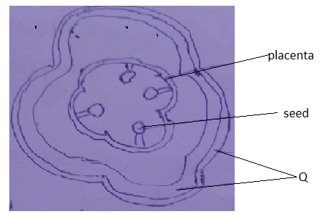
(a)(i) Name the two layers that comprise part labelled Q (2mks)

(ii) Name the type of placentation. (1mk)

(b) State two characteristics of fruits dispersed by animals. (2mks)

(c) State one immediate product from double fertilization (1mk)

(d) State one function of amniotic fluid (1mk)

(e) List down one effect of Testosterone hormone (1mk)

5. (a) Explain the roles of sweat produced by the human skin (2mks)

(b) A person was found to have traces of glucose in the urine after visiting a hospital laboratory.
Name the
(i) Disease the person was suffering from (1mk)

(ii) Hormone that was deficient in the body (1mk)

(c) Caffeine is a waste product in coffee plant. Through which process is that waste product excreted by the plant. (1mk)

d)(i) What is homeostasis? (1mk)

(ii) Name any two diseases of the liver (2mks)

SECTION B (40 MARKS)
Answer question 6 (compulsory) in the spaces provided and either question 7 or 8 in the spaces provided after question 8.

Time in weeks | 0 | 1 | 2 | 4 | 6 | 10 | 13 | 15 | 16 | 18
Dry mass in grams | 1 | 2 | 3 | 10 | 18 | 32 | 44 | 45 | 44 | 38
6. The following data represents the development in dry mass of germinating seedlings within 18 weeks:

(a) Using suitable scale plot a graph of dry mass against time (6mks)
(b) With reference to the graph, explain the changes in dry mass between:-
(i) Week 0 to 2 (4mks)

(ii) Week 5 to 13 (3mks)

(iii) Week 16 - 18 (3mks)

(c) (i) What is the significance of time zero? (1mk)

(ii) What difference would be expected from the above results if the experiment started with the seeds? Give a reason for your answer. (2mks)

(d) Name the phase of growth curve represented by the curve between 2nd and 13th week.(1mk)

7. How are xerophytes adapted to their habitats? (20MKS)
8(a) Define the term poikilotherm. (1mk)

(b) Describe the role of mammalian skin in thermoregulation. (19mks)

LAST PRINTED PAGE

