NAME:…………………………………………….………….. CLASS:……. .ADM NO…………

231/3
BIOLOGY
FORM 4 JANUARY 2023 TERM 1 OPENER EXAM
PAPER 3 (PRACTICAL)
TIME: 1³/₄ Hours

INSTRUCTIONS TO CANDIDATES
- Write your name, Admission number and name of your school in the spaces provided above
- Sign and write the date of examination in the spaces provided.
- This paper consists of three questions
- Answer all the questions in the spaces provided.
- You are required to spend the first 15 minutes of the 1³/₄ Hours allowed for this paper reading through all the questions before commencing your work.
- This paper consists of 5 printed pages.
- Candidates should check to ascertain that all pages are printed as indicated and that no questions are missing.

For Examiners Use Only
Question | Maximum score | Candidate’s score
1 | 17
2 | 10
3 | 13
Total Score | 40

- a)You are provided with solution W in a boiling tube. Using the provided reagents, carry out possible food tests to identify food substances present in solution W. (12mks)
Food substance | Procedure | Observation | Conclusion

b) Study the photographs below showing a certain type of tooth and teeth arrangement in man.
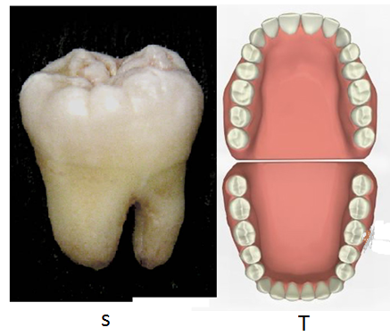

- Label any TWO parts of the tooth in photograph S (2mks)

- Give two observable adaptations of the tooth to its function (2mks)

- Write the dental formula for the teeth arrangement in photograph T (1mk)

- Examine the photographs I and II of seedling specimen shown below and answer the questions that follows;
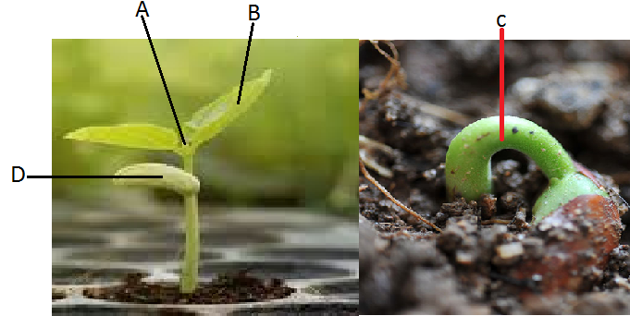

a) Name the parts labelled A, C and D. (3 mks)
A –
C -
D -

b) (i) Name the class to which the specimen belongs. (l mark)

(ii) Give two reasons, using observable features to support your answer in (b) (i) above (2 mks)

(c) Give two functions of the structure labeled D. (2 mks)

d) Name the type of germination exhibited by the seedlings. Give a reason for your answer. (2mks)
Type

Reason -

3. Below are photographs showing some observable features of animals

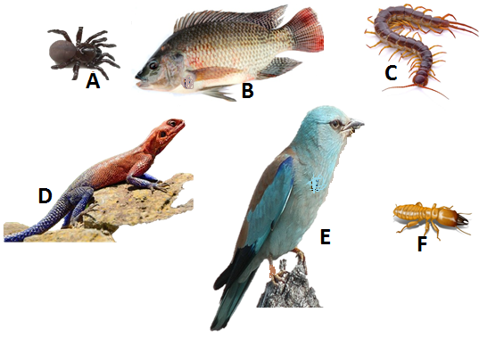

a. Complete and use the key below to identify the organism. 2mks
1a. Organism with endoskeleton ……………………………………………..… go to 2
1b. ______________________ ………………………………………………… go to 3
2a. Has scales on the body……………………………………………………… go to 4
2b. Has no scales on the body………………………………………..………… mammalian.
3a. Has cephalothorax ………………………………………….……………… Arachnida.
3b. Has no cephalothorax………………………….……………………………go to 5
4a. __________________________________................................................... Pisces
4b. Has no fins ……………………………………………….……………….. go to 7
5a. Has three pairs of legs …………………………………………….……… Insects.
5b. Has more than three pairs of legs ………………………………………… go to 6
6a. Two pairs of legs per segment ……………………………………..………Diplopoda
6b. One pair of legs per segment……………………………………….………Chilopoda.
7a. Has feathers ……………………………………………….……………… Aves
7b. Has no feathers ……………………………………………….……………go to 8
8a. Has a tail……………………………………………………………………Reptilia
8b. Has no tail……………………………………………………….…………Amphibia.

b). Identify the organisms above using the completed key above. 6mks
Specimen | Steps followed | identity
A
B
C
D
E
F

c). Name the phylum in which specimens A, C and F belong to 1mk

d). Give three reasons for your answer in (c). 3mks

e).Name one feature that is common in organisms B, D and E. 1mk

LAST PRINTED PAGE

