Name:…………………………………………………………….Adm. No…………………..

Class: ………………………………………………………

233
CHEMISTRY

FORM 2 JANUARY 2023 TERM 1 OPENER EXAM
Instructions to Candidates
- Write your name and admission number in the spaces provided.
- Answer all the questions in the spaces provided.
- All working must be clearly shown where necessary.
- Students should check the question paper to ascertain that all the pages are printed as indicated and that no questions are missing.

1. (a)A Bunsen burner produces two flames. Which flame is NOT preferred for heating and why? (2mk)

(b) How can the hotness of a Bunsen burner be increased? (1mk)

2. The following data gives the pH values of some solutions

Solution | pH
P  Q  R | 14.0  6.8  2.5

(a) What color change would occur in solution Q on addition of two drops of Methyl orange indicator? ( ½ mk)

(b) State the products formed when a carbonate reacts with solution R. ( 1½ mk)

3. Name the method used to separate the following mixture (5mks)
- Sand and water -
- Copper (ii) Sulphate crystals from its aqueous solution -
- Petroleum from crude oil -
- Oil from nuts -
- A mixture of Sodium Chloride crystals and ammonium chloride crystals

4. A student set up the apparatus below to separate a mixture of water (B.P=100⁰c) and ethanol (78⁰C). Study it and answer the questions that follow.
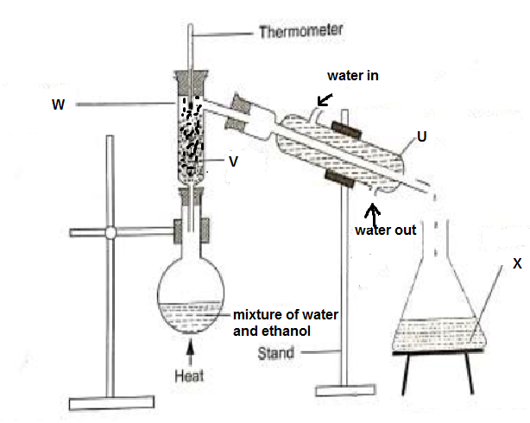

- Identify (4mks)
U –
V –
W –
X –
- Identify two mistakes in the arrangement of apparatus (2mks)

- What is the purpose of (2mks)
i) Part V -

(ii)Part U –

- Why is a round bottomed flask preferred when carrying out fractional distillation of miscible liquids (1mk)
5. The diagram below represents a paper chromatogram of pure A, B, C and D. K is a mixture and contains A and D only
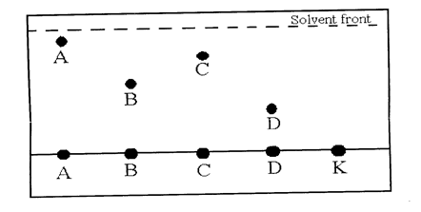
(a) Indicate on the diagram the chromatograph of K (1mk)
(b)State two factors that determine how far the substance will move on the chromatogram (2mks)

6. a) State two laboratory safety rules associated with gas preparation (2mks)

b) Name any two major laboratory apparatus used to measure accurate volume of liquids (2mark)

7. The diagram below shows a piece of a paper that was placed on a non-luminous flame of a Bunsen burner.
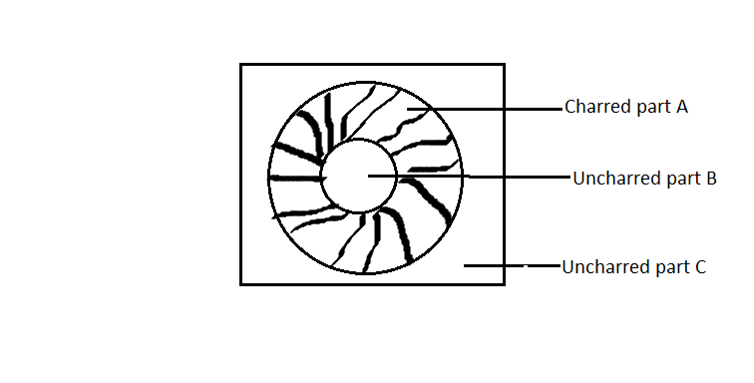
Name the part of the flame that came into contact with part labelled (2mks)
A –
B –
8. Fill the table below with correct symbols of elements and names (3mks)
ELEMENT | SYMBOL
Magnesium
 | Mn
Copper
Lead
Potassium
 | Na

9. Complete the following equations (2mks)
(a) Calcium carbonate + Hydrochloric acid --------------------- +------------------------------

(b) Copper (ii) nitrate Copper ii oxide + --------------------- + ---------------------------------

10. The set up below was used by a form student to investigate the effect of heat on hydrated copper (ii) sulphate.
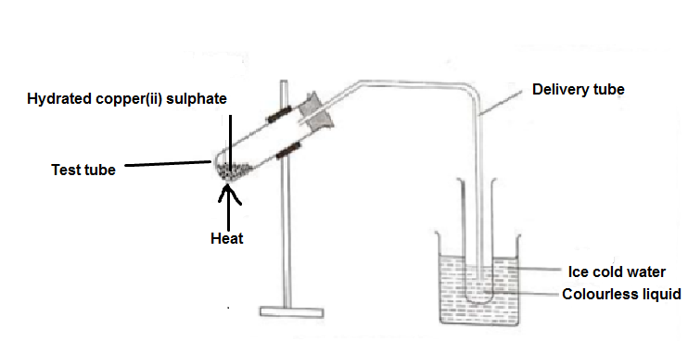
(a) State the observation made in the test tube. (1mk)

(b) Identify the colourless liquid (1mk)

(c) State the type of change that copper (ii) sulphate underwent on heating. (1mk)

11. Define the following terms (3mks)
- Matter

- Neutralization reaction

- Catalyst

12. a )Define the term oxidation (1MK)

b) Magnesium metal reacts with zinc oxide according to the following equation.
Magnesium + Zinc Oxide Magnesium oxide + Zinc
Identify;
I) The oxidized substance------ (1mk)

Ii) The oxidizing agent --------- (1mk)

iii) The name given to this kind of a reaction------ (1mk)

c) Explain what is likely to happen when Magnesium metal is replaced with Copper metal (2mk)

13.a)Write word equations for the reactions that occurs when each of the followings elements are heated in air; (2mk)
i) Copper metal

ii)Carbon

b) Explain the changes in mass that occurs during the above reactions (2mk)
i)
ii)

14. Below is an incomplete diagram for the preparation of oxygen gas.
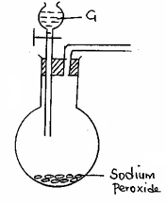

- Name substance G (1mk)

- Complete and label the diagram to show how oxygen gas is collected. (2mk)
- List another set of reagents that can be used to prepare oxygen gas in the lab.(1mk)

15. The following is a list of some oxides; magnesium oxide, carbon (ii) oxide, sulphur (iv) oxide, copper (ii) oxide, phosphorous (iii) oxide and nitrogen (i) oxide. From the list select a; (3mk)
i)A neutral oxide-
ii)A basic oxide –
iii)An acidic oxide-

16. Clean iron nails were treated as shown in the diagrams below and left for three days. Study the diagram and answer the questions that follow.
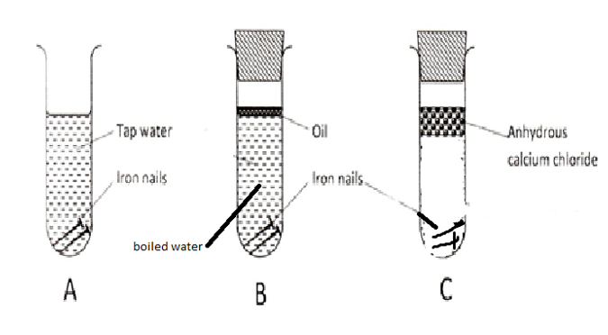
- State and explain the observations made in each test tube after 3 days (3mk)
Test tube A—

Test tube B-

Test tube C-

b) What is the chemical name of rust (1mk)

c) List any other two methods that can be used to prevent rusting other than alloying and sacrificial protection. (2mk)

b) State any two economic importance’s of rusting. (2mk)
17. In an experiment, rods of metals P, Q and R were cleaned with sand paper and placed in a beaker containing water. Another set of rods was also cleaned and placed in a beaker containing dilute acid. After placing the rods in the two liquids bubbles of gas were seen around some of the rods as shown in the diagrams below.
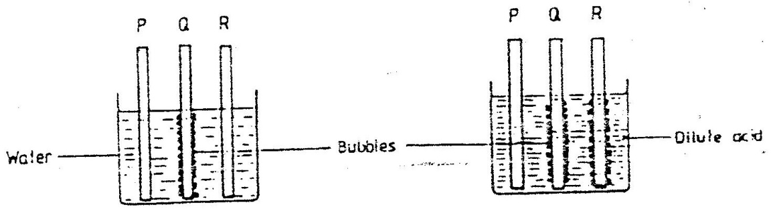

a)Why is it necessary to clean the rods with sand paper before dipping them into the liquids. (1mk)

b)Arrange the three metals in order of their reactivity starting with the most reactive. (1mk)

18. Study the diagram below and answer the questions that follow.
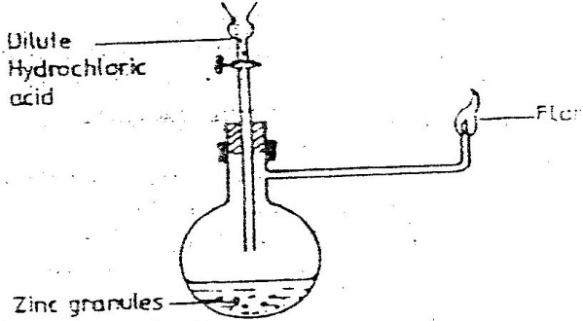
Dilute hydrochloric acid
Flame

a) Write an equation for each of the reaction that took place in the round bottomed flask represented by the diagram above (1mk)

b) What can be added to the contents in the flask to increase the rate of reaction? (1mk)

c) Explain why dilute nitric v acid cannot be used to prepare hydrogen gas (1mk)
d) State any 3 uses of hydrogen gas (3mk)

19. The diagram below represents a set-up that was used to react magnesium with steam study it and answer the questions that follow:

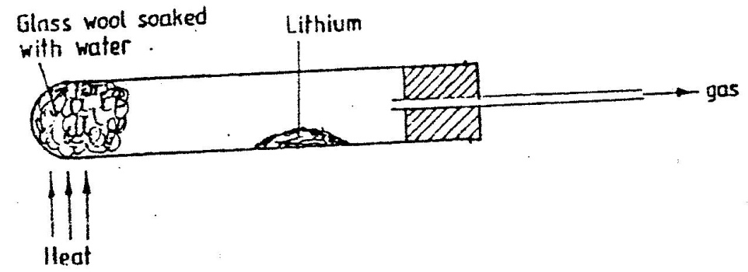
Magnesium

a) Write a word equation for the reaction that takes place in the boiling tube (1mk)

b) Why is it advisable to heat the wet glass wool before heating the magnesium metal? (2mk)

c) Describe a simple experiment to test for the presence of the gas being produced in the above experiment. (1mk)

20. In a laboratory experiment hydrogen gas was passed over heated copper (II) oxide as shown the diagram below.
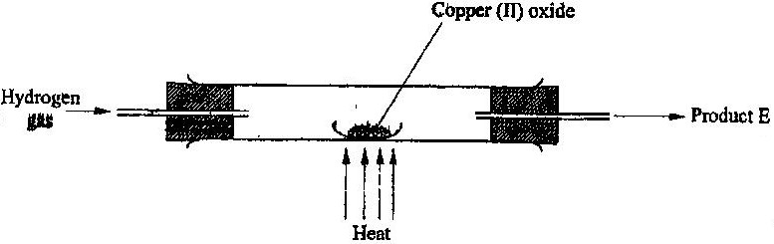

a) State and explain the observation made in the porcelain boat containing copper (ii) oxide (2mk)

b) Describe an experiment that can be o confirm the purity of product E (2mk)

THE END- BLESSED HOLIDAY

