Name:…………………………………………………………….Adm. No…………………..

School………………………………………………………

233/1
CHEMISTRY
PAPER 1
FORM 4 JANUARY 2023 TERM 1 OPENER EXAM
Instructions to Candidates
- Write your name and admission number in the spaces provided.
- Answer all the questions in the spaces provided.
- Mathematical table and electronic calculator may be used.
- All working must be clearly shown where necessary.
- Students should check the question paper to ascertain that all the pages are printed as indicated and that no questions are missing.

1.The table below shows a homologous series of organic compounds. Study it and answer the questions that follows.

formula | BOILING POINT (⁰C)
1. C₂H₄ | -104
2. C₃H₆ | -47.7
3. C₄H₈ | -62
4. C₅H₁₀ | 30

i) Write the general formula of the above homologous series. (1mk)

_{ii)} Write the formula for the 7th member of the series (1mk)

iii) State any two uses of members of the homologous series above (1mk).

2. The diagram below is used in preparation of gas X in the laboratory. Answer the questions
that follow;
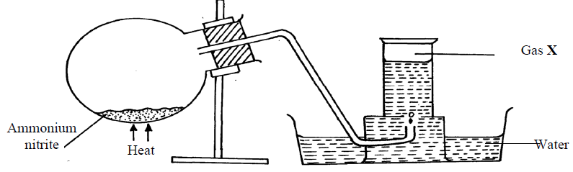

(a) Name gas X (1mk)

(b) State one physical property which makes it possible for the gas to be collected as shown (1mk)

(c) State one commercial use of gas X (1mk)

3. In an experiment magnesium ribbon was heated in air. The product formed was found to be
heavier than the original ribbon. Potassium manganate (VII) was on the other hand, heated in
air and product formed was found to be lighter. Explain the differences on the observation made (2mks)

4. In a titration experiment 25cm³ of a solution of Sodium Hydroxide containing 8g per
litre was required for complete neutralization of 0.245g of a dibasic acid. Calculate
the relative molecular mass of the acid (Na = 23.0, O = 16, H= 1) (3mks)

5. (a) State Graham’s law of diffusion (1mk)

(b) 30cm³ of hydrogen chloride gas diffuses through a porous pot in 20seconds. How long
would it take 42cm³ of sulphur(IV) oxide gas to diffuse through the same pot under
the same conditions (H =1 Cl = 35.5 S = 32 O =16) (3mks)

6.The set-up below was used to prepare a carbon (II) oxide gas.
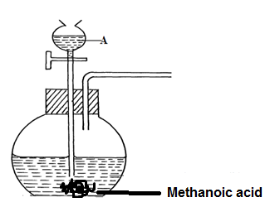

(a) Give the name of substance A (1mk)

(b) Complete the diagram to show how the gas can be collected (2mks)

(c)Write the equation for the reaction (1mk)

7. Starting with lead (II) oxide, describe how you would prepare a solid sample of
lead (II) Carbonate. (3mks)

8. The following data gives the pH values of some solutions;
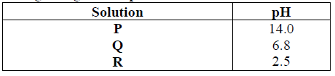
(a) What colour change would occur in solution P on addition of two drops of
phenolphthalein indicator? (1mk)
(b) State the pH value of a resulting solution when equal moles of solution P and R react.Explain. (2mks)

9.The set-up below was used to study some properties of air.

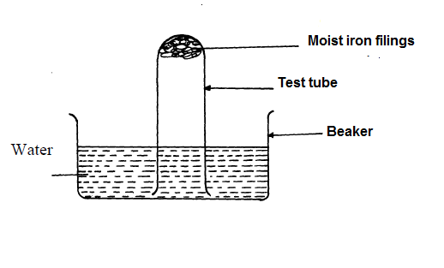

(a) Why was iron filings moistened? (1mk)

(b) State and explain two observations that would be made at the end of the experiment(2mks)

10.The electron arrangement of ions Q²⁺ and R³⁻ are as 2, 8, 8, and 2,8 respectively.
(a) Write the electron arrangement of the elements Q and R (1marks)

(b) Write the formula of the compound that would be formed between Q and R(1mark)

What type of a structure would have been formed if R reacted with oxygen? (1mk)

11. a) The set-up below is used to investigate the properties of hydrogen. Use it to answer the questions that follows.

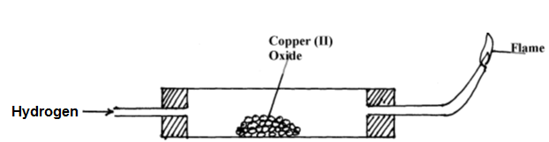
↑↑↑↑

(i) Hydrogen gas was allowed to pass through the tube for some time before it is lit. Explain (2mks)

(ii) State and explain one observation made in the combustion tube. (1mks)

(iii) State any two metal oxides that can be used in place of copper(ii)oxide. (1mk)

12. The grid below shows a part of the periodic table. The letters do not represent the actual
Symbols. Use it to answer the questions that follow:-

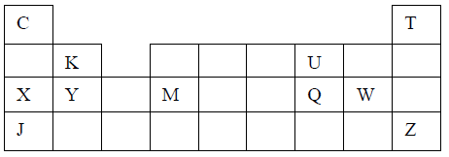

(a) How do the atomic radius of element X and Y compare (1mk)

(b) (ii) State the period and the group to which element Q belong (1mk)

(c) (i) The ionic configuration of element G is 2.8. G forms an ion of the type G⁻¹.
Indicate on the grid, the position of element G. (1mk)

(iii) State one use of element U ( ½ )

(iv) What is the nature of the compound formed between K and U (1mk)

13.(i)Distinguish between a covalent and dative bond (1mk)

(ii) Draw a dot (.) and cross (x) diagram to show bonding in:- (2mks)
Ammonium ion (NH4⁺) (N = 7.0, H= 1)

14. Study the table below and answer the questions that follow:-
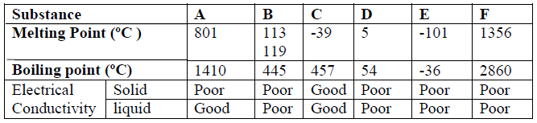

Identify with reasons the substances that:
(i) Have a metallic structure (1mk)

(ii) Have a molecular structure and exist in the liquid state at room temperature and pressure (1mk)

(iii) Suggest a reason why substance B has two melting points (1mk)

(iv) Substances A and C conduct electric current in the liquid state. State how the two substances
differ as conductors of electric current. (1mk)

15.The table below shows the decomposition of metal nitrates through heating.

Name of Metal | Products on heating
M | Metal Oxide, Nitrogen (iv) Oxide, Oxygen gas
N | Metal nitrite, oxygen
P | Metal, nitrogen (iv) Oxide, Oxygen

(a) Arrange the three metals in order of their reactivity starting with the least reactive. (2mks)

(b) Suggest an element that is likely to be metal N. (1mk)

16. 5.1g of sodium sulphite was reacted with excess dilute hydrochloric acid. Calculate the
Volume of the gas collected at room temperature and pressure (M.G.V = 24000cm³) (3mks)

17. Below is a set up of apparatus used to prepare a sample of chlorine gas.

(a) Name liquid T (½mk)

(b) Why was water used in the set up? (1mk)

(c) State and explain the effect of Chlorine on a wet blue litmus paper. (2 mks)

18. A hydrocarbon Q was found to decolourise potassium manganate (VII) solution. When 2
moles of Q are burnt completely, 6 moles of Carbon (iv) Oxide and 6 moles of water were
formed.

(a) Draw the structure of compound Q (1mk)

(b) Name the homologous series to which Q belongs. (1mk)

(c) Name the industrial source of Q. (1mk)

19. Oxygen was bubbled into concentrated ammonia solution as shown below.

Oxygen
Conc. Ammonia solution
Hot platinum wire

(a) Explain why the platinum wire remained red-hot even though it was no longer being heated.
(1mk)

(b) Brown fumes were observed in the boiling tube. Using chemical equations, explain this
observation. (2mks)

20.Sulphur is extracted from underground deposits by a process in which three concentric pipes are
sunk down to the deposits as shown below

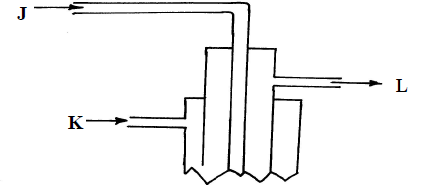

(a) What is passed through pipes J,K and L? ( 1½ mks)

(b)In the manufacture of sulphuric acid, sulphur (IV) oxide is oxidized to sulphur (VI) oxide. ( ½ mk)
i) Name the catalyst used

ii) Write the equation representing the conversion of sulphur (IV) oxide to sulphur(VI)oxide (1mk)

iii) State and explain the observation made concentrated sulphuric acid is added to sugar. (1mk)

21. Briefly describe how a sample of oil can be obtained from macadamia nuts. (2mks)

22. The set up below was used in electrolysis of molten lead(ii) bromide.

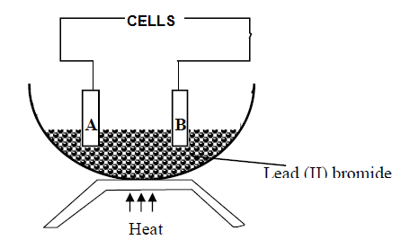
A grey solid was observed at electrode B as electrolysis continued.
(a) Name the grey solid. ( ½ mk)

(b) Idetify the anode. ( ½ mk)

(c) Write an equation for the reaction at the anode. (1mk)

23. 8. Study the information in the table below and answer the questions that follow.
(The letters do not represent the actual symbols of the elements)
Element | Electronic configuration | Ionization energy Kj/mol)
P | 2.2 | 1800
Q | 2.8.2 | 1450
R | 2.8.8.2 | 1150
(a) What is the general name given to the group in which elements P, Q and R belong? (1mk)

(b) Explain why P has the highest ionization energy (1mk)

(c) Write a balanced chemical equation for the reaction between element Q and water (1mk)

24.Name the process which takes place when: (3mks)
a) Solid Carbon (IV) oxide (dry ice) changes directly into gas.

b) A moist red litmus paper turns white when dropped into jar of chlorine gas.

c) Crystals of calcium chloride form a solution on long exposure to air.

25.When solid R was heated, it produced a black solid Q, a brown gas and a colourless gas that rekindled a glowing splint. A glass rod dipped in solution of R turns a non-luminous fame blue.
(a) write the formula of cation and anion present in solid R:
Cation………… ( ½ )

Anion…………. ( ½ )
(b)Name the brown gas. (1mk)

(c) Identify solid Q. (1mk)

THIS IS THE LAST PRINTED PAGE

