Name:…………………………………………………………Adm. No…………………..

School………………………………………………………

233/2
CHEMISTRY
PAPER 2
FORM 3 JANUARY 2023 TERM 1 OPENER EXAM Instructions to Candidates
- Write your name and admission number in the spaces provided.
- Answer all the questions in the spaces provided.
- Mathematical table and electronic calculator may be used.
- All working must be clearly shown where necessary.
- Students should check the question paper to ascertain that all the pages are printed as indicated and that no questions are missing.

- a) A Form 3 student set up apparatus as shown below to prepare carbon2 iv oxide gas.

Dilute sulphuric vi acid

Delivery tube

Gas jar
Calcium carbonate

- Write a chemical equation for the reaction taking place in the flask(1mk)

(ii) Identify two errors in the arrangement of the setup above (2mks)

(iii)The reaction started and then stopped immediately, explain this observation. (2mk)

Iv) State any two uses of carbon iv Oxide apart from fire extinguisher (1mks)

b) Study the flow chart below and answer the question that follow

Hydrogen
Product X
Product B + Gas C + Oxygen gas
Potassium Nitrate solution
Gas Q + water
Ammonia gas
Compound P
Nitric (v) acid
PRODUCTS
Step 1 Gas B
Burn in ZnO
oxygen Step II

Step III Oxygen +Catalyst + water

NH₃ Step IV

Step V Cu
Crystals of solid S
Step vI Excess NH₃
Solution S

Step VII

I) State one source of gas B (1 mark)

II) Name the catalysts used in; (2 marks)
i)Step I
ii)Step III
III) Write balanced chemical equations for the reactions that took place in the following steps;
II 1mk
V II 1mk
IV) State the observation made in the step where ammonia is added to solution S dropwise till in excess to form product X (1mk)

V) What name is given to the reactions taking place in the following steps; (3mks)
II -
IV-
VI-
2. The grid below shows a part of the periodic table. The letters do not represent the actual Symbols. Use it to answer the questions that follow: -
C

X
J
K
Y

M

U
Q

W
D
T

Z

(a) Compare the atomic radius of element M and W (2mks)

(b) (i) Draw the structure of the ion of Q and show its nuclear composition ( Q=32)(2mk)

(ii) The oxide of element Y and the oxide of element Q were separately dissolved in water. State and explain the effect the solutions would have on blue and red litmus papers. (2mk)

(c) (i) The ionic configuration of element G is 2.8. G forms an ion of the type G^{-1.} Indicate on the grid, the position of element G. (1mk)
(ii) The melting point of element D is higher than that of element W, explain this observation. (1mk)

(iii) State two industrial uses of element U (1mk)

d) 0.92 grams of element X were reacted with excess dilute sulphuric vi acid and the gas evolved collected. If the reaction took place at room temperature and pressure, calculate the volume of the gas produced. ( MGV=24dm³, X= 23). (3mk)

3.a )The table below shows the PH values of some solutions;
solution | PH
Y | 9
G | 2
F | 6.5
R | 7
V | 14

a) Choose a solution that is likely to be;
i) Aluminium chloride solution - ( ½ mk)
ii) Sodium Chloride solution - ( ½ mk)
iii) Potassium hydroxide solution- ( ½ mk)
b) What color would solution Y show with phenolphthalein indicator.( ½ mk)

c) Describe how a pure and dry sample of lead sulphate can be prepared given the following reagents; dilute nitric (v) acid, solid potassium sulphate, lead carbonate and distilled water and other laboratory apparatus. (3mk)

d) A student from Ushindi high school found two unlabeled beakers containing magnesium nitrate and magnesium carbonate solids. Describe an experiment the student would have carried out in order to label the two beakers appropriately. (2mk)

e) A sample of a green solid was strongly heated in a boiling tube. A colorless gas that formed a white precipitate with calcium hydroxide solution was evolved and a black residue was left. When dilute nitric (v) acid was added to the black solid, a blue solution was formed.
i) Write the formulae of the anion present in the green solid. (1mk)

ii) Write a balanced chemical equation for the reaction that took place between the black solid and dilute nitric (v) acid. (1mk)

4. a)Wooden splints F and G were placed in different zones of the non-luminous of a Bunsen burner . The diagram below gives the observations that were made.
G
F
Burnt parts
Burnt part

Explain the difference between F and G (2marks).

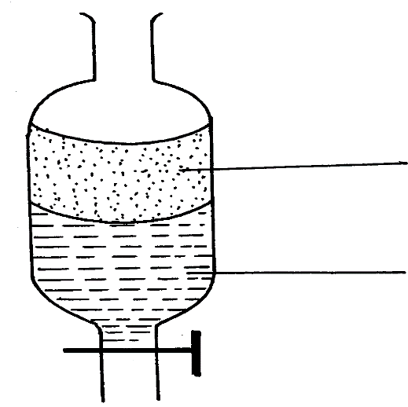
b)A mixture of oil and water was shaken and left to separate as shown in the diagram below:
P
W

i)State the identity of; (1mk)
P
W
ii) State two properties of the above liquids that helped them to get separated. (2mk)

c) A student left some crushed fruit mixture with water for some days. He found the mixture had fermented. He concluded that the mixture was contaminated with water and ethanol with boiling point of 100ºC and 78ºC respectively. The set-up of apparatus below is used to separate the mixture.
A
Thermometer
B
Mixture
Conical
flask
Distillate
Apparatus W

- Name the piece of apparatus labelled W ( ½ mk)

- What is the purpose of the thermometer in the set-up? ( ½ Mk)

- At which end of the apparatus W should tap water entry be connected?( ½ mk)

- Which liquid was collected as the first distillate? Explain. (1mk)

- What is the name given to the above method of separating mixture? ( ½ mk)

- State two applications of the above method of separating mixtures.(1mk)

d)During the extraction of Sulphur from underground deposits, three concentric pipes are dipped into the ground.
i) State two properties of sulphur that makes it possible to be extracted sulphur using this method. (2mk)

ii) Give a reason why the super-heated water is placed through the outermost pipe.(1mk)

iii) What is the function of the hot air placed in the inner most pipe. (1mk)

5 .A student in Magondo High School set up the following arrangement to prepare and react gases V and W. Use it to answer the questions that follow.(H=1, S=32, Cl=35.5)
Tap 1 and 2 were opened at the same time.
a) Write a balanced equation for the chemical reaction that took place in the flask A. (1mk)

b) State and explain the observations that were made in flask B and combustion tube.
Flask B (1 ½ mk)

Combustion tube (1 ½ mk)

c) Mark on the diagram, the approximate position where reaction occurred in the combustion tube. Explain your answer. (2mks)

d) State one possible objective of this experiment other than testing whether gas V reacts with W. (1mk)

e) State one precaution which should be taken when carrying out the experiment. (1mk)

f) Apart from KMnO4 list any other two that could have been used with hydrochloric acid in flask A. (2MK)

6. a) 120cm³ of oxygen gas takes 75 seconds to diffuse through a hole. Calculate the relative molecular mass of gas Q whose 120cm³ takes 50 seconds to diffuse through the same hole. ( O=16) (2mk)

b)i)Draw a graph representation of Boyles Law. (1mk)

ii) A certain gas occupies 45cm³ at a pressure of 790mmHg and a temperature of 27⁰c. What volume would the gas occupy if the temperature was doubled and the pressure is changed to 650mmHg? (2mk)

c) State Gay Lussac’s Law. (1mk)

d) . A hydrocarbon gas Y in which the percentage of hydrogen by mass is 14.3% and the rest carbon occupies a volume of 4.48dm3 at s.t.p and weighs 14g ( MGV=22.4dm³)
(i) Determine the empirical formula of y. ( C= 12,H=10 ) ( 2mks)

(ii) Give the molecular formula of Y. ( 2 mk)

iii) To which homologous series does Y belong? (1mk)

7. a) Draw the structure of the following compounds. (2mk)
i) Pent-2-ene

ii) 2, 4-dichloro-2, 3-dimethylpentane

b) Describe a simple experiment to show how ethane and ethene can be differentiated in the laboratory. (2mk)

c)i) Define the term isomerism. (1mk)

i)Draw and name all possible isomers of C₄H₁₀ (3mk)

d) Ethane gas was reacted with one mole of chlorine gas and two products were formed;
i) What condition must be present for the above reaction to take place (1mk)

ii) What name is given to such a reaction (1mk)

iii) Draw the compound formed in the above reaction. (1mk)

