**NAME ____________________________________________CLASS_________ADM______**

**DATE_______________________SIGNATURE_______________________**

**GEOGRAPHY (312)**

**TIME: 2HOURS**

**FORM 4 JANUARY 2023 TERM 1 OPENER EXAM**

**INSTRUCTIONS TO CANDIDATES.**

**ANSWER ALL QUESTIONS IN THE SPACES PROVIDED.**

**FOR EXAMINERS USE ONLY**

|  |  |
| --- | --- |
| **QUESTIONS** | **CANDIDATES SCORE** |
| **1** |  |
| **2** |  |
| **3** |  |
| **4** |  |
| **5** |  |
| **6** |  |
| **7** |  |
| **8** |  |
| **9** |  |
| **TOTAL SCORE** |  |

1. a) Define the term ‛habitat’. **2mks**

b) Give **two** types of environments. **2mks**

2. Describe the origin of the earth as proposed by the passing star theory. (**5mks)**

3(a)(i) Name the substancesin the occurrence of petroleum **(3mks)**

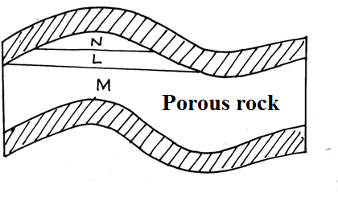

(ii)Give **three** by-products obtained when crude oil is refined **(3mks)**

(b State **five** effects of mining on the environment **(5mks)**

4.a) (a) Define the term Agroforestry. **(2mks)**

(b) Name **three** areas where softwood forests are found in Kenya. **(3mks)**

5a) Give **three** life cycles of a volcano. **(3mks)**

(b) State **three** characteristics of a composite cone. (3mks)

**6. The table below represents rainfall and temperature figures for a town in Africa. Use it to answer the questions that follow**

|  |  |  |  |  |  |  |  |  |  |  |  |  |
| --- | --- | --- | --- | --- | --- | --- | --- | --- | --- | --- | --- | --- |
| **Month** | **J** | **F** | **M** | **A** | **M** | **J** | **J** | **A** | **S** | **O** | **N** | **D** |
| **Temp (0C)** | **27** | **28** | **28** | **28** | **27** | **25** | **25** | **24** | **25** | **26** | **27** | **26** |
| Rainfall(mm) | 25 | 38 | 99 | 140 | 277 | 439 | 277 | 69 | 142 | 201 | 71 | 25 |

(a)i) Calculate the annual range of temperature for the town **(2mks)**

(ii) Calculate the total annual rainfall for the town. **(2mks)**

(b)i) Draw a combined line and bar graph(polygraph) **(Use the graph paper**

**provided)** **(10mks)**

ii) State three advantages of the polygraph **(3mks)**

(c) State **three** characteristics of the climate experienced in the town.**(3mks)**

7a) (i) Define the term faulting **(2mks)**

(ii) Name **four** main parts of a fault (4mks)

(b)(i) Name **two** examples block mountains in East Africa (2mks)

(c) Describe the formation of a Rift Valley through the compressional forces.**(3 marks)**

(d) Members of your class plan to conduct a field study on the section of the Gregory Rift Valley.

(i) Give **two** ways in which they would prepare for the study. **(2mks)**

ii)State **three** ways in which faulting may affect drainage.  **(3mks)**

8 a) The diagram below represents zones of natural vegetation on a mountain within tropical regions, use it to answer questions (a) and (b)

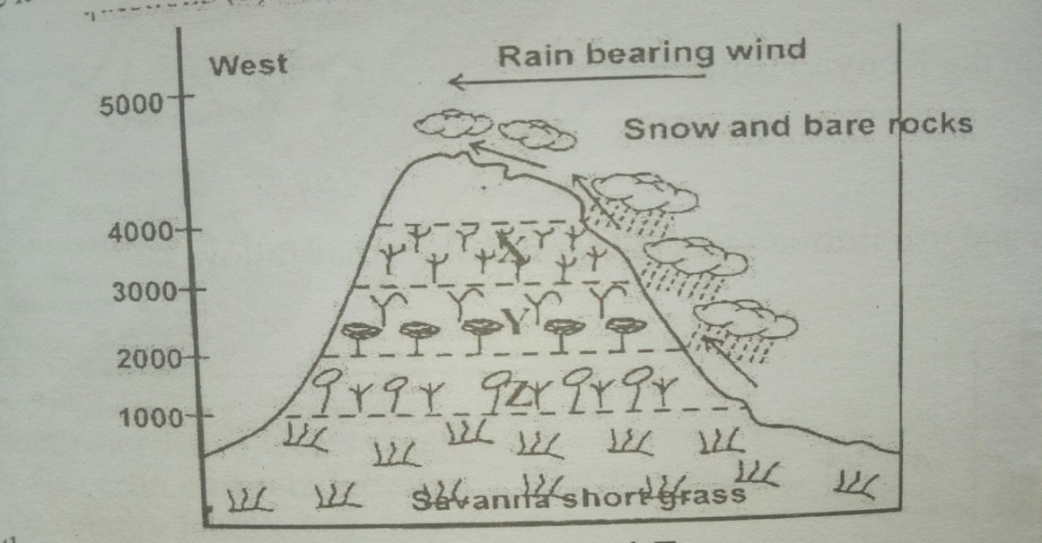

1. Name the vegetation zones marked X, Y and Z **(3mks)**

ii) Give **two** reasons why the mountain top has no vegetation **(2mks)**

b) Describe the characteristics of savanna grasslands **(4mks)**

c) Explain **three** factors that have led to the decline of natural grassland in Kenya

**(6mks)**

d) You carried out a field study of different tree species

i) Identify **three** activities you would carry out during the field study **(3mks)**

(ii). State **two** ways how would you identify the different tree species? **(2mks)**

iii) State two methods you would use to determine the height of the trees **(2mks)**

1. (a). Distinguish between direction and bearing. **(2mks**)

b. The diagram below is an illustration of the Grid reference system. Use it to answer questions that follow.



1. Give the four figure grid reference of points B and D. (2mks)
2. Give six figure grid reference of points C and E. (4mks)
3. Give the direction and bearing of point D from point B. (3mks)