NAME ……………………………………….…… ADM NO……….… DATE …….………
SCHOOL…………………………………………...……… SIGNATURE …………...……….
121
MATHEMATICS
FORM 4 PAPER 2
FORM 4 JANUARY 2023 TERM 1 OPENER EXAM
INSTRUCTIONS TO CANDIDATES
- Write your name and admission number in the spaces provided at the top of this page.
- This paper consists of two sections: Section I and Section II.
- Answer all questions in section I and any five questions in Section II.
- Show all the steps in your calculations, giving your answers at each stage in the spaces below each question.
- Marks may be given for correct working even if the answer is wrong.
- KNEC Mathematical tables may be used.

For Examiner’s Use Only

1 | 2 | 3 | 4 | 5 | 6 | 7 | 8 | 9 | 10 | 11 | 12 | 13 | 14 | 15 | 16 | Total

17 | 18 | 19 | 20 | 21 | 22 | 23 | 24
Grand
Total

SECTION I (50 marks)
Answer all questions in this section in the spaces provided.
- Use logarithm tables to evaluate (4 marks)
$$\sqrt[3]{\frac{36.72×({0.46)}^{2}}{185.4}}$$

- A tailor intends to buy a sewing machine which costs Ksh 48,000. He borrows the amount from a bank. The loan has to be repaid at the end of the second year .The bank charges an interest rate of 24% per annum compounded half-yearly .Calculate the total amount payable to the bank. (3 marks)

- The volumes of two similar solids are $800 {cm}^{3}$ and $2700 cm^{3}$. If the surface area of the larger one is $2160 cm^{2}$, find the surface area of the smaller figure. (3 marks)

- Rationalize the denominator and simplify (3 marks)
$$\frac{\sqrt{3}+2\sqrt{5}}{\sqrt{5}-\sqrt{3}}$$

- The length and width of rectangular piece of paper were measured as $6cm and 12cm$ respectively .Determine the relative error in calculation of its area (3 marks)

- The figure below shows a circle and a point P outside the circle.

Using a ruler and a pair of compass, construct a tangent to the circle from P. (4 marks)

- Solve for $x$ in the equation (3 marks)
$$2logx+log5=1+3log2$$

- Given that $y=\frac{2x-z}{x + 3z}$ , express $x$ in terms of $y and z$ (3 marks)

- A cylindrical piece of wood of radius 9.8 cm and length 2 m is cut length wise into two equal pieces. Calculate the total surface area of one piece. (Take $π=\frac{22}{7}$). (3 marks)

- Two passenger trains A and B which are 240m apart and travelling in opposite directions at 164 km/hr and 88 km/hr respectively approach one another on a straight railway line .Train A is 150km long and train B is 100m long .Determine the time in seconds that elapses before the two trains completely pass each other. (4 marks)

- In the figure below ABC is a triangle in which $AB=15cm ,BC=7.7cm and$ BC is produced to D Angle $BAC={30}^{0}$ and angle $ACD={80}^{0}$ .Calculate to one decimal place area of triangle ABC (3 marks)
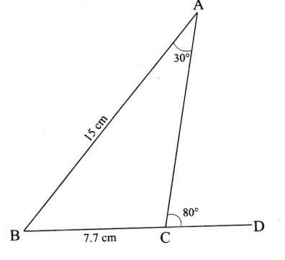

- Solve for $x$ in $2x^{2}+3x-6=0$ by completing the square. (3 marks)

- Find the radius and the centre of a circle whose equation is (4 marks)
$4x^{2}+4y^{2}+56x-104y-152=0$

- Mogaka and Onduso working together can do a piece of work in 6 days. Mogaka working alone takes 5 days longer than Onduso . How many days does it take Onduso to do the work alone? (3 marks)

- Expand the expression ${\left(1+\frac{1}{2x}\right)}^{5}$ upto the term $x^{3}$ hence find the value of ${\left(1\frac{1}{20}\right)}^{5}$. (3 marks)

- Given that $\tilde{p}=5\tilde{a}-2\tilde{b}$ where $\tilde{a}=\left(\begin{matrix}3 \\ 2\end{matrix}\right)$ and $\tilde{b}=\left(\begin{matrix}4 \\ 1\end{matrix}\right)$. Find;
- Column vector $\tilde{p}$ (2 marks)

- $P^{'}$ the image of $\tilde{p}$ under translation vector $\left(\begin{matrix}-6 \\ 4\end{matrix}\right)$ (1 mark)

SECTION II (50 Marks)
Answer only five questions in this section only
- The table below shows income tax rates.
Monthly taxable pay in K£ | Rate of tax Ksh in 1 K£
$$1-435$$  $$436-870$$  $$871-1305$$  $$1306-1740$$  Excess over 1740 | 2  3  4  5  6
A company employee earn a monthly basic salary of Ksh 30,000 and is also given allowances amounting to Ksh 10 480.
- Calculate the total income tax. (5 marks)

- The employee is entitled to a personal tax relief of Ksh 800 per month. Determine the net tax. (1 mark)

- If the employee received a 50% increase in his total income, calculate the corresponding percentage increase on the income tax. (4 marks)

- The probability that a school team will win a match is 0.6. The probability that the team will lose the match is 0.3 and the probability that the team will draw in the match is 0.1. Given that the team will play two matches.
- Draw a tree diagram to represent the above information. (2 marks)

- What is the probability that the team will;
- Win the two matches (2 marks)

- Either wins all the matches or losses all the matches? (2 marks)

- Wins one match and losses one (2 marks)

- Tie in one match. (2 marks)

- A parent has two children whose ages difference is 5years .Twice the sum of the ages of the two children is equal to the age of the parent.
- Taking $x$ to be the age of the elder child write an expression for:
- The age of the younger child. (1 mark)

- The age of the parent. (1 mark)

- In twenty years’ time, the product of the children’s ages will be 15 times the age of their parent.
- Form an expression in $x$ and hence determine the possible ages of the elder child (4 marks)

- Find the present possible ages of the parent (2 marks)

- Determine the possible ages of the younger child in 20 years’ time. (2 marks)

- In the triangle below P and Q are points on OA and OB respectively such that $OP:PA=3:2$ and $OQ:QB =1:2.$ AQ and BP intersect at T. Given that $OA=\check{a}$ and $OB= \check{b}$.
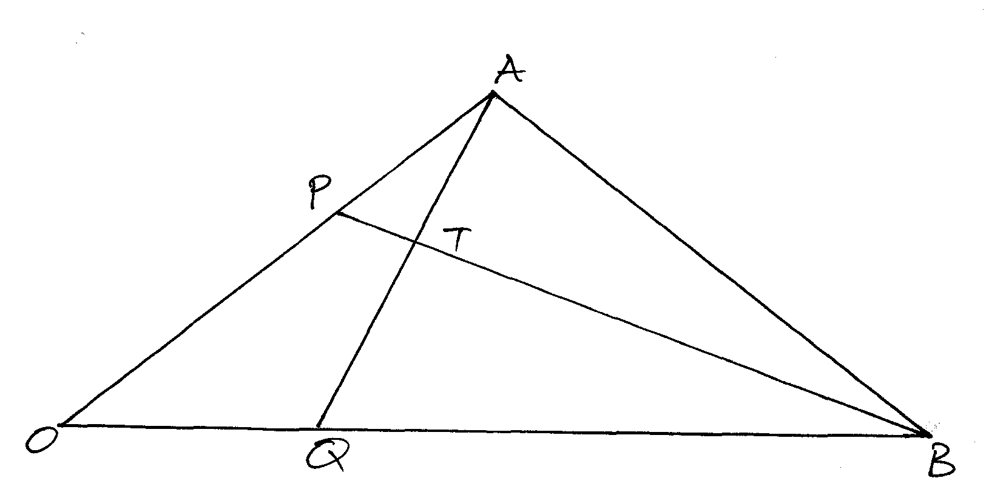
(a) Express AQ and PQ in terms of $\check{a}$ and $\check{b}$ (2 marks)

(b) Taking $BT=kBP$ and $AT=hAQ$ where h and k are real numbers.
- Find two expressions for OT in terms of and (2 marks)

- Use the expressions in b (i) above to find the values of $h$ and $k$. (3 marks)

(c) Show that B, T and P are collinear. (3 marks)

- The figure below is a right pyramid VEFGH with a square base of 8 cm and a slant edge of 20 cm. Points A, B, C and D lie on the slant edges of the pyramid such that VA = VB = VC = VD = 10 cm and plane ABCD is parallel to the base EFGH.
- Find the length of AB. (2 marks)

- Calculate, correct to 2 decimal places:
- The length of CA. (2 marks)

- The perpendicular height of the pyramid VABCD. (2 marks)

- The pyramid VABCD was cut off. Find the volume of the frustum ABCDEFGH correct to 2 decimal places. (4 marks)

- a) The 1st, 7th and 25th term of an arithmetic progression are the first three consecutive terms of a geometric progression .The 20th term of the arithmetic progression is 22 .Find
- The first term and common difference of the arithmetic progression. (4 marks)

- The sum of the first 20 terms of the arithmetic progression. (2 marks)

b) (i) The 7th term of the geometric progression (2 marks)

(ii) The sum of the first six terms of the geometric progression (2 marks)

- a) Given the matrix find the inverse of A. (2 marks)

b) Two universities, TECK and KCT purchased beans and rice. TECK bought 90 bags of beans and 120 bags of rice for a total of Sh 360, 000. KCT bought 200 bags of beans and 300 bags of rice for a total of Sh 850,000. Use the matrix method to find the price of one bag of each item. (5 marks)

c) The price of beans later decreased in the ratio $4:5$while the price of rice increased by 20%. A businessman bought 20 bags of beans and 30 bags of rice. How much did he pay? (3 marks)

- Three quantities X, Y and Z are such that X varies directly as the square root of Y and inversely as the fourth root of Z. When X = 64, Y = 16 and Z = 625.
- Determine the equation connecting X, Y and Z. (4 marks)

- Find the value of Z when Y = 36 and X = 160. (2 marks)

- Find the percentage change in X when Y is increased by 44%. (4 marks)

