NAME……………………………………………ADM NO.………..CLASS…………….
DATE: ……………………………..
FORM 2 JANUARY 2023 TERM 1 OPENER EXAM
Time: 2 Hours 30 mins

INSTRUCTIONS TO CANDIDATES:-
- Write your name, Admission number and class in the spaces provided above.
- This paper consists of two sections; I and II
- Answer all the questions in section I and II in the spaces provided
- All working must be clearly
- Candidates should answer the questions in English.
- Take g=10N/kg

For Examiner’s Use Only:

Section | Question | Maximum  Score | Candidate’s  Score
A | 1 – 16 | 50
 | 17 -22 | 50
Total Score |  | 100

SECTION A (50 MARKS)
1. Define physics (1mk)
………………………………………………………………………………………………………………………………………………………………………………………………………………
2. The following are branches of physics. Explain what each one of the them deals with.
a) Mechanics (1mks)
………………………………………………………………………………………………………………………………………………………………………………………………………………
b) Geometrical optics (1mks)
………………………………………………………………………………………………………………………………………………………………………………………………………………
3. State 2 laboratory rules a student should follow to avoid electrical shocks. (2mks)
………………………………………………………………………………………………………………………………………………………………………………………………………………
4. State the first aid measure for the case when an acid burns a hand (1mks)
………………………………………………………………………………………………………………………………………………………………………………………………………………
5. a) Differentiate between basic physical quantities and derived quantities. (2mks)
………………………………………………………………………………………………………………………………………………………………………………………………………………………………………………………………………………………………………………………
b) Give one examples of derived quantities . (1mks)
………………………………………………………………………………………………………………………………………………………………………………………………………………
6. Fill in the table below.
( 3mks )
Basic physical quantity | S.I. Unit | Symbol of unit
Electric current
luminous intensity
Time

7. Determine the density in kg/m³ of a solid whose mass is 1080g and whose dimensions in cm are length=3, width= 4 and height= 3 . (3mks)
………………………………………………………………………………………………………………………………………………………………………………………………………………………………………………………………………………………………………………………
8.State any two career opportunities in physics (2mks)
………………………………………………………………………………………………………………………………………………………………………………………………………………

9. Name any 2 items contained in the first Aid kit found in the laboratory (2mks)
………………………………………………………………………………………………………………………………………………………………………………………………………………………………………………………………………………………………………………………
10. Describe the method you would use to measure the circumference of a cylinder using a thread and a meter rule (3mks)
………………………………………………………………………………………………………………………………………………………………………………………………………………………………………………………………………………………………………………………………………………………………………………………………………………………………
11. a) Define force and state its SI Units (2 mks)
………………………………………………………………………………………………………………………………………………………………………………………………………………b) State 1 effects of force on a body. (1mk)
……………………………………………………………………………………………………………………………………………………………………………………………………………… c) State 1 ways of reducing surface tension in liquid. (1mk)
………………………………………………………………………………………………………………………………………………………………………………………………………………
d) A body weighs 120N in air and 70N when submerged in water. Calculate the upthrust acting on the body. (2 mks)
………………………………………………………………………………………………………………………………………………………………………………………………………………
e) Give a reason why weight of a body varies from one place to another. (1mk)
………………………………………………………………………………………………………………………………………………………………………………………………………………
12. Sketch a diagram to show the direction and magnitude of the resultant force for two forces acting as shown in figure 5 below (2mks)
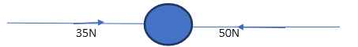
………………………………………………………………………………………………………………………………………………………………………………………………………………
13. Study the diagram bellow and indicate on the diagram the right position of the eye when taking the measurements. record the right reading. (2mks)
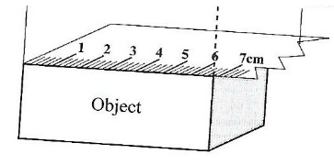

14. Estimate the height of the tree in the diagram below. (3mks)
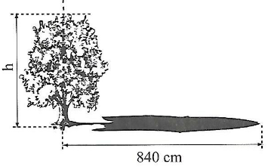
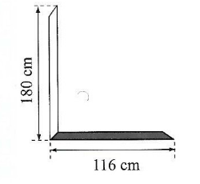
………………………………………………………………………………………………………………………………………………………………………………………………………………
………………………………………………………………………………………………………
15. Distinguish between heat and temperature. (2mk)
………………………………………………………………………………………………………………………………………………………………………………………………………………
16. The diagram below shows a ball and ring apparatus used in an experiment, the ball goes through the rings at room temperature. When it is heated it does not go through the ring, but when left on the ring for some time, it goes through. Explain this observation (3mks)
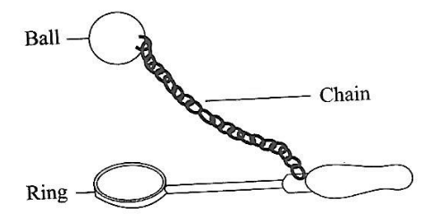
………………………………………………………………………………………………………………………………………………………………………………………………………………………………………………………………………………………………………………………
17. The figure 3 below shows a flask filled with coloured water. The rubber cork is pushed in until the in water rises a short distance in the glass tube.
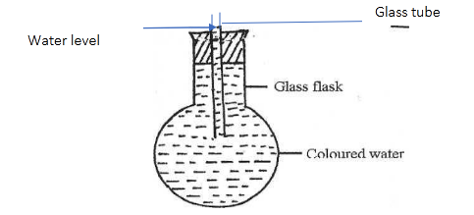
State and explain what is observed when the flask is placed in a hot water bath (2mks)
....................................................................................................................................................................................................................................................................................................................................................................................................................................................................................
18. Figure 8 shows a clinical thermometer which is not graduated
a) Name the parts indicated with letters: A and B (2mks)
A .............................................................................................
B .............................................................................................
b) Mark the appropriate scale range in degrees Celsius (2mks)
........................................................................................................................................................................................................................................................................................................................
20. When a negatively charged rod is brought near the cap of a leaf electroscope, the leaf rises. Explain this observation, (2mks)
........................................................................................................................................................................................................................................................................................................................
21. a) Why is topping of an accumulator done with distilled water? (1mk)
........................................................................................................................................................................................................................................................................................................................
b) Name two advantages which a lead accumulator has over a dry cell (2mks)
........................................................................................................................................................................................................................................................................................................................

SECTION B (50mks)
22. (a) State one disadvantage of using a pin hole camera to take photographs (1mk)
............................................................................................................................................................ ............................................................................................................................................................
(b)What property of light is illustrated by formation of shadows? (1mk)
........................................................................................................................................................................................................................................................................................................................
(c)Give one difference between luminous and non-luminous sources of light. (1mk)
........................................................................................................................................................................................................................................................................................................................
(d) A ray of light makes an angle of 20 degrees with a plane mirror as shown in figure below. Determine the angle of reflection (2mks)
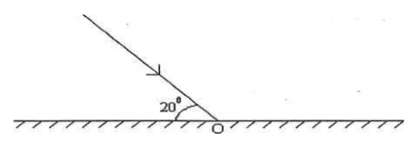
........................................................................................................................................................................................................................................................................................................................
23 a) State Pascal’s principle (principle of transmission f pressure in liquids) (1mk)
………………………………………………………………………………………………………………………………………………………………………………………………………………
b) The figure below represents a section of a hydraulic machine. The area of piston A and B are 0.03m² and 0.5m² respectively. A force of 60N is applied on the smaller piston as shown.
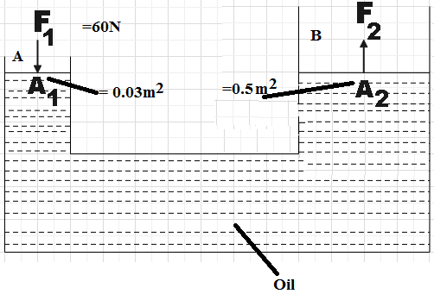
Determine:
i) Pressure exerted on the oil by piston A (2mks)
………………………………………………………………………………………………………………………………………………………………………………………………………………
………………………………………………………………………………………………………
ii) Pressure exerted by the oil on piston B (1mk)
………………………………………………………………………………………………………………………………………………………………………………………………………………
iii) Maximum force (load) that can be lifted by the system. (3mks)
………………………………………………………………………………………………………………………………………………………………………………………………………………
………………………………………………………………………………………………………
iv) Give one reason why oil and NOT water is selected for use in the system above. (1mk)
………………………………………………………………………………………………………………………………………………………………………………………………………………
c) The figure below shows a U-tube filled with water, mercury and another liquid.
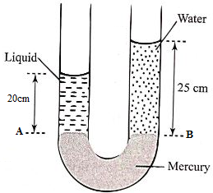
Given that the densities of mercury and water are 13600kg/m³ and 1000kg/m³ respectively.
Determine:
i) Pressure due to water column at B (1mk)
………………………………………………………………………………………………………………………………………………………………………………………………………………
ii) Pressure at point A (1mk)
………………………………………………………………………………………………………………………………………………………………………………………………………………
iii) Density of liquid L (3mks)
………………………………………………………………………………………………………………………………………………………………………………………………………………
………………………………………………………………………………………………………
24. a) i) Define density (1mk)
………………………………………………………………………………………………………………………………………………………………………………………………………………
ii) The density of a material is 5g/cm³. Express this in SI units (2mks)
………………………………………………………………………………………………………………………………………………………………………………………………………………
………………………………………………………………………………………………………
b) The mass of an empty density bottle is 20g when empty and 40g when full of water. When full of a liquid L is mass is 220g. Given that the density of water is 1g/cm³. Determine:
i) Mass of water in the density bottle (1mk)
………………………………………………………………………………………………………………………………………………………………………………………………………………

ii) Volume of the density bottle (2mks)
………………………………………………………………………………………………………
iii) Density of the liquid L (3mks)
………………………………………………………………………………………………………………………………………………………………………………………………………………
………………………………………………………………………………………………………

25. a) i) State 2 properties of a good thermometric liquid (2mks)
………………………………………………………………………………………………………………………………………………………………………………………………………………
ii) Convert each of the following to the unit in brackets
i) OK (⁰C) (1mk)
………………………………………………………………………………………………………
………………………………………………………………………………………………………
ii) 40⁰C (Kelvin) (1mk)
………………………………………………………………………………………………………
………………………………………………………………………………………………………
b) State 2 factors that thermal conductivity in materials depends (2mks)
………………………………………………………………………………………………………………………………………………………………………………………………………………
………………………………………………………………………………………………………
c) Two tins A and B each carrying the same amount of water, tin A is blackened (dull) while tin B is shiny (polished. Two thermometers P and Q were inverted in the two tins and a heater placed equidistant from the two tins as shown below in the diagram.
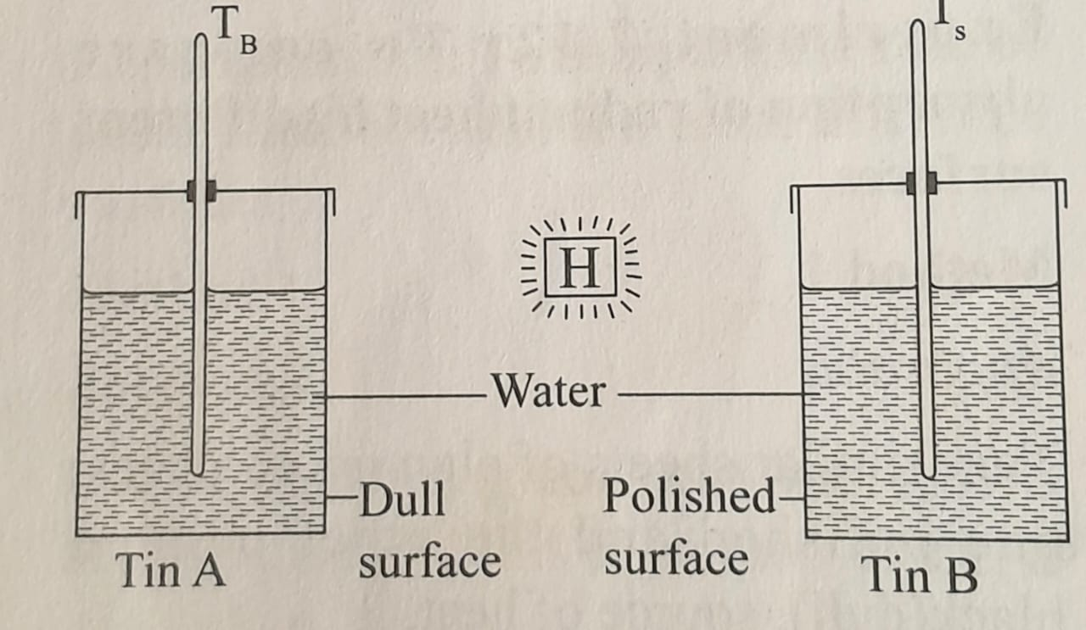
The two thermometers were read after sometime.
i) State which thermometer recorded a lower reading (1mk)
………………………………………………………………………………………………………
ii) Give a reason (explain) your answer in (i) above (2mks)
………………………………………………………………………………………………………………………………………………………………………………………………………………
d) The diagram below shows a vacuum flask with enlarged view of the part circled.
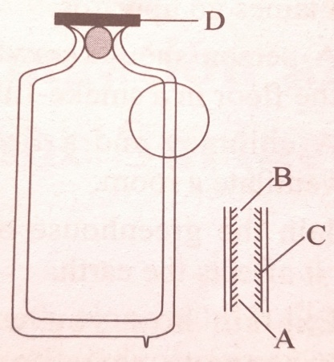

i) State type of heat energy transfer reduced by the parts labelled D (1mk)
………………………………………………………………………………………………………………………………………………………………………………………………………………
ii) Name the parts labelled B and C (2mk)
………………………………………………………………………………………………………………………………………………………………………………………………………………
iii) Explain how B is effective in reducing heat transfer (2mks)
………………………………………………………………………………………………………………………………………………………………………………………………………………
26 a) Define matter (1mk)
………………………………………………………………………………………………………
b) Differentiate between solids and gases in terms of arrangement of particles in the 2 states of matter. (2mks)
………………………………………………………………………………………………………………………………………………………………………………………………………………
c) The diagram below shows an experiment by form 1 students in a certain school.
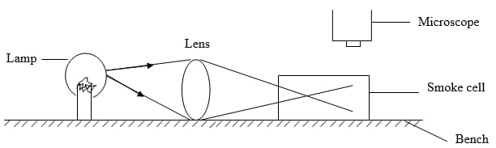
i) What were the form one students investigating by the above set up. (1mk)
………………………………………………………………………………………………………………………………………………………………………………………………………………
ii) What is the purpose of the converging lens? (2mk)
………………………………………………………………………………………………………………………………………………………………………………………………………………
iii) Describe what is observed in the smoke cell (2mks)
………………………………………………………………………………………………………………………………………………………………………………………………………………
iv) Explain your answer in (iii) above (2mks)
………………………………………………………………………………………………………………………………………………………………………………………………………………

