Name ………………………..……………………………... ADM No: ………………..…….…Date:……………………………….
232/3
PHYSICS
(PRACTICAL)
Paper 3
FORM 4 JANUARY 2023 TERM 1 OPENER EXAM
TME: 2 ½ Hours

Kenya Certificate of Secondary Education (KCSE)
MULTILATERAL EXAM

INSTRUCTIONS TO CANDIDATES
a) Answer all questions in the spaces provided in the question paper.
b) You are supposed to spend the first 15 minutes reading the whole paper carefully before
commencing your work.
c) Candidates are advised to record their observations as soon as they are made.
d) Marks are given for observation actually made, their suitability, accuracy and the use made of
them.

FOR EXAMINER’S USE ONLY

QUESTION | MAXIMUM SCORE | CANDIDATE’S SCORE
1 | 20
2 | 20
TOTAL | 40

QUESTION 1
PART A
You are provided with the following;
- Metre rule
- Complete stand
- A spring with a pointer
- Three masses ( one 100g mass and two 50g mass)
- Stop watch
Proceed as follows;
- Set up the apparatus as shown;
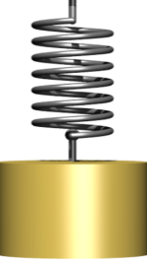
pointer
Metre rule
spring
stand
M

- Hang the unloaded spring and record the pointer readings.
X₀ ……………………………………………….. m ( 1 mk)
- i) Load a mass of 150g and determines the extension of the spring
e₁ ………………………………………………… m (1mk)
ii) Displace the 150g mass slightly downwards and release it to oscillate vertically. Time 20 oscillations and obtain t₁.
t₁ ………………………………… s (1mk)
iii) find the periodic time T₁.
T₁ ……………………………….. s ( 1mk)
iv) use the equation T₁ = 2$π√\frac{e}{p}$ to find the value of P_{1 .} ( 2mks)
……………………………………………………………………………………………………………………………………………………………………………………………………………………………………………………………………………………………………………………………..
- i) Load a mass of 200g and determines the extension of the spring
e₂ ………………………………………………… m (1mk)
ii) Displace the 200g mass slightly downwards and release it to oscillate vertically. Time 20 oscillations and obtain t₂.
t₂ ………………………………… s (1mk)
iii) find the periodic time T₂.
T₂ ……………………………….. s ( 1mk)
iv) use the equation T₂ = 2$π√\frac{e}{p}$ to find the value of P_{2 .} ( 2mks)
…………………………………………………………………………………………………………
- find the average of p. (2mks)
p_{av} = $\frac{p1+p2}{2}$
……………………………………………………………………………………………………………………………………………………………………………………………………………………………………………………………………………………………………………………………..

PART B
You are provided with the following;
- A rubber bung
- Vernier caliper
- Beam balance
Proceed as follows
- Using the vernier caliper, measure the length D, d and h as shown in the figure.

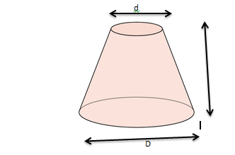
D……………………………………………………m ( 1mk)
d…………………………………………………..m ( 1mk)
h…………………………………………………..m (1mk)
- Measure the mass M, of the rubber bung using the beam balance.
M = ………………………………… Kg ( 1mk)
- Given that Q = $\frac{d+D}{4}$ , determines the value of Q. ( 1mk)
- Determines the value of “ r “ given that ( 3mks)
$π$rQ² = M/h

QUESTION 2
You are provided with the following.
- An ammeter (0-3A )
- A voltmeter ( 0-5V )
- 2 Dry cells
- A resistance wire mounted on mm scale
- 6 c0nnecting wires
- A torch bulb in a bulb holder
- A cell holder
- A switch
- A jockey

Proceed as follows.
- Connect the apparatus as shown in the diagram below.
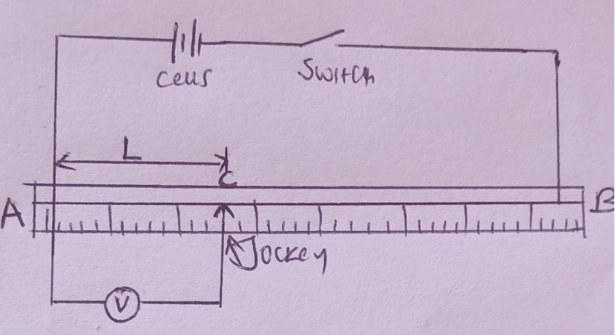
- With AB= 100cm and jockey at C, 10cm from A, close the switch and record the voltmeter reading, V, in the table below.
- Repeat the experiment in (b) above for the following lengths L= 20cm, 30cm, 40cm, 50cm, 60cm, 70cm, and 80cm. (4mks)
Length L (cm) | 10 | 20 | 30 | 40 | 50 | 60 | 70 | 80
Pd V (v)

- Plot a graph of Pd v against length L (5mks)
- Determine the slope S of the graph (2mks)
………………………………………………………………………………………………………………………………………………………………………………………………………………Connect the circuit as shown in the circuit diagram below.

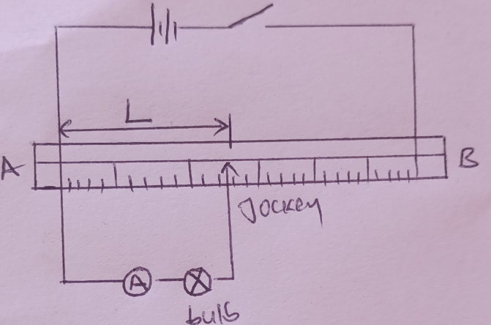
- Close the switch and record the ammeter readings I₁, I₂, and I₃ for the corresponding values of lengths
L₁= 30cm I1=………………………………. (1mk)
L₂= 50cm I2=………………………………. (1mk)
L₃= 70cm I3=………………………………. (1mk)
- Given that V = LS, where V is the Pd across the length AC of the wire, S is the slope of the graph in (d) above and L is the length of the resistance wire. Determine the potential difference V1, V2, V3 across the length AC of the wire for length LI, L2 and L3in (g) above.

L₁= 30cm V1 =………………………………. (1mk)
………………………………………………………………………………………………….
………………………………………………………………………………………………….

L₂= 50cm V2 =………………………………. (1mk)
………………………………………………………………………………………………….
………………………………………………………………………………………………….

L₃= 70cm V3 =………………………………. (1mk)
…………………………………………………………………………………………………
…………………………………………………………………………………………………

- Using the values V1, V2 and V3 and the corresponding currents I1, I2 and I3, calculate the corresponding resistance R1, R2 and R3.

L₁= 30cm R1=………………………………. (1mk)

L₂= 50cm R2=………………………………. (1mk)

L₃= 70cm R3=………………………………. (1mk)

- Compute the average value of the resistance R of the bulb. (2mks)
……………………………………………………………………………………………………………………………………………………………………………………………………………………………………………………………………………………………………………………

