PANGANI POST MOCK EXAMINATION

2022

NAME: ……………………………………..ADM NO.:………CLASS ………
SIGNATURE:…………………...DATE:………………TEACHER…………..

PHYSICS
Paper 3 (Practical)
Time: 2 ¼ Hours

Kenya Certificate of Secondary Education (K.C.S.E)

PHYSICS
Paper 3 (Practical)

INSTRUCTIONS TO CANDIDATES:
- Write your name and index number in the spaces provided above.
- Sign and write the date of the examination in the spaces provided above.
- You are supposed to spend the first 15 minutes of the 2 ½ hours allowed for this paper reading the whole paper carefully before commencing your work.
- Marks are given for a clear record of the observation actually made, their suitability, accuracy and the use made of them.
- Candidates are advised to record their observations as soon as they are made
- Non-programmable silent electronic calculators may be used.
- Candidates should check the question paper to ascertain that all the pages are printed and that no questions are missing.

Question | Maximum score | Candidate’s score
1 | 20
2 | 20
Total | 40
For Examiner’s Use Only.

This paper consists of 8 printed pages candidates should check the questions to ascertain that all pages are printed as indicated and that no questions are missing

QUESTION 1
You are provided with the following: -
- 2 dry cells
- A cell holder
- A switch
- An ammeter
- Five connecting wires
- Wire mounted on the metre rule labelled x
- A micrometer screw gauge [ to be shared
- A Voltmeter

Proceed as follows
  - Measure the diameter of the wire three times and determine the average diameter,

  - D ………………. m (2 marks)

  - Determine the cross-section area of the wire, A………………. m² (1 marks)

  - Connect the circuit as shown in the figure below.
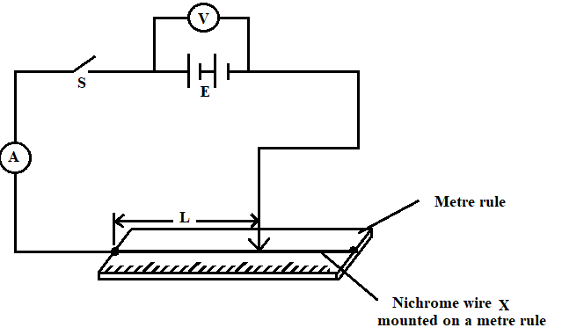
  - Measure the voltage E from the Voltmeter, before closing the switch.

E = ................................ (1 mark)
  - Adjust the length, of the wire to 0.2m, close the switch, S and read the value of current and record in the table below.

Length, (m) | 0.2 | 0.3 | 0.4 | 0.5 | 0.6 | 0.7
Current, I (A)

  - Repeat the procedure in (c) above for the values of lengths given. (5 marks)
  - Calculate the value of $1/{I }$and record in the table above. (1 mark)
  - On the grid provided plot a graph of (y- axis) against l (5 marks)

  - Determine the gradient of the graph. (2 marks)
…………………………………………………………………………………………………………………………………………………………………………………………………………………………………………………………………………………………………………………………………………………………………………………………………………………………………………………………………………………..

  - Given that, $\frac{1}{I}=\frac{δ}{EA}l+\frac{r}{E}$, determine the value of$δ and r$. (3 marks)
…………………………………………………………………………………………………………………………………………………………………………………………………………………………………………………………………………………………………………………………………………………………………………………….

QUESTION 2
You are provided with the following:
- a metre rule
- knife edge raised 20 cm above bench
- one 50 g mass and one 100 g mass
- a beaker or any container
- some thread
- some water in a beaker
- Liquid L in a beaker
- tissue paper
- A triangular glass prism
- A piece of soft board
- Four optical pins
- Four office pins
- A sheet of plain paper

PART A
Proceed as follows:
- Balance the metre rule edge and record the reading at this point

$Balance point =$ cm (1 mark)
For the rest of this experiment the knife edge must be placed at this position
- Set up the apparatus as shown in the figure below.
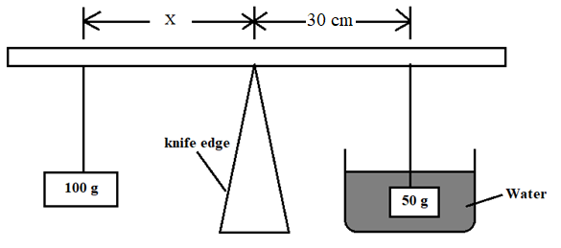

- Use the thread provided to hang the masses such that the positions of support can be adjusted. The balance is attained by adjusting the position of the 100g mass.
Note that the distances X is measured form the knife edge and the 50g mass is fully submerged in the water.

- Record the value of X .

$X=$ cm (1 mark)

- Apply the principle of moments to determine the weight W_{w} of the 50 g mass in water and hence determine the up thrust U_{w} in water

W_{w} N (2 marks)

U_{w} N (1 mark)

- Remove the 50 g mass from the water and dry it using tissue paper.

- Maintaining the distance of 30cm in step (d), now balance the metre rule when the 50 g mass is fully submerged in the liquid L Record the value of the distance X.

$X=$ cm (1 mark)
- Apply the principle of moments to determine the weight W_{L} of the 50 g mass in the liquid L and hence determine the upthrust U_{L} in the liquid
- W_{L}$=$ (2 mark)
……………………………………………………………………………………

- U_{L}$=$ (1 mark)
…………………………………………………………………………………….
- RD of liquid L (2 marks)

………………………………………………………………………………………………………………………………………………………………………………………………………………………………………………………………………………

PART B

Proceed as follows:
- Place the plain sheet of paper on the soft board and pin it using the office pins at the comers. Trace the triangular prism outline of the prism on the sheet of paper (use the upper part to leave space for two other outlines on the same page). Label the vertices of the outline at A, B and C. Remove the prism from the paper.
- On the outline at a point O near the centre of side AB draw a normal ON.
- Draw a line PO at an angle of 30° to the normal ON as shown in the figure below.
- Replace the prism accurately on the outline. Fix two optical pins vertically on line PO at different points (see the figure below).
- View the images of the two pins through side AC of the outline. Fix a third and fourth pin vertically such that they are in line with the images of the first and second pin. Remove the prism and the pins. Draw a line joining the marks made by the third and fourth pins and extend it to join line PO (also extended) as shown below.
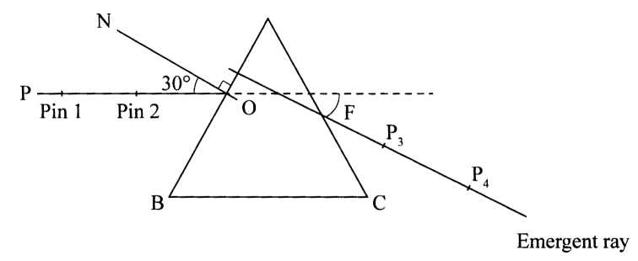
Measure F, the angle of deviation of the emergent ray. (2 marks)
……………………………………………………………………………………………………………………………………………………………………………………
- Repeat part (e) for other angles of incidence shown in the table below. (Draw a fresh outline of the prism for each angle of incidence)

Complete table 1 (3 marks)

Angle of incidence | 30° | 50° | 70°
Angle of deviation

- Determine:
- E the angle of emergence (between the emergent ray and the normal at the point of emergence) at the least angle of deviation. (2 marks)
…………………………………………………………………………………………………………………………………………………………………………………………………………………………………………………………………………………………………………………………………………………………………………
- K given that $K=2\sin\left(30+\frac{F_{o}}{2}\right)$ (where F₀ is the least angle of deviation) (2 marks)
………………………………………………………………………………………………………………………………………………………………………………………………………………………………………………………………………………………………………………………………………………………………………………………………………………………………………………………………….

(Attach the plain sheet of paper to your question paper and hand them in).

