NAME: ……………………………………………. ADM NO.…………… CLASS: ……...

PHYSICS FORM 4
PAPER 2
FORM 4 JANUARY 2023 TERM 1 OPENER EXAM
Time: 2 Hours

INSTRUCTIONS TO CANDIDATES:-
- Write your name, Admission number and class in the spaces provided above.
- This paper consists of two sections; A and B
- Answer all the questions in section A and B in the spaces provided
- All working must be clearly shown.
- Mathematical tables and electronic calculators may be used
- This paper consists of 12 printed pages. Candidates should check to ascertain that all pages are printed as indicated and that no questions are missing.
- Candidates should answer the questions in English.
- Take g=10N/kg
For Examiner’s Use Only:

Section | Question | Maximum  Score | Candidate’s  Score
A | 1 – 11 | 25
 | 12 | 12
 | 13 | 11
B | 14 | 12
 | 15 | 9
 | 16 | 11
Total Score |  | 80

SECTION A (25 MARKS)
- The diagram below shows an object O placed in front of a plane mirror.

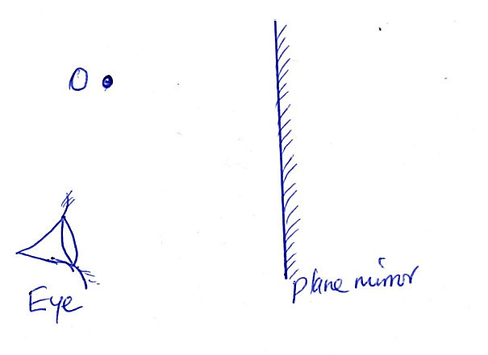

Draw rays to locate the position of the image as seen by the eye. (2mks)

- The wavelength of a wave in air was 1.33M and 1.0 M in another medium when the wave travelled from air to that medium. Determine the refractive index of that medium (3mks)

- The figures below shows a 6V battery connected to an arrangement of resistors. determine :

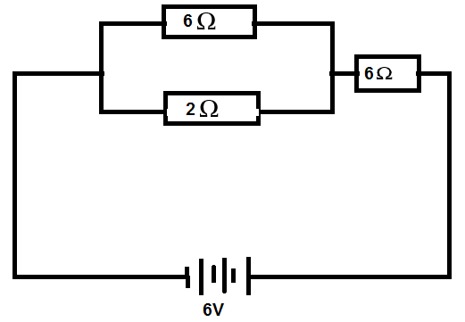
  - Effective resistance in the circuit (2mks)

  - Current flowing through the 2 Ωresistor (2mks)

- Explain how polarization affects the working of a simple cell (1mk)

- The figure below shows a negative point charge near a positively charged rod. Draw on the figure the resulting electric field pattern (2mks)

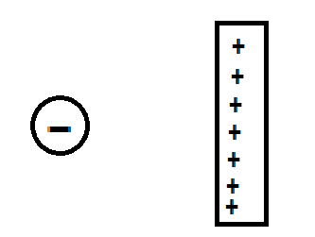
- The figure below shows how magnets are stored in pairs with keepers at the end.
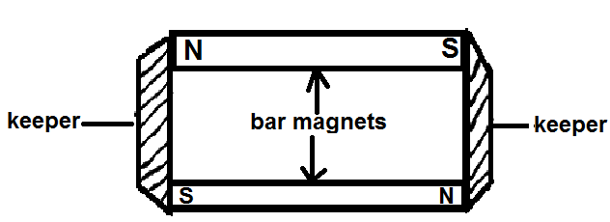
  - Name the most suitable metal used to make the keepers(1mk)

  - Explain how the metals above help in retaining magnetism longer (1mk)

- State three (3) uses of electroscope (3mks)

- A form 2 student rubbed a comb against his dry hair, thereafter he brought the comb closer to small pieces of paper.
  - State the observation made (1mk)

  - Explain the above observation (1mk)

- The figure below shows a soft iron bar PQ placed in a coil near a freely suspended magnet
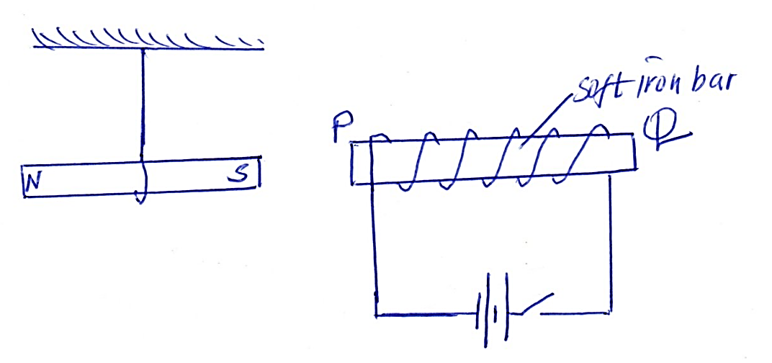
  - State what is observed when the switch is closed (1mk)

  - Explain the above observation (1mk)

- The figure below shows progressive waves coming from a deep to a shallow region.
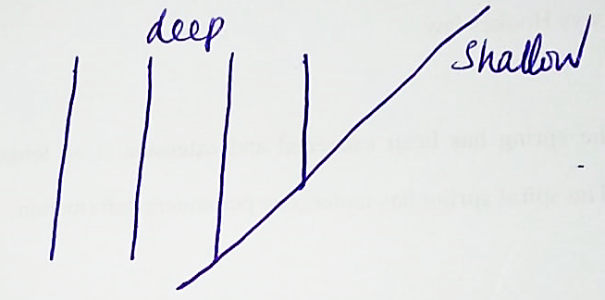
Draw on the diagram to show how the waves proceed in the shallow region (2mks)

- A form 2 student placed a current – carrying conductor between a north and a south pole of two bar magnets as shown below.
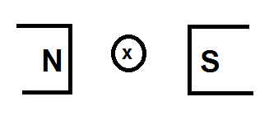
  - Using an arrow show the direction of motion of the conductor after it experiences a force when the current is switched on. (1mk)

  - State the rule you have applied to determine the direction of motion of the conductor (1mk)

- (a) State ohms law (1mk)

(b) In an experiment to determine the internal resistance of a cell, a form 3 student drew
the following graph after obtaining values of currents, I and their corresponding
Terminal voltages, V.
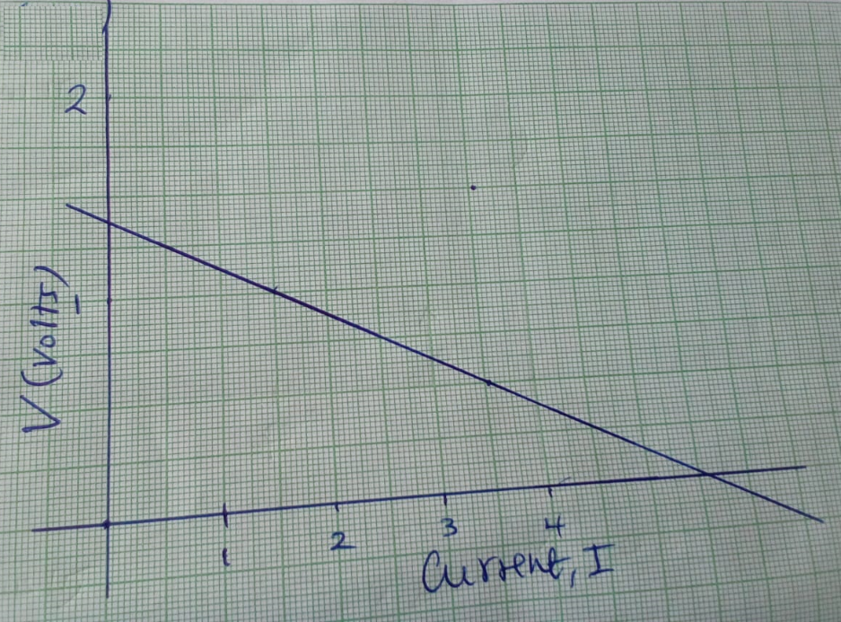
From the graph determine the
    - internal resistance , r of the cell (3mks)

    - the EMF of the cell (1mk)

(c) State two (2) factors affecting amount of heat energy in an electric heater (2mks)

(d) The heating element of an iron box is made of a wire of resistance 28.8 ohms and the
power supply is 240v. Determine
      - the power rating of the iron box (3mks)

      - then current flowing in the circuit (2mks)

(c) State two(2) factors affecting amount of heat energy in an electric heater (2mks)

- (a) State snells law (1mk)

(b) A coin is placed beneath a transparent block of thickness 10cm and reflective index
1.56. Calculate the vertical displacement of the coin. (2mks)

(c) (i) Define critical angle (1mk)

(ii)State the conditions for total internal reflection to take place. (2mks)

(d) The diagram shows light travelling from a glass prism to air. If the reflective index of
the glass prism is 1.5464, determine the critical angle, C.
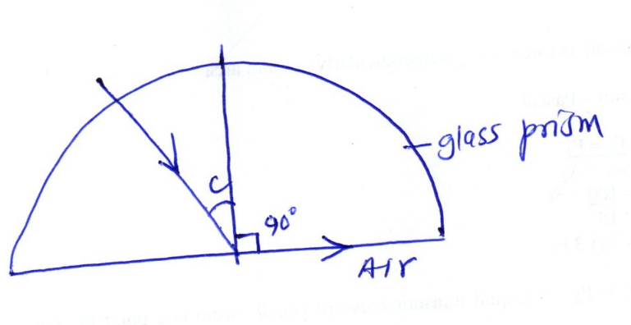
(e) The reflective indices of water and glass are 4/3 and 3/2 respectively.
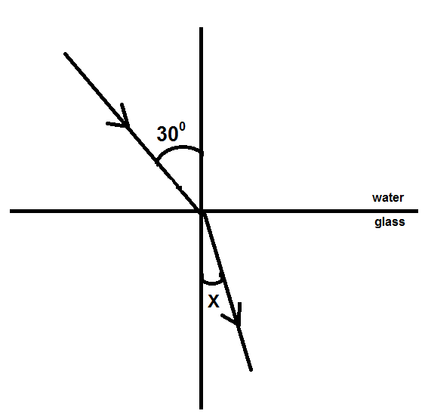
Find value X in the figure below. (3mks)

- (a) State what is meant by the term capacitance (1mk)

(b) Distinguish between a paper Capacitor And An Electrolyte Capacitor (1mk)

(c) State two (2) factors that determine capacitance of a parallel plate capacitor (2mks)

(d) The figure below shows a network of capacitors in series
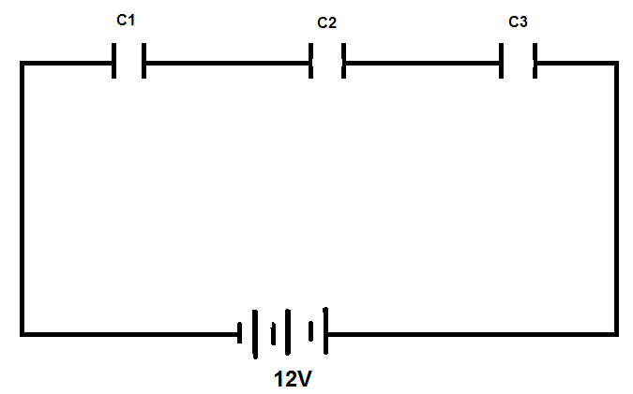
  - Derive an expression for their effective capacitance ce from the first principles (3mks)

  - Given that c1 = 1.5 mf, c2 = 2mf and c3 = 3mf, calculate the effective capacitance and determine the charge stored on each capacitor (3mks)

  - State two applications of capacitors (2mks)

- The figure below shows an object placed in front of a concave mirror of focal length 5cm. c is the centre of curvature. (diagram drawn to scale – 1big square represent 1cm x 1cm)
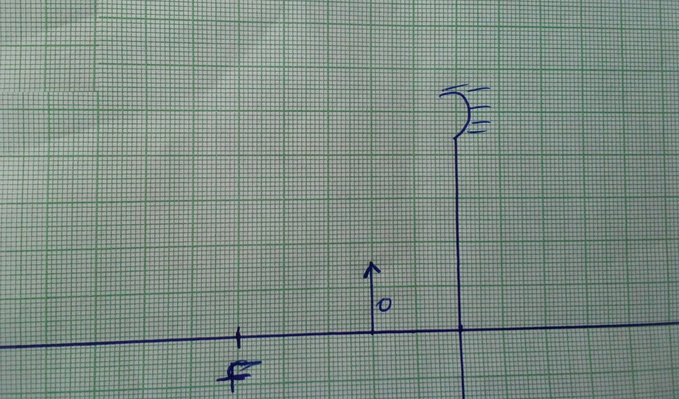
    - On the same diagram draw rays to locate the image (3mks)

    - Use the ray diagram you have drawn above to determine the
      - Image distance (1mk)

      - Magnification (2mks)

    - A convex mirror of focal length 9cm produces an image on its axis 6cm from the mirror. Determine the position of the object (3mks)

- (a) Distinguish between transverse and longitudinal waves (1mk)

(b) Water waves are observed as they pass a fixed point at a rate of 30 crests per minute. A particular wave crest takes 2seconds to travel between two fixed points 6m apart. Determine for the wave the:
  - Frequency (2mks)

  - Wavelength (2mks)

c) The figure below shows a displacement position graph of a slinky spring as it is continuously vibrated at one end.
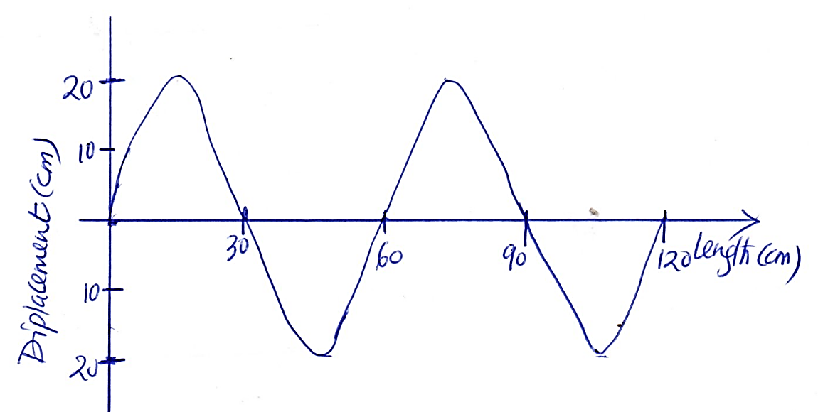
- Name the type of wave generated (1mk)

- Determine the amplitude of the wave (1mk)

        - Copy the wave in c above and on it draw a wave showing the wave when the frequency is doubled (2mks)

        - State two (2) factors affecting velocity of sound in air (2mks)

