NAME_______________________________INDEX NUMBER___________________ SCHOOL_____________________________CANDIDATE’S SIGN___________DATE___________
443
AGRICULUTURE
FORM TWO
SEPTEMBER 2021
TIME: 2 HOURS
CASPA AMUKURA PARISH 2021 EXAMINATION
443
AGRICULUTURE
FORM TWO
SEPTEMBER 2021
TIME: 2 HOURS
INSTRUCTIONS TO EXAMINEES
- Write your name ,index number and school in the spaces provided above
- Sign and write the date of examination in the space provided
- This paper consists of three sections A,B and C
- Answer all the questions in section A and B
- Answer any two questions in section C
- All answers should be written in the space provided
For Examiners Use Only

section | Question | Maximum score | Candidate’s score
A | 1-17 | 30
B | 18-21 | 20
C | 22-24 | 40
 | TOTAL | 90

SECTION A (30MARKS)
- Name two plumbing tools (1mk)
…………………………………………………………………………………………………………………………………………………………………………………………………………………………………………………………………………………………………………..
- State four factors influencing the rate of soil formation (2mks)
……………………………………………………………………………………………………………………………………………………………………………………………………………………………………………………………………………………………………………………………………………………………………………………………………………………………………………………………………………………………………………………………………………………………………………………………………………………..
- Give four conditions that necessitate clearing of land. (2mks)
……………………………………………………………………………………………………………………………………………………………………………………………………………………………………………………………………………………………………………………………………………………………………………………………………………………………………………………………………………………………………………………………………………………………………………………………………………..........
- Give four physical weathering agents in the soil formation process (2mks)
……………………………………………………………………………………………………………………………………………………………………………………………………………………………………………………………………………………………………………………………………………………………………………………………………………………………………………………………………………………………………………………………………………………………………………………………………………………
- Give two forms in which nitrogen is absorbed from the soil by plants (1mk)
…………………………………………………………………………………………………………………………………………………………………………………………………………………………………………………………………………………………………………..

- Outline four pieces of information contained in field operation records (2mks)
……………………………………………………………………………………………………………………………………………………………………………………………………………………………………………………………………………………………………………………………………………………………………………………………………………………………………………………………………………………………………………………………………………………………………………………………………………………
- A farmer is to apply a compound fertilizer 25:15:5 on a plot measuring 10M by 40M at a rate of 200kg
- Calculate the amount of fertilizer the farmer would require for his plot (2mks)

- What do the figures 25, 15 and 5 in the fertilizer stand for? (1 ½ mks)

- State four factors which characterize small scale farming (2mks)
……………………………………………………………………………………………………………………………………………………………………………………………………………………………………………………………………………………………………………………………………………………………………………………………………………………………………………………………………………………………………………………………………………………………………………………………………………………..
- State three reasons why sub-soiling is important practice in land preparation (1 ½ mks)
……………………………………………………………………………………………………………………………………………………………………………………………………………………………………………………………………………………………………………………………………………………………………………………………………………………………………………………………………………………………………………………………………………………………………………………………………………………
- What is minimum tillage (1mk)
…………………………………………………………………………………………………………………………………………………………………………………………………………………………………………………………………………………………………………
- Give four problems associated with organic manure (2mks)
……………………………………………………………………………………………………………………………………………………………………………………………………………………………………………………………………………………………………………………………………………………………………………………………………………………………………………………………………………………………………………………………………………………………………………………………………………………
- State four characteristics of a dairy animal (2mks)
……………………………………………………………………………………………………………………………………………………………………………………………………………………………………………………………………………………………………………………………………………………………………………………………………………………………………………………………………………………………………………………………………………………………………………………………………………………
- State two conditions under which the opportunity cost is zero in a farming enterprise (1mk)
…………………………………………………………………………………………………………………………………………………………………………………………………………………………………………………………………………………………………………
- a) state any four factors that influence spacing when planting a pure stand maize (2mks)
……………………………………………………………………………………………………………………………………………………………………………………………………………………………………………………………………………………………………………………………………………………………………………………………………………………………………………………………………………………………………………………………………………………………………………………………………………………
- Calculate the plant population per hectares of a maize crop planted at a spacing of 100cm×50cm. Show your working. (2mks)

- State four characteristics of nitrogenous fertilizers (2mks)
…………………………………………………………………………………………………………………………………………………………………………………………………………………………………………………………………………………………………………………………………………………………………………………………………………………………………………………………………………………………………………………………………………………………………………………………………………………….
- State two factors that determine the time of planting of a crop. (1mk)
……………………………………………………………………………………………………………………………………………………………………………………………………………………………………………………………………………………………………………………………………………………………………………………………………………………………………………………………………………………………………………………………………………………………………………………………………………………..

SECTION B (20MKS)

- The diagram below illustrates a final seedbed after tertiary operation done during land preparation. Study it carefully and answer the questions that follow.

A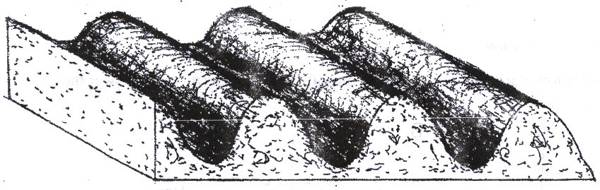

- Name the tertiary operation carried out on the seedbed (1mk)
…………………………………………………………………………………………
- Describe how the tertiary operation named in (a) above is carried out (2mks)
……………………………………………………………………………………………………………………………………………………………………………………..........................................................................................................................................
- Give two advantages of planting crops on the final seed back illustrated above (2mks)
……………………………………………………………………………………………………………………………………………………………………………………

- Name the deficient nutrient element in plants showing the following symptoms

  - Stunted growth, die back of plant tips, leaves roll up and chlorosis along Margins of younger leaves (½ mk)
.........................................................................................................................................................
  - Yellowing of leaves appears first lower leaves turn brown and fall prematurely, stunted growth ( ½ mk)
………………………………………………………………………………………………………

  - Leaf curling, yellowing of leaves, tips and edges of leaves are scorched and have small mottles ( ½ mk)
………………………………………………………………………………………………………

  - Purpling of leaves, stunted growth, slender stalks and lateral buds remain dormant ( ½ mk)

- The diagram below shows a method of soil sampling

- Name the method illustrated in the diagram above.(1mk)
………………………………………………………………………………………………………
- State 3 precautions taken when collecting the soil for testing using the above method.(3mks)
………………………………………………………………………………………………………………………………………………………………………………………………………………………………………………………………………………………………………………………

- Give 4 reasons why soil from the farm is tested.(4mks)
………………………………………………………………………………………………………………………………………………………………………………………………………………………………………………………………………………………………………………………............................................................................................................................................................
- The diagram below illustrates a method of preparing compost manure. Study it and answer the questions that follow.

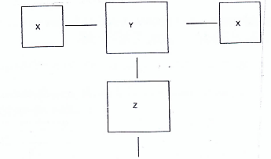
- Identify the method illustrated above. (1mk)
………………………………………………………………………………………………….
- By using arrows, indicate the direction of the materials from X to the field (2 marks)

- State two desirable factors considered when sitting compost manure pit (2mks)
………………………………………………………………………………………………………………………………………………………………………………………………………………………………………………………………………………

SECTION C (40MKS)
- a) State and explain 5 characteristics of a fertile soil (10mks)
b) State and explain five factors considered when establishing nursery bed site. (10mks)
23. a) Explain the four different methods of farming (8 marks)
b) A farmer was asked to apply fertilizers as follow: 200 kg/ha of DSP (40% P₂O₅), 150kg/ha of sulphate of ammonia 20% Nitrogen and 150kg/ha of Muriate of Potash 60% K₂O)
- How much P₂O₅ did the farmer apply per ha? (2mks
- How much K₂O did the farmer apply per ha? (2mks)
- How much nitrogen did the farmer apply per/ha. (2mks)
c) Explain contribution of agriculture to National development. (6mks)
24. a) Describe five methods of drainage (5mks)
b) Describe five advantages of sub-surface irrigation. (5mks)
c) Outline five importance of livestock rearing (5marks)
d) ) Outline five methods of maintenance of a wheelbarrow. (5marks)

