NAME: …………………………………… DATE……………………….
SCHOOL: …………………………………. SIGN………………………..

443
AGRICULTURE
SEPTEMBER 2021
TIME: 2 HOURS
CASPA AMUKURA PARISH EXAM 2021
AGRICULTURE FORM THREE
INSRUCTIONS TO CANDIDATES
- Write your name and name of your school in the above space provided.
- Sign and write the date of examination in the space provided.
- This paper consist of three Sections A, B and C.
- Answer all questions in section A and B.
- Answer any two questions in section C.
- Answers should be written in the spaces provided.
- Candidates should check the question paper to ascertain that all pages are printed as indicated and that no page is missing.

FOR EXAMINER’S USE ONLY
SECTION | QUESTION | MAXIMUM SCORE | CANDIDATE’S SCORE
A | 1-15 | 30
B | 16-19 | 20
C |  | 20
 |  | 20
 |  | 20
 | TOTAL SCORE | 90

SECTION A: 30 MARKS
ANSWER ALL QUESTIONS IN THIS SECTION.
- State four characteristics of extensive farming systems. ( 2 marks)
_______________________________________________________________________________________________________________________________________________________________________________________________________________________________________________________________________________________________________
- Give four reasons why burning of land as a method of land preparation is discouraged. ( 2 marks)
_______________________________________________________________________________________________________________________________________________________________________________________________________________________________________________________________________________________________________
- State four physical factors in soil formation. ( 2 marks)
_______________________________________________________________________________________________________________________________________________________________________________________________________________________________________________________________________________________________________
- Give the meaning of the following terms as used in crop production.
- Crop rotation ( 3 marks)
____________________________________________________________________________________________________________
- Pruning
____________________________________________________________________________________________________________
- Rogueing
____________________________________________________________________________________________________________
- State four factors that determine the depth of planting. (2 marks)
_______________________________________________________________________________________________________________________________________________________________________________________________________________________________________________________________________________________________________

- Name one crop that is propagated by each of the following.
- Stem tuber ( ½ mark)
______________________________________________________
- Split ( ½ mark)
______________________________________________________
- Slip ( ½ mark)
______________________________________________________
- Bulbil ( ½ mark)
______________________________________________________
- Name four light breeds of chicken in poultry rearing. ( 2 marks)
_______________________________________________________________________________________________________________________________________________________________________________________________________________________________________________________________________________________________________
- State four harmful affects ticks on livestock. (2 marks)
_______________________________________________________________________________________________________________________________________________________________________________________________________________________________________________________________________________________________________
- Differentiate between cropping and harvesting in fish farming. ( 2 marks)
_________________________________________________________________________________________________________________________________________________________________________________
- List three maintenance practices carried out on a fish pond. (1 ½ marks)
____________________________________________________________________________________________________________________________________________________________________________________________________________________________________________
- State three functions of vitamins in an animal’s body. (1 ½ marks)
____________________________________________________________________________________________________________________________________________________________________________________________________________________________________________
___________________________________________________________

- Give four reasons why farmers invest in Agriculture. ( 2 marks)
_______________________________________________________________________________________________________________________________________________________________________________________________________________________________________________________________________________________________________
- Distinguish between the following pair of terms as used in crop production.
- Seed dressing and seed inoculation. ( 1 mark)
________________________________________________________________________________________________________________________________________________________________________________________________________________________
- Under sowing and over sowing. ( 1 mark)
________________________________________________________________________________________________________________________________________________________________________________________________________________________
- State four factors considered while sitting an apiary. ( 2 marks)
_______________________________________________________________________________________________________________________________________________________________________________________________________________________________________________________________________________________________________
- Give two reasons for each of the following.
- Nitrogenous fertilisers should not be used during planting. ( 1 mark)
_______________________________________________________________________________________________________________________________________________________________
_____________________________________________________
- Too much nitrogenous fertilisers should not be applied when growing tomatoes. (1 mark)
____________________________________________________________________________________________________________________________________________________________________________________________________________________

SECTION B: ( 20 MARKS)
ANSWER ALL QUESTIONS FROM THIS SECTION.
- The diagram below shows a farm record. Use it to answer questions that follow.
Daily feeding record for the month of …………………………………..

Enterprise ……………………………………………………………….

Type of feed……………………………………………………………..

Date | No of animals | Amount received (kg) | Amount used | Balance in stock | Remarks

- Identify the type of farm record above. ( 1 mark)
________________________________________________________________________________________________________________
- On 16th June 2021, Kocho farm received 120kgs of Layers mash. 40kg of the feed was given to 20 layers on the same day. Use this information to fill in the above table. ( 3 marks)
- Name any other type of farm records. ( 1 mark)
________________________________________________________________________________________________________________________________________________________________________
- A poultry farmer has maize containing 8% DCP and Soya beans containing 43% DCP. If the farmer wants to make 100kg of a feed, using the Pearson’s square method, calculate the proportions in which the two ingredients would have to be mixed to make a feedstuff containing 15% DCP. ( show your working) ( 5 marks)

- Below is an illustration of an internal parasite in livestock. Study it and use it to answer questions that follow.

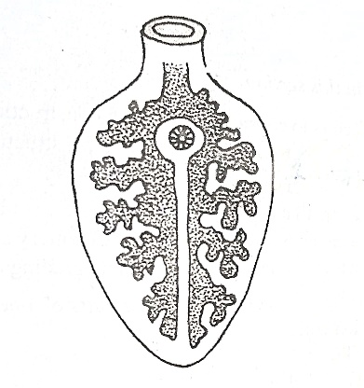

- Identify the parasite. ( 1 mark)
________________________________________________________________________________________________________________
- Name one intermediate host and one final host for the parasite above (2 marks)
Intermediate host
________________________________________________________
Final host
________________________________________________________
- Outline two control measures for the above parasite. (2 mark)
________________________________________________________________________________________________________________________________________________________________________________________________________________________________
- The following is an illustration of a structure used in crop propagation. Study it and use it to answer questions that follow.
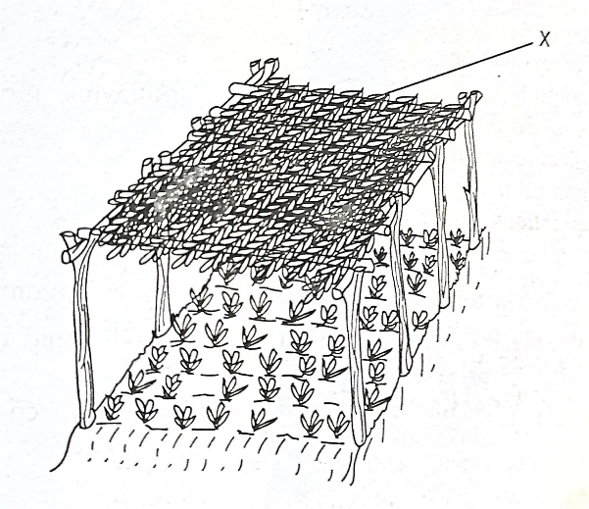

- Identify the structure. ( 1 mark)
________________________________________________________________________________________________________________
- What is the function of part labelled X on the above structure. ( 1 mark)
________________________________________________________________________________________________________________
- Why is it recommended to remove part labelled X one week before transplanting. ( 1 mark)
________________________________________________________________________________________________________________
- State two advantages of using the structure illustrated above. ( 2 marks)
________________________________________________________________________________________________________________________________________________________________________________________________________________________________

SECTION C: 40 MARKS.
ANSWER ANY TWO QUESTIONS FROM THIS SECTION.

- Outline precautions that should be taken into account when using workshop tools. ( 6 marks)
- Discuss six reasons for carrying out minimum tillage. ( 6 marks)
- Explain four ways in which soil losses fertility. ( 8 marks)

- Describe seven field management practices in tomato production. ( 7 marks)
- Outline five factors that determine water requirements in an animal’s body. ( 5 marks)
- Describe the transplanting of tree seedlings. ( 8 marks)

- Outline six reasons why bees swarm beehive. ( 6 marks)
- Explain six signs that will indicate a sow is on heat. ( 6 marks)
- Discuss eight factors considered when selecting a breeding stock. ( 8 marks)

