DECEMBER 2022 ASSIGNMENT
FORM 2 AGRICULTURE
ANSWER ALL QUESTIONS IN THE ASSIGNMENT BOOK
1. What is a production ration as used in animal nutrition? (1mk)
2. Name two groups into which vitamins are classified. (1 mk)
3. State three factors that influence the amount of water intake by a farm animal. (1¹/₂mks)
4(a) Differentiate between a roughage and a concentrate feed in animal nutrition. (2mks)
(b) State three ways in which a production ration may be utilized by cattle. (3mks)
5. Give four characteristics of a livestock roughage feedstuff.
6. Outline four functions of proteins in the body of an animal. (2mks)
7. Outline four factors that determine the nutritional requirements in cattle (2mks)
8. Give four functions of calcium in dairy cow. (2mks)
9. State four factors that are considered when formulating a livestock ration (2mks)
10. (a) Explain the term “production ration” as used in livestock production. (1mk)
b) State four factors which determine the amount of feed an animal can consume. (4mks)
11. State three reasons for feeding livestock. (1¹/₂mks)
12. (a) Give one cause of blossom end rot in tomatoes (1mk)
(b) State two methods of controlling blossom end rot in tomatoes (2mks)
13. State four factors to consider when grading tomatoes for fresh market. (2mks)
14. a) Which livestock disease is transmitted by each of the following ticks? (2mks)
(i) Blue tick (Boophilous decoloratus)
(ii) Brown ear tick (Rhipicephalous appendiculatus)
(b) How many hosts does the red-legged tick (Rhipicephalous averts) require to complete its life cycle? (1mk)
15. (a) State four signs of infestation by external parasites in livestock? (2mks)
16. (a) State four signs of infestation by external parasites in livestock? (2mks)
(b) Name the intermediate host for each of the following internal parasites. (2mks)
(i)Tape worm (Taenia solium)
(ii) Liver fluke (Fasciola hepatica)
17. How does crossbreeding improve livestock production. (2mks)
18. State six signs that are likely to be observed when a cow is on heat (3mks)
19. State four disadvantages of natural mating as a method of breeding in dairy cattle management (2mks)
20. Explain the term hybrid vigour as used in livestock production. (2mks)
21.Describe the factors a farmer should consider when selecting a young female pig (Guilt) for breeding.(4mks)
22. (a) Define the following terms as used in livestock breeding. (2mks)
(i) Inbreeding
(ii) Out crossing
(b) Outline three disadvantages of artificial insemination in cattle management (3mks)
23. Describe the life cycle of a three- host tick. (8mks)
24. Explain measures used to control livestock diseases. (12 mks)
25. Below is a chemical water treatment plant
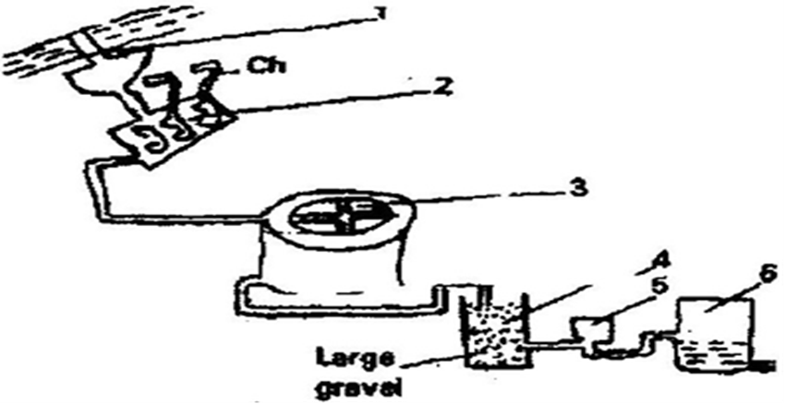
Explain stages 1-5 (10mks)

