Name ………………………..……………………………… Index No…………………………..

School ………………………………………………... Sign………………………………..

LONDIANI SUB COUNTY JOINT EXAM
443/2
AGRICULTURE
AUGUST/SEPTEMBER 2022
Paper 2
Time: 2 Hours

INSTRUCTION TO CANDIDATES
- Write your name and index number in the spaces provided above.
- Sign and write the date of Examination in the space provided.
- This paper consists of three sections A, B and C.
- Answer ALL the questions in section A and B.
- Answer TWO questions in section C in the spaces provided.

FOR EXAMINER’S USE ONLY.
SECTION | QUESTIONS | MAXIMUM SCORE | CANDIDATES SCORE
A | 1 – 15 | 30
B | 16 – 19 | 20
C | 20– 22 | 20  20
TOTAL SCORE |  | 90

SECTION A (30MKS|)
Answer all questions in this section on spaces provided.
- State four non-chemical method used to control ticks (2marks)
i)……………………………………………………………………………………………………
ii)……………………………………………………………………………………………………
iii)…………………………………………………………………………………………………
iv)…………………………………………………………………………………………………
- Highlight two management practices carried out on a broody hen (2marks)
i)……………………………………………………………………………………………………
ii)……………………………………………………………………………………………………
- Give four characteristics of a good fish pond (2marks)
i)……………………………………………………………………………………………………
ii)……………………………………………………………………………………………………
iii)…………………………………………………………………………………………………
iv)…………………………………………………………………………………………………
- Mention four physical characteristics of exotic beef cattle breeds (2marks)
i)……………………………………………………………………………………………………
ii)……………………………………………………………………………………………………
iii)…………………………………………………………………………………………………
iv)…………………………………………………………………………………………………
- Give four features of calf pen that help to control calf diseases (2marks)
i)……………………………………………………………………………………………………
ii)……………………………………………………………………………………………………
iii)…………………………………………………………………………………………………
iv)…………………………………………………………………………………………………
- a) What is dry cow therapy (1mark)
………………………………………………………………………………………………………………………………………………………………………………………………………………
b) At what stage of gestation is dry cow therapy practiced (1mark)
………………………………………………………………………………………………………

- Name four farm structures used for handling livestock (2marks)
i)……………………………………………………………………………………………………
ii)……………………………………………………………………………………………………
iii)…………………………………………………………………………………………………
iv)…………………………………………………………………………………………………
- Give four symptoms of respiratory disorders in a sick cow (2marks)
i)……………………………………………………………………………………………………
ii)……………………………………………………………………………………………………
iii)…………………………………………………………………………………………………
iv)…………………………………………………………………………………………………
- Mention two characteristics of abdomen of a poor layers (2marks)
i)……………………………………………………………………………………………………
ii)……………………………………………………………………………………………………
- Distinguish between mothering ability and prolificacy (2marks)
………………………………………………………………………………………………………………………………………………………………………………………………………………………………………………………………………………………………………………………
- List two factors that can lead to conception failure after female cow has been served (2marks)
i)……………………………………………………………………………………………………
ii)……………………………………………………………………………………………………
- Give four factors that may lead to a farmer culling dairy cattle (2marks)
i)……………………………………………………………………………………………………
ii)……………………………………………………………………………………………………
iii)…………………………………………………………………………………………………
iv)…………………………………………………………………………………………………
- State four reasons for doing Agriculture as a discipline (2marks)
i)……………………………………………………………………………………………………
ii)……………………………………………………………………………………………………
iii)…………………………………………………………………………………………………
iv)…………………………………………………………………………………………………
- Name four tools that are used when laying concrete blocks during construction of a wall
(2marks)
i)……………………………………………………………………………………………………
ii)……………………………………………………………………………………………………
iii)…………………………………………………………………………………………………
iv)…………………………………………………………………………………………………
- State four features on the animal which may pre-dispose it to livestock diseases (2marks)
i)……………………………………………………………………………………………………
ii)……………………………………………………………………………………………………
iii)…………………………………………………………………………………………………
iv)…………………………………………………………………………………………………
SECTION B (20 MARKS)
Answer ALL questions in this section in the spaces provided
16. The following is a diagram of an artificial incubator. Study it and answer questions that follow.
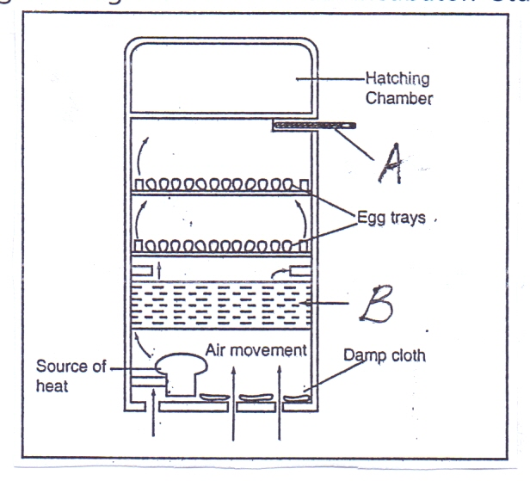
(a) Identify the following parts shown by letters A and B. (2marks)
A …………………………………………………………………….
B …………………………………………………………………….
(b) State three conditions that are necessary for a successful hatching. (3marks)
..................................................................................................................................................................................................................................................................................................................................................................................................................................................................

17. Study the following farm implement and answer the questions below.
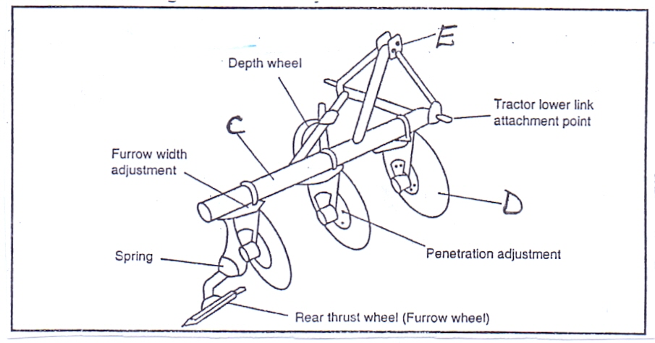
(a) Identify the above implement. (½mark)
......................................................................................................................................................
(b) Identify the parts shown by letters C, D, E. (1½marks)
C ……………………………………………………..
D ……………………………………………………..
E ……………………………………………………..

(c) Give three reasons that make the implement better in land preparation. (3marks)
...................................................................................................................................................... ............................................................................................................................................................................................................................................................................................................
18. Study the following diagram and answer questions below.

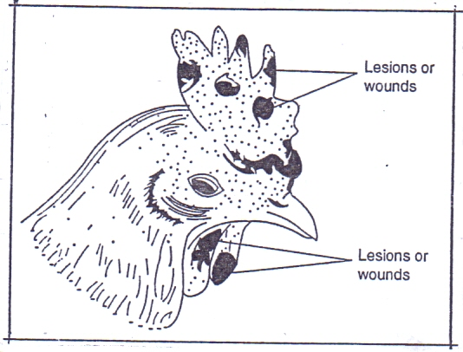
(a) Identify the above disease. (1mark)
…………………………………………………………………………………………

(b) What causes the above disease? (1mark)
………………………………………………………………………………………………
(c) Give two predisposing factors of the disease. (2marks)
……………………………………………………………………………………………………………………………………………………………………………………………………
(d) Give one control measure of the disease. (1mark)
…………………………………………………………………………………………………………
19.The illustration below shows a farm practice used in controlling external parasites in livestock. Study it and answer the questions that follows.

- Identify the methods of parasite control in the illustration above (1mark)
………………………………………………………………………………………………
- Name the equipment used for the practice in the illustration (1mark)
………………………………………………………………………………………………
- State two factors that leads to maximum effectiveness when using the practice above in tick control (2marks)
………………………………………………………………………………………………………………………………………………………………………………………………
- Name any other equipment that is used for the same practice (1mark)
………………………………………………………………………………………………
SECTION C (40 MARKS)
Answer any two questions from this section.

20.(a) Explain eight practices you can carry out in a crush. (8 marks)
(b) Describe six advantages of rotational grazing. (6 marks)
(c) Describe six effects of parasites on livestock. (6 marks)
21 (a) Describe eight short term services that should be done to a farm tractor. (8 marks)
(b) Explain five reasons for maintaining farm tools and equipment. (5marks)
(c) State eight causes of long calving intervals. (7marks)
22.(a) Describe ten uses of fences on a farm. (10 marks)
(b) Explain five factors a farmer should consider in the construction of farm structures. (10 marks)

……………………………………………………………………………………………………………………………………………………………………………………………………………………………………………………………………………………………………………………………………………………………………………………………………………………………………………………………………………………………………………………………………………………………………………………………………………………………………………………………………………………………………………………………………………………………………………………………………………………………………………………………………………………………………………………………………………………………………………………………………………………………………………………………………………………………………………………………………………………………………………………………………………………………………………………………………………………………………………………………………………………………………………………………………………………………………………………………………………………………………………………………………………………………………………………………………………………………………………………………………………………………………………………………………………………………………………………………………………………………………………………………………………………………………………………………………………………………………………………………………………………………………………………………………………………………………………………………………………………………………………………………………………………………………………………………………………………………………………………………………………………………………………………………………………………………………………………………………………………………………………………………………………………………………………………………………………………………………………………………………………………………………………………………………………………………………………………………………………………………………………………………………………………………………………………………………………………………………………………………………………………………………………………………………………………………………………………………………………………………………………………………………………………………………………………………………………………………………………………………………………………………………………………………………………………………………………………………………………………………………………………………………………………………………………………………………………………………………………………………………………………………………………………………………………………………………………………………………………………………………………………………………………………………………………………………………………………………………………………………………………………………………………………………………………………………………………………………………………………………………………………………………………………………………………………………………………………………………………………………………………………………………………………………………………………………………………………………………………………………………………………………………………………………………………………………………………………………………………………………………………………………………………………………………………………………………………………………………………………………………………………………………………………………………………………………………………………………………………………………………………………………………………………………………………………………………………………………………………………………………………………………………………………………………………………………………………………………………………………………………………………………………………………………………………………………………………………………………………………………………………………………………………………………………………………………………………………………………………………………………………………………………………………………………………………………………………………………………………………………………………………………………………………………………………………………………………………………………………………………………………………………………………………………………………………………………………………………………………………………………………………………………………………………………………………………………………………………………………………………………………………………………………………………………………………………………………………………………………………………………………………………………………………………………………………………………………………………………………………………………………………………………………………………………………………………………………………………………………………………………………………………………………………………………………………………………………………………………………………………………………………………………………………………………………………………………………………………………………………………………………………………………………………………………………………………………………………………………………………………………………………………………………………………………………………………………………………………………………………………………………………………………………………………………………………………………………………………………………………………………………………………………………………………………………………………………………………………………………………………………………………………………………………………………………………………………………………………………………………………………………………………………………………………………………………………………………………………………………………………………………………………………………………………………………………………………………………………………………………………………………………………………………………………………………………………………………………………………………………………………………………………………………………………………………………………………………………………………………………………………………………………………………………………………………………………………………………………………………………………………………………………………………………………………………………………………………………………………………………………………………………………………………………………………………………………………………………………………………………………………………………………………………………………………………………………………………………………………………………………………………………………………………………………………………………………………………………………………………………………………………………………………………………………………………………………………………………………………………………………………………………………………………………………………………………………………………………………………………………………………………………………………………………………………………………………………………………………………………………………………………………………………………………………………………………………………………………………………….................................................................................................................................................................................................................................................................................................................................................................................................................................................................................................................................................................................................................................................................................................................................................................................................................................................................................................................................................................................................................................................................................................................................

