CASPA AMUKURA PARISH EXAM
BIOLOGY FORM 3 MARKUNG SCHEME
SECTION A
1. (a) (i) Entomology
(ii) Store sugars (in plants)
(b) Manufacture ribosomes.
2. Arachnida;
Crustacea;
3. (a) Oxygen gas
(b) dissociate in water to provide carbon (IV) oxide; which is necessary for photosynthesis;
4. Have cytoplasmic filaments to enhance mass flow; sieve plate has pores for passage of organic material;
Have companion cell with numerous mitochondria which provide energy;presence ofplasmodesmata to communicate between sieve tube elements and companion cells.
5. Sensitive to change in temperature; pH;
Has electrical charges, positive and negative charges;
Selectively permeable;
6. Enzymes
Thrombin;
Thromboplastin / thrombokinase;
Mineral ion
Calcium ions;
7 .(i) Arthropoda;
(ii) X- Arachnida;
Y- Insecta;
Z- Crustacea;
(iii) - Useful in plant pollination;
-Produce edible food eg. Honey and royal jelly;
(iv) –Transmits disease causing organisms/disease vector;
-Sucks blood hence can cause anemia; (any two)
-Bites on animals destroy the quality of hides and skins;
-Wounds created become avenues for secondary bacterial infection;
8. Carbon(IV)oxide increases in the guard cell; pH increases leading to conversion of glucose to starch; starch is osmotically inactive compared to glucose; this leads to guard cells loosing water to the surrounding epidermal cells; guard cells becomes flaccid and hence stoma closes.
9. - Exoskeleton (1mk)
- Jointed appendages (1mk)
- Segmented bodies (1mk)
Reject answers relating to characteristics of living things like growth and development, reproduction etc.
10 a)i) Z has a wider lumen than W (acc converse)
iii) This increases high blood pressure within the glomerulus.
(b) - One cell thick to reduce distance for reabsorption.
- Cells have numerous mitochondria to produce energy for active transport ; have microvilli to increase surface area for re-absorption ; Highly coiled to reduce spread of flow to increase time available for reabsorption
11. (a) RQ ratio of carbon (iv)oxide produced to oxygen used during breakdown of a food substrate.
(b) R.Q = CO₂ produced
O₂ used up

RQ = 102 = 0.7
145

(c) fat/lipid

SECTION B
12. (a) On the graph.
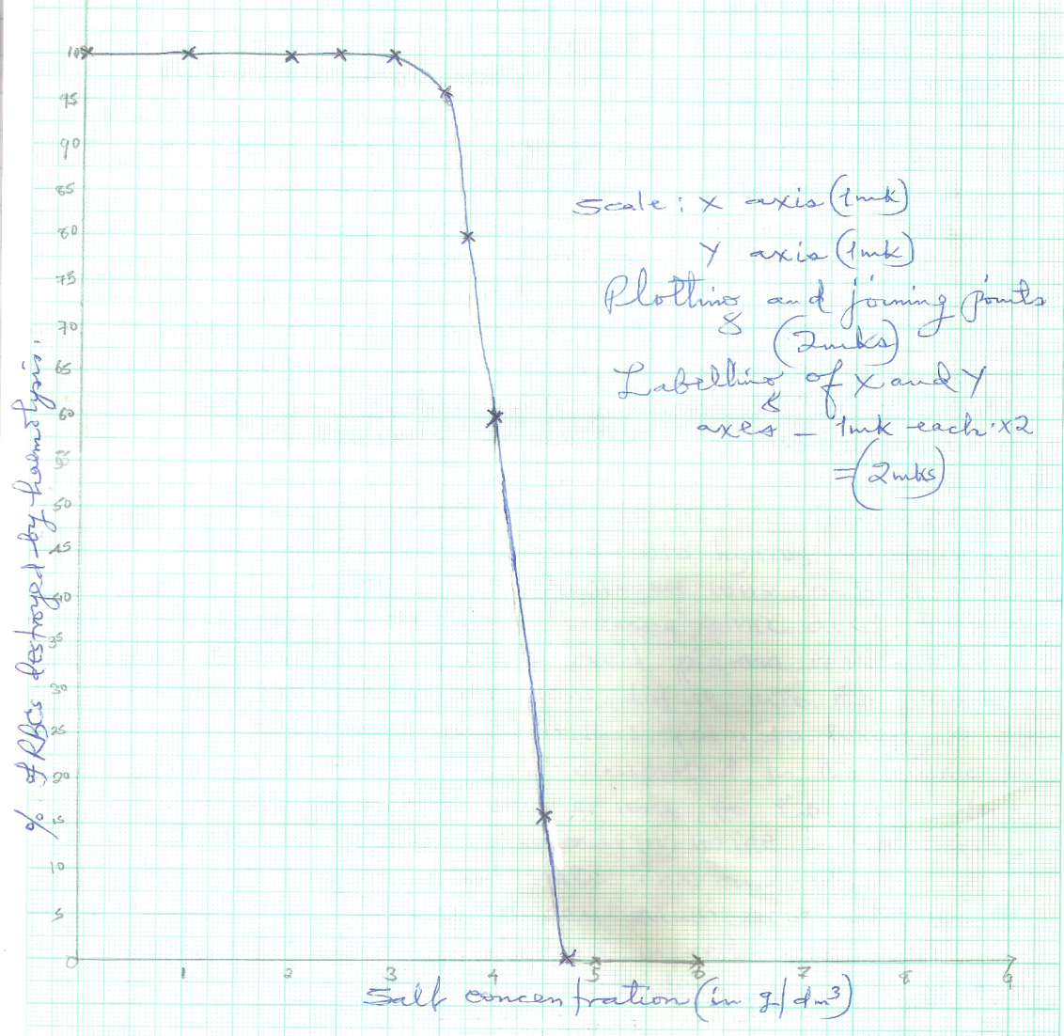

- Haemolysis of red blood cells occurs when they are placed in a hypotonic solution;
they gain a lot of water; swell an then burst; (3 mks)
(c)(i) 4.1 g/dm3; + 0.1; (1 mk)
(ii) 3.0 g/dm3; + 1; (1 mk)
(d)(i) 4.7 g / dm3+ 0.1; (1 mk)
(ii) At 4.7 g / dm3 salt concentration; as there is no haemolysis / haemolysis was zero; (2 mks)
(iii) Isotonic solution; (1 mk)

(e) Osmoregulation; Rej. homeostasis (1 mk)

(f) - Osmosis enables movement of water from one cell to another;
- Osmosis helps in closing and opening of the stomata;
- Osmosis helps in support when cells become turgid in plants;
- Osmosis helps in absorption of water by the root hairs; (max 4)
13. Are long and folded to provide large surface area for digestion;
- They are long, coiled and folded which allows more time for digestion and absorption;
- Their inner lining has villi and microvilli, which increase the surface area for absorption;
- Have opening of ducts through which pancreatic juice and bile get into lumen;
- Have goblet cell and Bruner’s glands that secretes mucus for lubrication of food and protection of wall from digestive enzyme;
- Bruner’s gland also secretes alkaline fluid which maintains a pH of 7-8 which is optimum pH for action of intestinal enzymes;
- Has intestinal gland that secrete digestive enzyme;
- Has rich network of blood capillaries that supplies oxygen and removes metabolic wastes from the intestinal tissue and transports digested food and offer nutrients;
- The walls have circular and longitudinal muscles whose peristaltic contraction causes movements of food in the gut and mixing of food with digestive enzyme;
- Intestine have a thin epithelium that allows soluble food material to pass through rapidly into the blood stream’
- The villi have numerous blood vessels to transport absorbed nutrients and lacteals to transport absorbed lipids;
14. (i) Process of inhalation in mammals
- External intercostals muscles contract; while internal intercostals muscles relax;
- (This movement) pulls ribs upwards and outwards;
- The diaphragm muscles contract; and the diaphragm flattens;
- (All the above movements) increases the volume of thoracic cavity; and decreases its pressure; Atmospheric pressure being higher than thoracic cavity pressure; Forces the air to rush into the lungs; (through the nose and trachea)
- The lungs are inflated. (Max.10Marks)

(ii) During the day, chloroplast of guard cells accumulate sugar/glucose produced through the process
of photosynthesis;
- Accumulated sugar/glucose in the guard cells increases osmotic pressure of the cell sap of the guard cells;
- Water is drawn from the neighbouring epidermal cells by osmosis;
- Guard cells become turgid and bulges outward;
- This opens the stomata;
- At night, sugar/glucose which had accumulated in guard cells is converted to starch;
- Osmotic pressure of guard cells falls;
- The cells lose water to the neighbouring epidermal cells and become flaccid;
- The guard cells are drawn towards one another.
- The stomata closes; (Max 10 Marks)

