NAME:…………………………………………….………….. INDEX NO: ………………..…..DATE………
SCHOOL:……………………………………………………... CANDIDATE’S SIGNATURE: ……..………..
CLASS:…………………………………. . ADM NO:……………………………………….
TERM 1 2021 CASPA
AMUKURA PARISH EXAM

231/3
BIOLOGY
PAPER 3 (PRACTICAL)
TIME: 1³/₄ Hours

INSTRUCTIONS TO CANDIDATES
- Write your name, Admission number and name of your school in the spaces provided above
- Sign and write the date of examination in the spaces provided.
- This paper consists of three questions
- Answer all the questions in the spaces provided.
- You are required to spend the first 15 minutes of the 1³/₄ Hours allowed for this paper reading through all the questions before commencing your work.
- This paper consists of 5 printed pages.
- Candidates should check to ascertain that all pages are printed as indicated and that no questions are missing.

For Examiners Use Only
Question | Maximum score | Candidate’s score
1 | 14
2 | 13
3 | 13
Total Score | 40

- You are provided with solution W in a boiling tube. Using the provided reagents, carry out possible food tests to identify food substances present in solution. (14marks)
FOOD SUBSTANCE | PROCEDURE | OBSERVATION | CONCLUSION

- Examine the photographs I and II of seedling specimen shown below and answer the questions that follows;
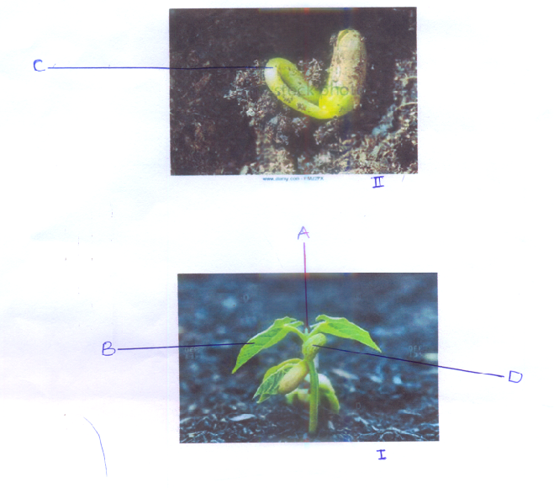

a) Name the parts labelled A, C and D. (3 marks)
A______________________________________
C______________________________________
D_______________________________________
b)(i) Name the class to which the specimen belongs. (l mark)
______________________________________________________________________________
______________________________________________________________________________
(ii) Give two reasons, using observable features to support your answer in (b) (i) above (2 marks)
______________________________________________________________________________
______________________________________________________________________________
(c) Give two functions of the structure labeled D. (2 marks)
______________________________________________________________________________
______________________________________________________________________________
______________________________________________________________________________
______________________________________________________________________________

d) Explain how the curvature labeled C is formed (3marks)
______________________________________________________________________________
______________________________________________________________________________
______________________________________________________________________________
______________________________________________________________________________
______________________________________________________________________________

e) Name the type of germination exhibited by the seedlings. Give a reason for your answer. (2marks)
Type
______________________________________________________________________________
______________________________________________________________________________
Reason
______________________________________________________________________________
______________________________________________________________________________

- Below are photographs labelled J and K of organs obtained from different animals. The organs perform similar functions. Examine them.
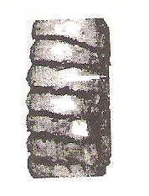
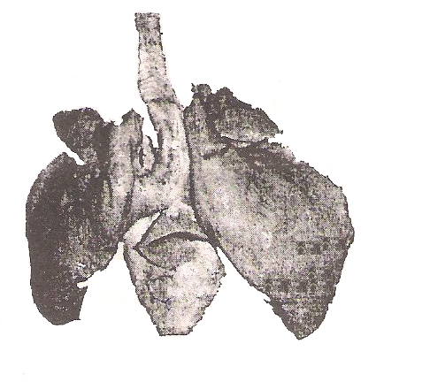
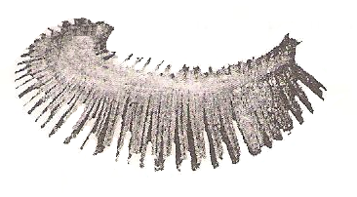
1
W
X
Y
Z
Part labelled W Enlarged
Photograph J
Photograph K
3
2

- Name the phylum to which the organs were obtained from (1 mark)
______________________________________________________________________________
______________________________________________________________________________

- Identify the organs. (2 marks)
J__________________________________________________________________________

K__________________________________________________________________________

- State the function performed by the organs. (1 mark)
_____________________________________________________________________________
_____________________________________________________________________________

- Name the parts labelled X, Y and Z in photograph J (3 marks)
X_______________________________________________________________________
Y_______________________________________________________________________
Z_______________________________________________________________________

- Identify the parts labelled 1, 2 and 3 in photograph K. (3 marks)
1___________________________________________________________
2___________________________________________________________
3___________________________________________________________

- Using observable features, state how the parts labelled 1 and 3 you identified in (d) above
are adapted to their functions (3 marks)
______________________________________________________________________________
______________________________________________________________________________
______________________________________________________________________________
______________________________________________________________________________
______________________________________________________________________________
______________________________________________________________________________

