2023 MID TERM 1 EXAMINATION

FORM 4

BIOLOGY

NAME ADM. CLASS
- Name the hormone which controls moulting in insects. 1mrk

  - b) what is the importance of moulting in insects. 1mrk

- (a) Give two functions of the kidney 2mrks

(b) Name two substances that are not found in urine of a healthy person 2mrks

Name two diseases that affect the kidney 2mrks

- The diagram below represents a growth pattern of arthropods.

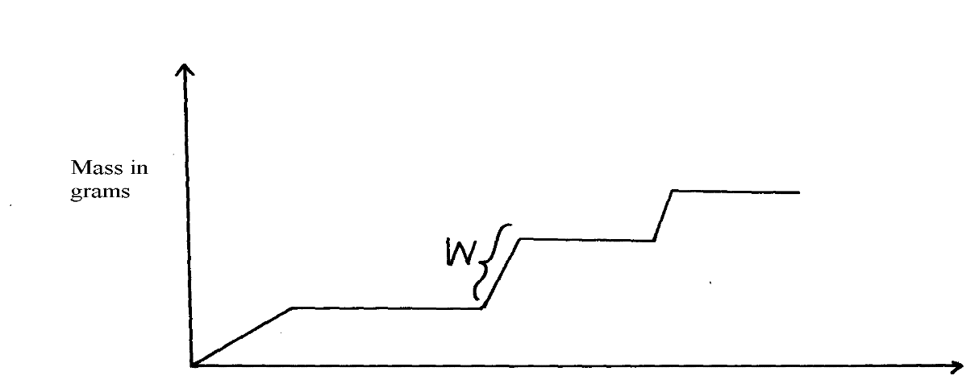
X

Time (days)

(a) Name the type of growth pattern represented on the graph 1mrk
(b)Identify the process represented by X. 1MRK

- ;(c) Which hormone is responsible for process at X in 15 (b) above? 1mrk

- Distinguish between primary growth and secondary growth in a flowering plant 4MRKS

  - What is the role of the following to a germinating seed:
(i) Oxygen 1mrk

(ii)Cotyledons 1mrk
- Give three applications of plant growth hormones in agriculture 3mrks

- State two functions of calcium in the human body 2mrks

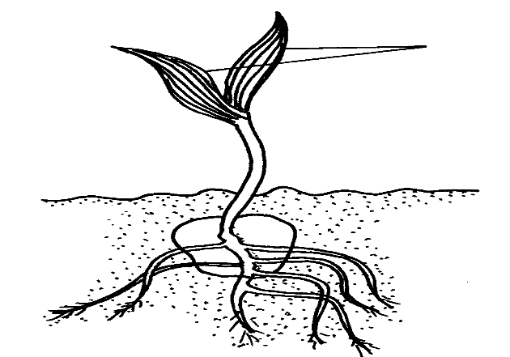
- The diagram below represents a stage during the process of germination.
X

Name the type of germination illustrated in the diagram. 1mrk

Give a reason for your answer in (a) (i) above. 1mrk

(b) Give two functions of the part labelled X 2mrks

- Differentiate between

I)Dorminant and recessive gene. 2 mrks

ii) Homozygous and homozygote. 2mrks

- State the role of the following during germination: 2MRKS
oxygen
enzyme

- Part of one strand of a DNA molecule was found to have the following base sequence.
    - G – T – C – A – G – T
      - What is the sequence on m-RNA strand copied from this DNA portion?

- State two roles of DNA molecule. 2mrks

- State three ways by which plants compensate for lack of ability to move from one place to another. 3mrks

- A student mixed a sample of urine from a person with Benedict’s solution and heated, the colour changed to orange.
a)What was present in the urine sample? 1mrk

b)What did the student conclude on the health status of the person? 1mrk

c)Which organ in the person may not be functioning properly 1mrk

- Differentiate between continuous and discontinuous variations 2mrks

- Members of the same species of organism tend to differ due to variation. State three causes of variation in organisms 3mrks

- How is the placenta adapted to its functions? 4mrks

