NAME…………………………………………………………………….. INDEX NO. ……………

121/1
MATHEMATICS
AUGUST 2021
2 ½ HRS
FORM 2

CASPA AMUKURA PARISH EXAM
Kenya Certificate of Secondary education
MATHEMATICS PAPER 1

INSTRUCTIONS TO CANDIDATES
1. Write your name, Admission number and class in the spaces provided.
2. Sign and write date of the examination in the spaces provided.
3. The paper contains TWO sections: Section A and B
4. Answer ALL questions in section I and STRICTLY ANY FIVE questions from section II.
5. All working and answers must be written on the question paper in the spaces provided below each question.
6. Show all the steps in your calculations, giving your answers at each stage in the spaces below each question.
7. Marks may be awarded for correct working even if the answer is wrong.
8. Non-programmable silent electronic calculators and KNEC Mathematical tables may be used except where stated otherwise.

FOR EXAMINERS USE ONLY

SECTION A

1 | 2 | 3 | 4 | 5 | 6 | 7 | 8 | 9 | 10 | 11 | 12 | 13 | 14 | 15 | 16 | TOTAL

SECTION B

17 | 18 | 19 | 20 | 21 | 22 | 23 | 24 | TOTAL

SECTION 1 (50MKS)
Answer all the questions in the section in the provided
1. Evaluate: (3 marks)

2. | (a) On line MN below construct angle of 450 at point M using a ruler and a pair of compasses only. | (1 mark)

M N N

(b) Hence mark a point A on MN such that MA: AN = 2:4 (3 marks)

3. Evaluate: (3 marks)

4. The surface area of a cube is 311.04 determine the diagonal of the cube. (4 mks)

5. 5 goats and 2 sheep cost sh 5400 while 3 goats and 4 sheep cost sh 5200. Find the cost of each goat and each sheep. (3 mks)

6. The currency exchange rates of a given bank in Kenya are as follows;
Currency | Buying | Selling
1 sterling pound | 135.50 | 135.97
1 US dollar | 72.23 | 72.65
A tourist arrived in Kenya with 5,000 US dollars which he converted to Kenya shillings upon arrival. He spent ksh.214, 500 and converted the remaining to sterling pounds. How many pounds did he receive? (3marks)

7. If (5χ + 6y): (2χ + 10y) = 22: 10 find χ: y. (3mks)

8. Work out correct to 2 decimal places
  - 0.321 ) – (0.31 x 2.56) (3mks)

9. In the figure below, lines AB and LM are parallel.
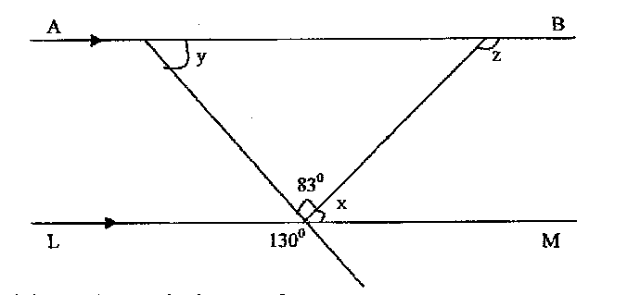
Find the values of the angles marked x, y and z. (3 mks)

10. The exterior angle of a regular polygon is equal to one-third of the interior angle. Calculate the number of sides of the polygon and give its name. (4 mks)

11. Convert the recurring decimal 12.$\dot{1}\dot{8}$ Into fraction (3 mks)

12. The sum of three consecutive whole number is 84. Find the numbers (3mks)

13. Evaluate without using tables or calculators. (3mks)

14. A cylindrical solid metal is 3m long and has a mass of 4kg. If its density is 5.6g/cm³, find the radius of its end. (take π=3.142) (4mks)

15. Express the number 9000 as a product of its prime factors. (2mk)

b) Find the value of P if the number 9000P is a perfect cube. (2mks)

16. A shop keeper sells a shirt for Kshs. 350 thereby making a profit of 40%. Calculate the buying price of the shirt. (3mks)

SECTION II
Answer only five questions from this section in the spaces provided
17. A farmer has four containers of capacity 240 litres, 360 litres, 600 litres and 700 litres. Find the capacity of:
a) The smallest container that can be filled by each one of them an exact number of times (3mks)

b) The largest container that can be used to fill each one of them an exact number of times (3mks)

c) A tank K is such that when it is filled by any of the containers above, there is always a deficit of 17 litres for the tank to be full. Find the smallest possible capacity of the tank (2mks)

d) Express the answer (c) above in standard form (2mks)

18. A surveyor recorded the following information in his field book after taking measurements in metres of a plot. the baseline is the straight line AH = 300m.

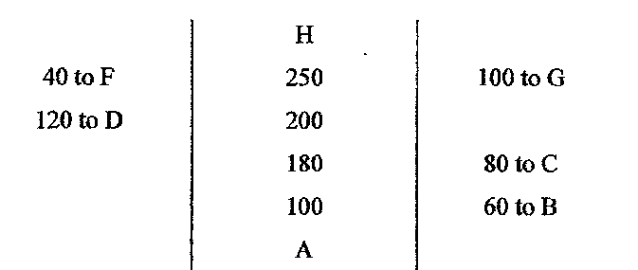
- Using a scale of 1cm to represent 20m, draw an accurate diagram of the plot.(5 mks)

- Use your diagram to calculate the actual area of the field in hectare. (5 mks)

19. Three business partners Susan, Immaculate and Joyce contribute sh.20,000, shs.30,000 and sh. 50,000 to start a business. The three agree that a quarter of the profit from business at the end of the month would be saved for emergencies and fifth of the remainder would be used to buy more stock. The remaining part of the profit would be shared in the ration of their contributions. At the end of the first month, the profit was sh.18,480. Find
a) The amount set aside to buy stock. (5 mks)

b) The amount that each received at the end of the month. (5 mks)

20. a) Fill the tables for the following equations

x – 2y = -1 2x – y = 4

x -2 -1 0 1 2 x 0 1 2 3 4
y y

b) Plot the lines x – 2y = -1 and 2x – y = 4 on the same axes. (5 mks)

c) Use your graph in b) above to find solutions to the simultaneous equations. (1 mk)

x – 2y = -1
2x – y = 4

21. Jane is a Sales executive earning a salary of KSh. 20,000 and a commission of 8% for the sales in excess of KSh.100,000. If in January 2010 she earned a total of KSh. 48,000 in salaries and commissions.
  - Determine the amount of sales she made in that month (4 marks)

  - If the total sales in the month of February and March increased by 18% and then dropped by 25% respectively.
Calculate
    - Jane’s commission in the month of February (3 marks)

    - her total earning in the month of March (3 marks)

22. A carpenter constructed a closed wooden box with internal measurements 1.5m long, 0.8m wide and 0.4m high. The wood used in constructing the box was 1.0cm thick and had a density of 0.6g/cm3.
- Determine:-
- Volume of the wood used in constructing the box in cm3. (4 mks)

- Mass of the box in kilograms. Give answer to one decimal place. (2 mks)

- Identical cylindrical tins of diameter 10cm, height 20cm with a mass of 120g each, were packed into the box.
Calculate:-
- the maximum number of the tins that can be packed. (2 mks)

- The total mass of box and the tins in kg. (2 mks)

23. Three submarine fighters P, Q, R are such that Q is 400 km on a bearing of 030º from fighter P. Fighter R is 750km from fighter Q on a bearing of 120º. Another submarine fighter S is 1000km due south of fighter Q.
- Taking a scale of 1cm to represent 100km locate the position of fighters P, Q, R and S. (4 marks)

- Find the compass bearing of;
- Jet P from jet S. (1 mark)

- Jet S from Jet R. (1 mark)
- Use the scale drawing to determine;
- The distance of S from P (1 mark)

- The distance of R from S
- Find the bearing of;
- Q from R

- P from R

