NAME: …………………………………………. ADM NO: ……………… CLASS:……
233/1 CHEMISTRY
PAPER 1
(THEORY)
TERM 2 2022 JOINT EXAM
TIME: 2 HOURS

233/1
CHEMISTRY
PAPER 1
AUG/SEPT, 2022
TIME: 2 HOURS

INSTRUCTIONS TO CANDIDATES

- Write your name and index number in the spaces provided.
- Answer all questions in the spaces provided
- KNEC mathematical tables and silent electronic calculators may be used for calculations.
- All workings must be clearly shown where necessary.
- Candidates should check the question paper to ascertain all the pages are printed as indicated and no questions are missing.

For Examiners Use Only

Questions | Maximum Score | Students Score
1-27 | 80

- A given element E has atomic number 14 and consist of isotopes as shown below:
Isotope X Y Z
Isotopic mass 28 29 30
Percentage abundance 92.2 4.7 3.1
- What are isotopes? (1mk)

- Determine the relative atomic mass of E. (2mks)

- Passing a small quantity of carbon (iv) oxide through limewater, forms a white precipitate which dissolves when excess carbon (IV) oxide is bubbled through.
- Name the white precipitate. ( ½ mk)

- Explain using a chemical equation why the white precipitate dissolves in excess carbon (IV) oxide. (1 ½ mks)

- What will happen when solution in (b) above is boiled? (1mk)

- Study the set up below and answer the questions that follow.

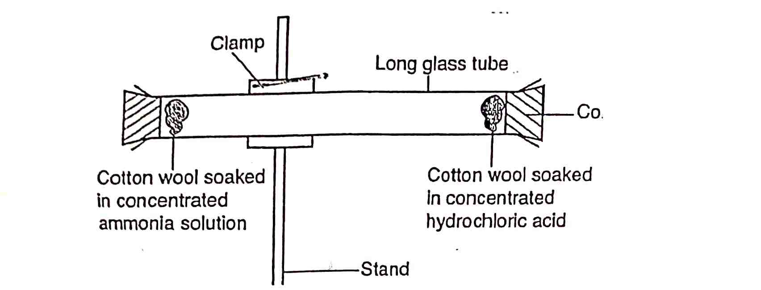
- State and explain the observation made in the tube. (2mks)

- Indicate with a cross (x) on the diagram the likely position where the observation stated in (a) above would be made. (1mk)
- Explain the observation made above in relation to Graham’s law. (1mk)

- In an experiment a small amount of charcoal was added into a test tube and 5cm³ of concentrated nitric (V) acid added, then warmed.
- State the observation that was made. (1mk)

- Explain the observation made in (a) above. (1mk)

- Write an equation for the reaction that took place. (1mk)

- Compare the electrical conductivity of dilute ethanoic acid and dilute sulphuric (VI) acid, explain your answer. (2mks)

- a. What is meant by solubility? (1mk)

b. In an experiment to determine the solubility of solid Y in water at 30ºC the following results were obtained.
Mass of evaporating dish = 26.2g
Mass of evaporating dish + saturated solution = 42.4g
Mass of evaporating dish + dry solid y = 30.4g
Using the information, determine the solubility of solid y at 30ºC in grammes per 100g of water. (2mks)

- The scheme below represents some reactions starting with a white solid A.

White solid A
Yellow solid B
Carbon (IV) Oxide
Colourless solution P
Colourless solution Z
2MH₂SO₄
Heat

Excess NH₄⁺ (aq)

- Identify solid A (1mk)

- Write an equation for the reaction between solid B and 2M sulphuric (VI) acid. (1mk)

- Write ionic equation for the formation of colourless solution Z. (1mk)

- Element A and B have atomic numbers 6 and 1 respectively. Using a dot (.) and cross (x) diagram illustrate the type of bond formed when the two elements combine. (1mk)

b. Explain why solid sodium chloride does not conduct electricity while sodium chloride solution conducts. (2mks)

- The diagram below shows the laboratory preparation of hydrochloric acid.

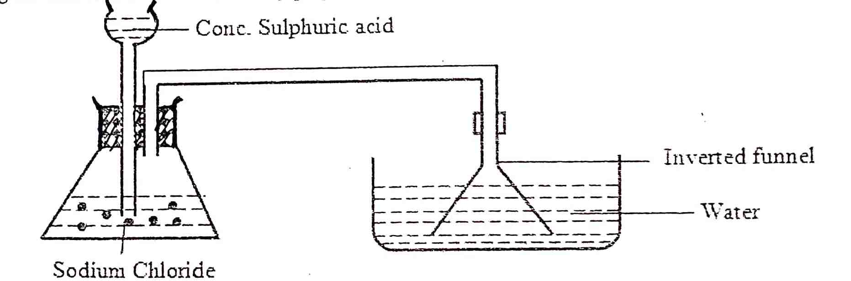

- State the condition necessary for the reaction to occur. (1mk)

- Write a chemical equation for the reaction between sodium chloride and concentrated sulphuric (VI) acid. (1mk)

- Give one reason why an inverted funnel is used instead of delivery tube. (1mk)

- Use the reaction scheme below to and the questions that follow.

Alkanol X
Propene
Compound Z
Ni /180^{O}C
H₂
Process y

- Draw the structure of alkanol X. (1mk)

- Name process Y. (1mk)

- Write the molecular formula of the 5th member in which propene belong. (1mk)

- The structural formula of compounds Q and R are as follows:
Q CH₃CH₂CH₂COOCH₂CH₃

R CH₃CH₂CHCH₂CH₃

HO-C=O
- Give the empirical formula that represents both compounds Q and R. (1mk)

- Which single chemical term best describes the two substances Q and R? (1mk)

- Which unique physical property of substance Q is used to identify it? (1mk)

- 18.7cm³ of a dibasic acid, H₂A required 25cm³ 0.1M sodium hydroxide for complete neutralization.
- How many moles of sodium hydroxide are contained in 25cm³? (1mk)

- Calculate the molarity of the dibasic acid, H₂A. (2mks)

- Fill the empty spaces in the table below. (2mks)
Apparatus | Use
Pipe-clay triangle
Pair of tongs

- Some reaction of metals P,Q,R, and S are given below.
Metal | Reaction with water | Reaction with dilute hydrochloric acid
P | A few bubbles form slowly in water | Vigorous reaction. Gas is given off
Q | Vigorous reaction , metal melts gas given off | Explosive reaction (Should not be attempted)
R | No reaction | No reaction
S | Does not react with cold water. Hot metal reacts with steam | Steady fizzing
- Arrange the metals in order of the reactivity starting with the least reactive.(1mk)

- Write a chemical equation for the reaction between metal Q and water. (1mk)

- Which of the metals could be copper? Explain. (2mks)

- Below is a set up used to collect hydrogen gas?

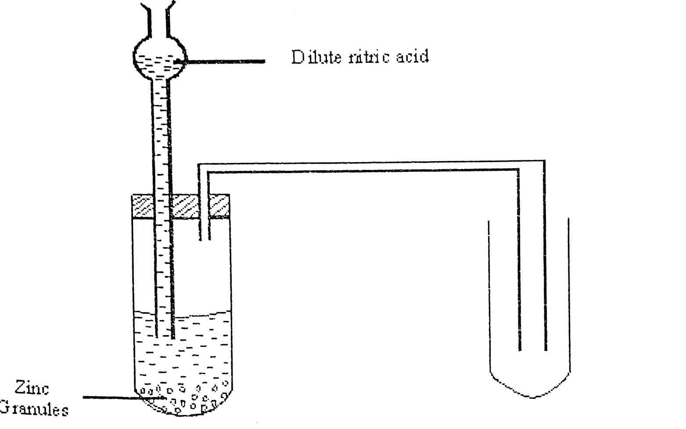
- Identify with reason, two mistakes in the set up. (2mks)

- Explain the role of hydrogen in the manufacture of margarine. (1mk)

- Identify the acid and base in the above equation using Bronsted Lowry theory. (2mks)

b. What causes permanent water hardness? (1mk)

- Study the information in the table below and answer the questions that follow
Element | Electron arrangement | 1st ionization energy
Beryllium | 2.2 | 900
Magnesium | 2.8.2 | 740
Calcium | 2.8.8.2 | 590
- What chemical family does the elements belong to? (1mk)

- What is meant by the term ionization energy? (1mk)

- Explain the trend in the 1st ionization energy of the elements above. (2mks)

- State the role of the following parts during fractional distillation of a mixture of water and ethanol.
- Fractionating column (1mk)

- Glass beads in the fractionating column. (1mk)

- Draw a labeled diagram of the set up of apparatus that can be used to electrolyse lead (II) bromide. (3mks)

- The following table shows pH values of solution of compounds D, E,F and G.
Compound | D | E | F | G
pH value of solution | 2 | 5 | 7 | 13
- State which one of the compounds is likely to be;
- Sodium chloride (1mk)

- Sodium hydroxide. Explain. (1mk)

- Select two compounds that can be used to illustrate the amphoteric nature of an oxide. (1mk)

- An experiment was carried out to determine the presence of substance P,Q, R and S in the mixture T. The results obtained one shown below

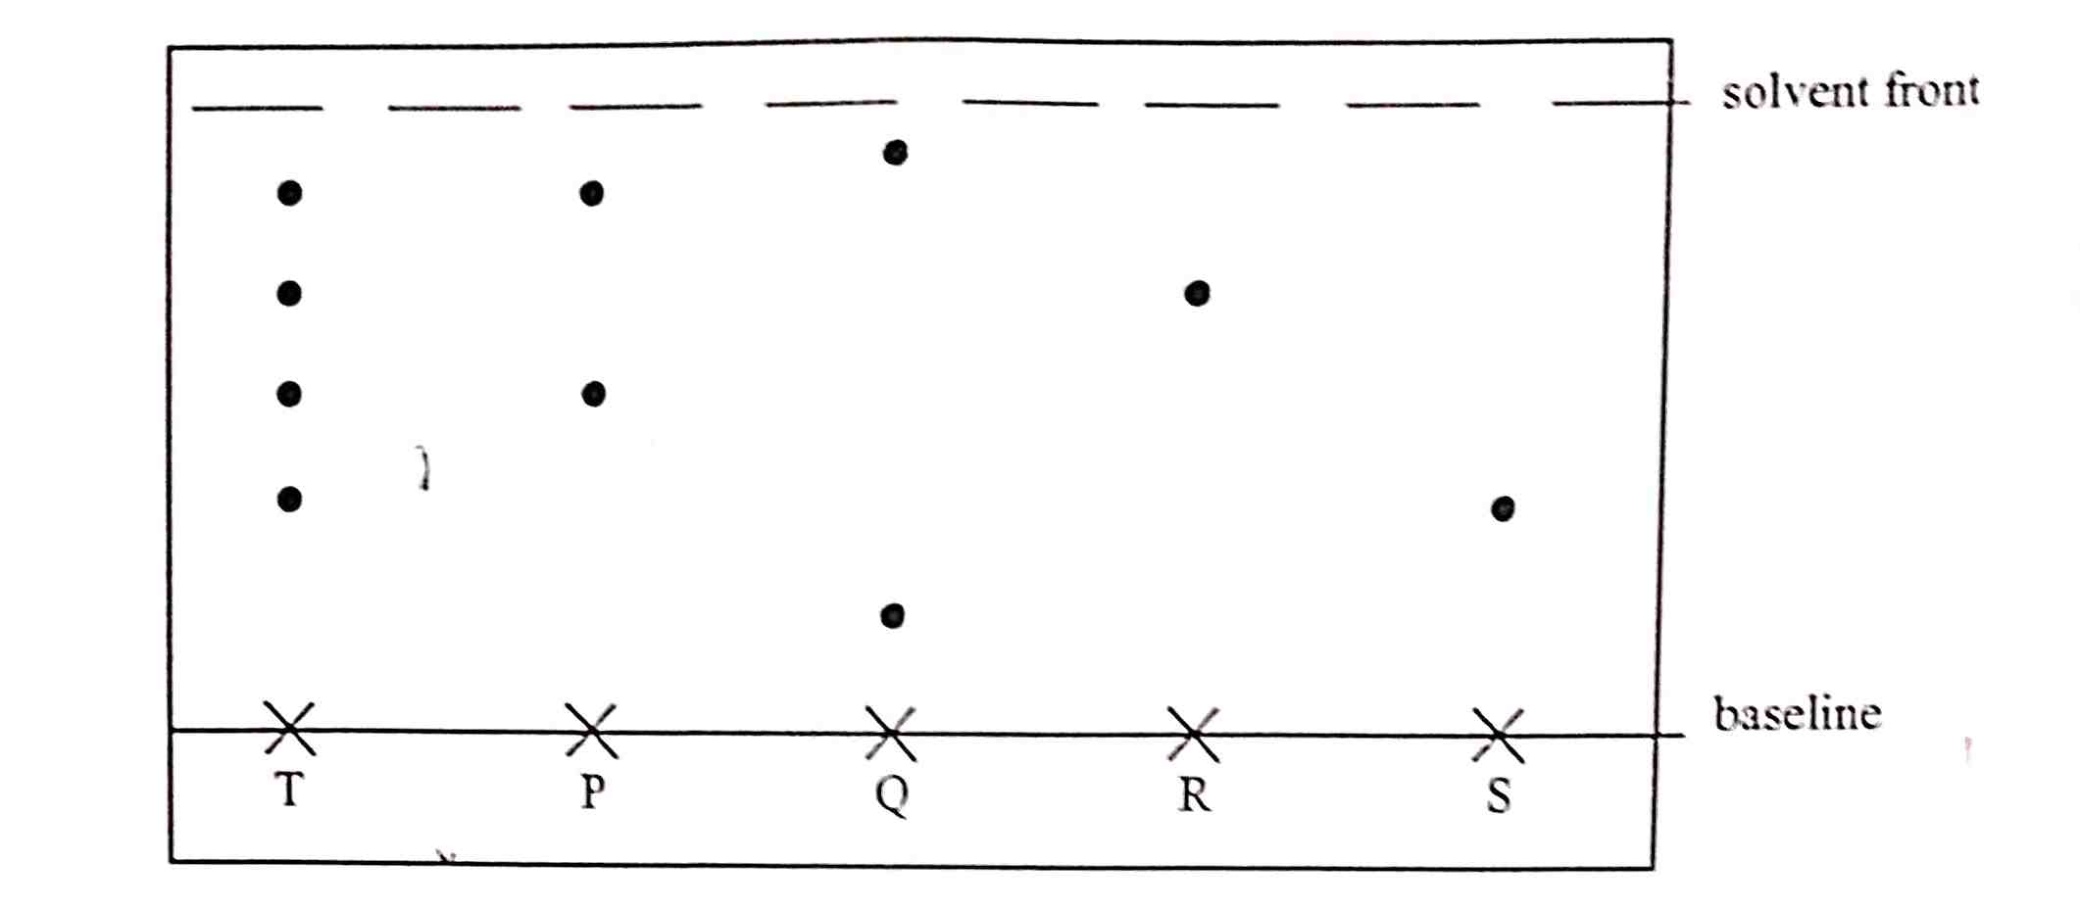

- Name the method of separation illustrated above. (1mk)

- Select;
- One substance which contains a component not present in T. (1mk)

- A substance which is least soluble in the solvent used. (1mk)

- During laboratory preparation of oxygen, manganese (IV) oxide is added to reagent H.
- Name reagent H (1mk)

- State the role of manganese (IV) oxide. (1mk)

- Write the equation for the reaction that takes place. (1mk)

- The heat of solution and hydration energy of potassium chloride is -17.2kJ and -689kJ respectively. Calculate the lattice energy of potassium chloride. (2mks)

- Define molar heat of displacement. (1mk)

b. The following ionic equation represents the reaction between metal Y and an aqueous solution of Z²⁺.
Y(s) +Z²⁺(aq) Y²⁺(aq) +Z(s)
ΔH=-ve
Draw an energy level diagram to represent the reaction. (2mks)

- a. What is meant by the term bleaching? (1mk)

b. Write the formula of the bleaching agent formed when chloride gas reacts with aqueous sodium hydroxide. (1mk)

c. State the role of chlorine in water treatment. (1mk)

- The flow chart below shows the process of obtaining a sample of nitrogen gas. Study it and answer the questions that follow.

Purifier
X
Copper turnings
Nitrogen
Dry air

- Identify X (1mk)

- Write an equation for the reaction with heated copper turnings. (1mk)

- Name an impurity in the sample of nitrogen gas. (1mk)

- A mixture contains ammonium chloride, copper (II) oxide and sodium chloride. Describe how each of the substances can be obtained from the mixture. (3mks)

