CHEMISTRY P3 Marking scheme

Mark allocation per question

Question | Maximum score
1. | 22 marks
2. | 09 marks
3. | 09 marks
Total score | 40 marks

Q1. You are provide with:
- 5.3g solid A, sodium carbonate;
- Solution B, hydrochloric acid.
You are required to determine the:
- Molar heat of solution of solid A;
- Concentration of hydrochloric acid solution B.
Procedure I
Using a burette place 30 cm³ of distilled water in a 100 ml plastic beaker. Stir the water with a thermometer and measure its temperature after every half-minute interval. Record the readings in Table 1.
At exactly 2 minutes add all of solid A to the water at once. Stir well and continue measuring temperature of the mixture after every half-minute interval. Record the readings in Table 1. Retain the mixture in the beaker for use in Procedure II.
Table 1 (3 mks) (The four possible expectations are as shown below)
Time(minutes) | 0 | ½ | 1 | 1 ½ | 2 | 2 ½ | 3 | 3 ½ | 4 | 4 ½ | 5
Temperature (⁰ C) | 22.0 | 22.0 | 22.0 | 22.0 | X | 26.0 | 30.0 | 30.0 | 29.0 | 28.5 | 28.0
 | 22.0 | 22.0 | 22.0 | 22.0 | X | 26.0 | 30.0 | 29.5 | 29.0 | 28.5 | 28.0
 | 22.0 | 22.0 | 22.0 | 22.0 | X | 30.0 | 30.0 | 30.0 | 29.0 | 28.5 | 28.0
 | 22.0 | 22.0 | 22.0 | 22.0 | X | 30.5 | 30.0 | 29.0 | 28.0 | 27.5 | 27.0

The table is given 3 marks distributed as follows:
(A) Complete table 1 mk.
(B) Decimals ½ mk.
(C) Accuracy ½ mk.
(D) Trends 1 mk.

A) Complete Table: ………………………. (1 mk)
Penalties/conditions
Peanalise ½ mk ONCE:
(i) for any space not filled subject to at least 5 readings otherwise penalize fully.
(ii) for any unrealistic temperature i.e. temperature of less than 10 ⁰C and greater than 40 ⁰C for readings
t = 0 to t = 1½ minutes and temperature greater than 50 ⁰C for readings t = 2½ to t = 5 minutes.
(iii) if temperature readings from t = 0 to t = 5 minutes are constant.
(iv) if temperature readings at t = 2½ minutes is below or equal to temperature readings t = 1½ minutes and if any temperature readings from t = 2½ to t = 5 minutes is below temperature readings t = 1½.
(v) If two or more rows of temperature readings are given. However for use of decimals, accuracy and trends the two rows MUST each meet the criteria provided to be credited.
B) Use of decimals; ……………………….. ( ½ mk)
(Tied to at least two temperature readings)
Penalties/conditions
(i) Reading should be recorded consistently as whole number one or two decimal places.
(ii) Reading recorded to one decimal places should be .0 or .5.
(iii) Reading recorded to two decimal places should be .00, .25, .50, or .75.
C) Accuracy; …………………………………. ( ½ mk)
Compare candidates temperature readings at t = 1 ½ minutes with the school/teacher values at the same time. If within ±2 award ½ mk. Otherwise penalize fully.
NB. Mark the correct student temperature reading at t = 1 ½ minutes on the table with a tick ($√$)

D) Trends; ………………………………. (1 mk)
The 1 mk is distributed as follows;
Award 1st ½ mk if temperature readings from t = ½ to t = 1 ½ minutes are constant and the 2nd ½ mk from t = 2 ½ to t = 5 minutes:
I. for continuous rise to maximum followed by a constant at maximum then continuous drop.
II. for continuous rise to maximum followed by continuous drop.
III. for constant at maximum followed by continuous drop.
IV. a sudden rise to maximum followed by continuous drop.

(b) On the grid provided, plot the graph of temperature (vertical axis) against time. (3 mks)
Time(minutes) | 0 | ½ | 1 | 1 ½ | 2 | 2 ½ | 3 | 3 ½ | 4 | 4 ½ | 5
Temperature (⁰ C) | 22 | 22.0 | 22.0 | 22.0 | X | 26.0 | 30.0 | 30.0 | 29.0 | 28.5 | 28.0
 | 22.0 | 22.0 | 22.0 | 22.0 | X | 26.0 | 30.0 | 29.5 | 29.0 | 28.5 | 28.0
 | 22.0 | 22.0 | 22.0 | 22.0 | X | 30.0 | 30.0 | 30.0 | 29.0 | 28.5 | 28.0
 | 22.0 | 22.0 | 22.0 | 22.0 | X | 31.0 | 30.0 | 29.0 | 28.0 | 27.5 | 27.0

The four expected graphs from the 4 results:

Temp | 0 | ½ | 1 | 1 ½ | 2 | 2 ½ | 3 | 3 ½ | 4 | 4 ½ | 5
Time | 22 | 22.0 | 22.0 | 22.0 | X | 26.0 | 30.0 | 30.0 | 29.0 | 28.5 | 28.0

I) Graph of constant temperature readings, continuous rise to maximum followed by a constant at maximum then continuous drop.

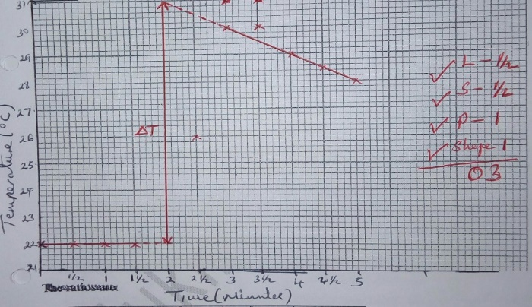

Temp | 0 | ½ | 1 | 1 ½ | 2 | 2 ½ | 3 | 3 ½ | 4 | 4 ½ | 5
Time | 22.0 | 22.0 | 22.0 | 22.0 | X | 26.0 | 30.0 | 29.5 | 29.0 | 28.5 | 28.0

II) Graph of constant temperature readings, continuous rise to maximum followed by continuous drop.

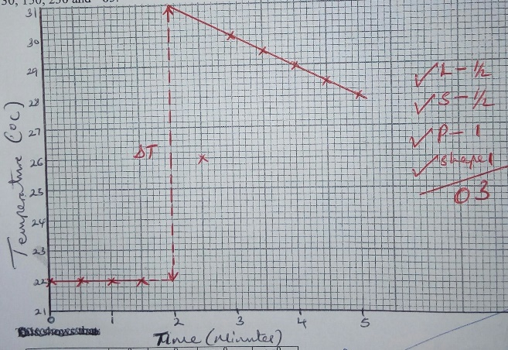

Temp | 0 | ½ | 1 | 1 ½ | 2 | 2 ½ | 3 | 3 ½ | 4 | 4 ½ | 5
Time | 22 | 22.0 | 22.0 | 22.0 | X | 30.0 | 30.0 | 30.0 | 29.0 | 28.5 | 28.0

III) Graph of constant temperature readings, constant at maximum followed by continuous drop.

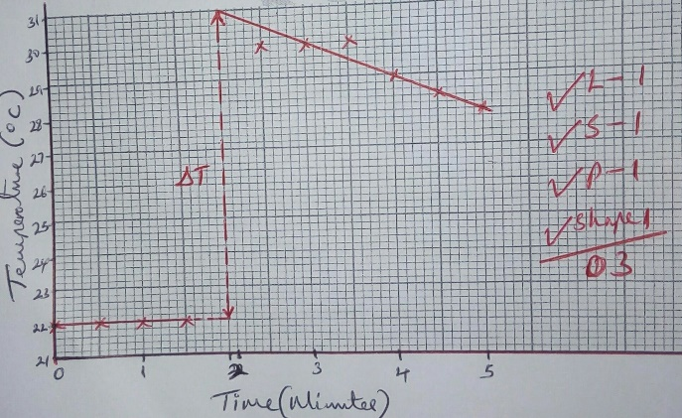

Temp | 0 | ½ | 1 | 1 ½ | 2 | 2 ½ | 3 | 3 ½ | 4 | 4 ½ | 5
Time | 22.0 | 22.0 | 22.0 | 22.0 | X | 30.5 | 30.0 | 29.0 | 28.0 | 27.5 | 27.0
IV) Graph of constant temperature readings, sudden rise to maximum followed by continuous drop.

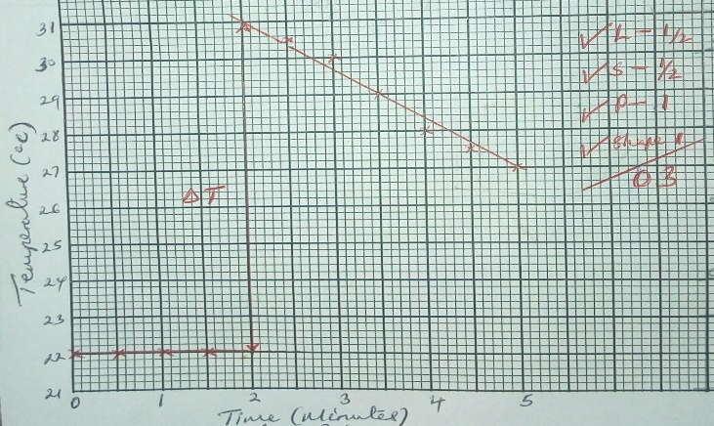

Marking of the graph, the 3 marks are distributed as follows:
(A) Labelling of axes ½ mk.
(B) Scale ½ mk.
(C) Plotting 1 mk.
(D) Shape of the graph/line 1 mk.

(A) Labelling of axes: ……………. ½ mk.
Award ½ mk if both axes are correctly labelled.
Penalties
(i) Penalise fully for inverted axes.
(ii) Units may or may not be used but if given they must be correct otherwise penalize fully for wrong unit given.
NB. Mark the correct labelled axes on the student graph with a tick ($√$)

(B) Scale: ……………. ½ mk.
Conditions
Penalise fully if any of the conditions below is not met.
(i) Area covered by plots must be at least half the grid provided. (including extrapolation on correct graph)
(ii) Scale intervals must be consistent on each of the axes.
(ii) Scale chosen must be able to accommodate all the plots (temperature readings on the student table) whether plotted or not.
Note: - Award for scale even if the axes are inverted.

(C) Plotting. ………………. 1 mk.
Conditions
(i) If 9 or 10 plots are correctly plotted award 1 mk.
(ii) If 5 to 8 plots are correctly plotted award ½ mk
(ii) If less than 5 plots are correctly plotted award 0 mk

Note:
(i) Accept correct plots even if the axes are inverted and award accordingly.
(ii) If the scale intervals are inconsistent mark the plots if any within the first interval and treat all other as wrong and award accordingly.
NB. Mark all the student correct plots on the graph with a tick ($√$) or a cross (x)

(D) Shape of the graph/line 1 mk.
Conditions
(i) Accept 2 straight lines correctly extrapolated up 2 minutes with initial line being horizontal and the other line dropping for 1 mk.
(ii) Accept 2 straight lines not extrapolated and not joined with initial line being horizontal and the other line dropping for ½ mk.

Note:
(i) Each of the 2 straight lines must pass through at least two correctly plotted points otherwise penalize fully. (i.e. award 0 mk)
(ii) Extrapolation may be solid/continuous line or broken line.

Two straight lines extrapolated |  | Two straight lines not extrapolated
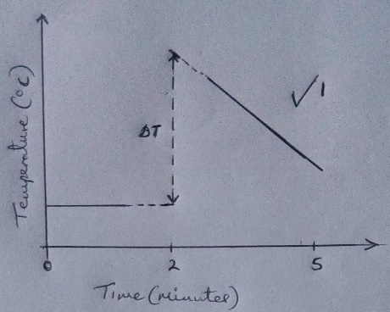 | 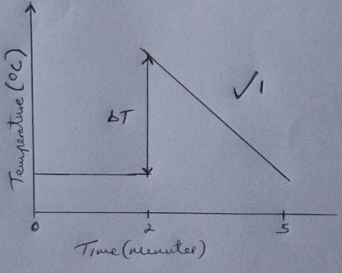 | 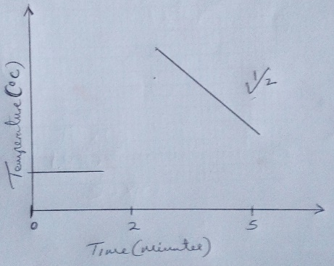

(c) Determine from the graph the temperature change $∆$T. (1 mk)
$∆$T = 31 – 22 $√$ ½ = 9 $√$ ½
Conditions
(i) Accept for 1 mk correct value of $∆$T from a correct graph (graph that score 1 mk for the shape or line) with or without showing on graph even if the axes are inverted.
(ii) Accept for ½ mk if $∆$T is shown correctly on the correct graph but its value is either missing or wrong. (i.e. Award ½ mk for correct showing on the graph).
(ii) If not shown on the correct graph award ½ mk for the correct working and another ½ mk for correct $∆$T.
Note:
(i) Reject reading and showing from a wrong graph (i.e. A graph that scored ½ mk or zero mk.
(ii) The units may or may not be shown but if shown must be correct otherwise penalize ½ mk for wrong.

(d) Calculate the:
(i) number of moles of solid A used. (RFM = 106) (1 mk)
Number of moles = $\frac{mass used in g}{RFM}$ = $\frac{5.3}{106}$ $√$ ½ = 0.05 moles $√$ ½
Conditions
(i) If the expression is not shown but the answer is correct, award ½ mk only for correct answer.
(ii)The unit may or may not be shown but if shown it must be correct otherwise penalize fully for wrong unit given.
(iii) The 5.3 and 106 must be transferred intact, otherwise penalize fully.
(ii) molar enthalpy of solution, $∆$H_{soln} and show the sign of $∆$H_{soln}. (Assume that for the solution density = 1 g/cm³ and specific heat capacity = 4.2 Jg⁻¹K⁻¹) (2mks)
$∆$H = mc$∆$T = (30 cm³ x 1 g/cm³ x 4.2 x Answer (c) above $√$ ½ = correct answer in J/mole $√$ ½
$∆$H = mc$∆$T = 30 x 4.2 x 9 = 1134 joules then
Molar enthalpy of solution = $\frac{Correct answer }{Answer d\left(i\right)above}$ = correct final answer
= $\frac{1134}{0.05}$ = 22680 joules/mole (J/mole) = -22680 J/mole $√$ ½ or
0.05 moles liberate 1134 joules of heat
1 moles would liberate $\frac{1134}{0.05}$ $√$ 1 = 22680 kJ/mole = -22680 J/mole $√$ ½
OR
$∆$H = mc$∆$T = $\frac{30 x 4.2 x ∆T from \left(c\right) above }{1000}$ = correct answer in kJ
= $\frac{30 x 4.2 x 9 }{1000}$ $√$ ½ = 1.134 kJ then
Molar enthalpy of solution = $\frac{Correct answer above }{Answer d\left(i\right)above}$ = Final correct answer in kJ/mole
= $\frac{1.134}{0.05}$ $√$ 1 = 22.68 kJ/mole = -22680 kJ/mole $√$ ½ or
0.05 moles liberate 1.134 kJ of heat
1 moles would liberate $\frac{1.134}{0.05}$ $√$ 1 = 22.68 kJ/mole = -22.68 kJ/mole $√$ ½
OR
Molar enthalpy of solution = $\frac{(30 x 4.2 x Answer \left(c\right)above)}{Answer d\left(i\right)above}$ = Final correct answer in J/mole.
= $\frac{(30 x 4.2 x 9)}{0.05} √$ 1 ½ = 22680 J/mole = -22 68 J/mole $√$ ½
OR
Molar enthalpy of solution = $\frac{30 x 4.2 x Answer \left(c\right) above}{1000 x d\left(i\right)above}$ = Final correct answer in kJ/mole
= $\frac{(30 x 4.2 x 9)}{1000 x 0.05}$ $√$ 1 ½ = 22 68 kJ/mole = -22 68 kJ/mole $√$ ½
Conditions/penalties
(i) Accept correct transfer of answer (c) and d(i) above even if rejected on (c) and d(i) above.
(ii) Penalise ½ mk for wrong transfer of either answer (c) or d(i) above or both otherwise penalize fully for strange figure used.
(iii) Penalise ½ mk on the final correct answer if the negative sign (-) and or the unit used are wrong or missing.
(iii) Penalise ½ mk for wrong answer if arithmetic error is outside ±2 units in the 3rd digit.
(iv) Penalise fully (i.e. ½ mk) for unrealistic final answer if outside the range of -12 kJ/mole to – 28 kJ/mole or -12000 J/mole to – 28000 J/mole if the expressions are correct.

Procedure II
(i) Fill the burette with solution B.
(ii) Transfer all the mixture in the 100 ml plastic beaker from Procedure I into a 250 ml volumetric flask. Add distilled water to make up to the mark and shake. Label the solution mixture as solution A.
(iii) Using pipette and pipette filler, place 25.0 cm³ of solution A into 250 ml conical flask. Add two to three drops of phenolphthalein indicator and titrate with solution B.
Do not pour out the content of the conical flask. Record the readings in Table 2.
Add two to three drops of methyl orange indicator into the contents of the conical flask.
Titrate the mixture with solution B. and record the readings of this second titration in Table 3.
Repeat Procedure II, step (iii) and complete Table 2 and 3.
Table 2 (3 ½ mks )
 | I | II
Final burette reading | 16.6 | 16.4
Initial burette reading | 0.0 | 0.0
Volume of solution B used (cm³) | 16.6 | 16.4

Average volume V₁, of solution B used = …………………………….. ( ½ mk)
Average volume V₁, of solution B used = $\frac{16.6 + 16.4}{2}$ $√$ = 16.5 cm³ $√$
The table is given 4 marks distributed as follows:
(A) Complete table 1 mk.
(B) Decimals ½ mk.
(C) Accuracy 1 mk.
(D) Principle of averaging ½ mk
(E) Final accuracy 1 mk.

A) Complete table ………………….….. 1mk

Penalize ½ mk for each mistake to a maximum of ½ mark for
(i) Inverted table (i.e. exchanging final burette readings with initial burette readings)
(ii) Wrong arithmetic (i.e. wrong additions/subtractions)
(iii) Unrealistic burette readings of:
- Over 50 cm³ (> 50) unless explained or
- Below 1cm³ (< 1) and in hundreds.

B) Decimal points…………….……...… ½ mk
(Tied to 1st and 2nd row of the table)

(i) Accept 1 or 2 d.p. used consistently and if 2 d.p. are used the 2nd d.p must be 0 or 5.
(ii) Accept inconsistent in the use of zero as initial burette readings i.e. 0, 0.0, 0.00.

C) Accuracy…………………….……… 1 mk
Correct student value titre/value is compared to school value.(i.e. Teacher average titre)

- If any student value is within ±0.1 of school value award 1mk.
- If any student value is beyond ±0.1 but within ±0.2 of school value award ½ mk.
- If none of student value is beyond ±0.2 award 0 mk.
NB. Mark the correct student titre on the table with a tick ($√$)

D) Principles of averaging …….…..…. ½ mk.
The values/titres averaged must be consistent readings within ± 0.2cm³.
i.e.
If 2 titrations are done consistent and averaged award 1 mk.
If 2 titrations are inconsistent averaged award 0 mk.

Note:
(i) Answer should expressed to at least 2 d.p. unless it workout to 1 d.p or a whole number otherwise penalize fully.
(ii) If no working is shown but the answer given is correct credit fully.
(iii) Mark the principle of averaging before posting the mark.

Penalties
(i) Penalise fully for wrong arithmetic if error is outside 2 units in the 2nd decimal place.
(ii) Penalise fully if there is no working shown and the answer given is wrong.

E) Final accuracy ………………..…. 1mk
Student final average titre is compared to school value (teacher average titre) and marked as follows:

- If student value is within ±0.1 of school value award 1mk
- If student value is beyond ±0.1 but within ±0.2 of school value award ½ mark
- If student value is beyond ±0.2 award 0 mk
Note:
If teachers school values is missing or it cannot be worked out from the teachers/school values given, sample students close titre values per session and average them to get the school value.
If the students titre values are too varied use KNEC titre values which are for Table 1, 16.45 cm³ and Table 3, 16.50 cm³.

Table 3 ( 3 ½ mks)
 | I | II
Final burette reading | 33.5 | 16.3
Initial burette reading | 17.0 | 0.0
Volume of solution B used (cm³) | 16.5 | 16.3

Average volume V₂, of solution B used = …………………………….. ( ½ mk)
Average volume V₂, of solution B used = $\frac{16.5 + 16.3}{2}$ $√$ = 16.4 cm³ $√$ ½
Note:
(i) Mark Table 3 as per Table 2.
(ii) If the titre values for Table 3 is almost double or double or more than double that of
Table 1, treat The titres for Table 3 as unrealistic value. This means for teacher titre value
sample and for student titre value penalize ½ mk on compete table.

Calculate the:
(i) concentration in moles per litre, of sodium carbonate in solution A. (RFM = 106) (1 mk)
Molarity of solution A = $\frac{Answer d\left(i\right)above x 1000}{250}$ = $\frac{0.05 x 1000}{250}$ $√$ ½ = 0.2 M $√$ ½
OR
= $\frac{5.3 x 1000}{106 x 250}$ $√$ ½ = 0.2 M $√$ ½
OR
Conc. in g/l = $\frac{5.3 x 1000}{250}$ = 21.2 g/l then
Molarity of solution A = $\frac{Conc. in g/l}{RFM}$ = $\frac{21.2}{106}$ $√$ ½ = 0.2 M $√$ ½
Note:
If there is arithmetic error in the intermediate answer of 21.2 g/l then award ½ mk for the correct expression otherwise penalize fully.
(ii) number of moles of sodium carbonate in 25 cm³ of solution A. (1 mk)
No of moles of solution A = $\frac{Answer f\left(i\right)above x 25}{1000}$ = $\frac{0.2 x 25}{1000}$ $√$ ½ = 0.005 moles $√$ ½
OR
= $\frac{5.3 x 25}{106 x 250}$ $√$ ½ = 0.005 moles $√$ ½
OR
= $\frac{Answer d\left(i\right)above x 25}{250}$ = $\frac{0.2 x 25}{250}$ $√$ ½ = 0.005 moles $√$ ½
(iii) number of moles of hydrochloric acid in the total volume, V₁ + V₂, of solution B. (1 mk)
Reacting moles ratio of Carbonate to acid = 1 : 2
Thus moles of acid in (V₁ + V₂ ) = Answer f(ii) above x 2 = 0.005 x 2 $√$ ½ = 0.01 moles$√$ ½
(iv) concentration in moles per litre, of hydrochloric acid in solution B. (1 mk)
Molarity of solution B = $\frac{Answer f\left(iii\right)above x 1000}{V_{1} + V_{2}}$ = $\frac{0.01 x 1000}{16.5 + 16.4}$ = $\frac{0.01 x 1000}{32.9}$ = 0.304 M
Conditions/penalties:
(i) Answer d(i) and f(i) to f(iii) must be transferred intact otherwise penalize for wrong transfer in each case However penalize fully for strange figure in each case.
(ii) Answer f(i) to f(iv) should be to at least 3 decimal places unless they work out to exactly 2 or 1 d. p. otherwise penalize ½ mk for rounding to 2 or 1 d.p. in each case.
(iii) In answer f(i) to f(iv) units may or may not be given but if given must be correct otherwise penalize ½ mk for wrong units in each case.
(iv) Answer f(iv) should be in the range between 0.1M to 0.5M otherwise penalize fully for unrealistic answer.

Q2. Your are provided with solid C. Carry out the following tests. Write your observations and inferences in the spaces provided.
b) Place all of solid C in a boiling tube. Add about 20 cm³ of distilled water and shake until all of the solid dissolves. Label the solution as solution C. Use about 2 cm³ of solution C in a test tube for each of the following tests.
(a) Add aqueous sodium hydroxide drop wise until in excess.
Observations (1 mk) | Inferences (1 mk)
White precipitate $√$ ½ insoluble in excess $√$ ½  Or  White precipitate in excess $√$ 1  Accept for ½ mk  White solid/suspension for white precipitate. | Ca²⁺, Mg²⁺, Ba²⁺ $√$ 1  Award/accept  - All three correct ions given 1 mk.  - Any two correct ions given 1 mk.  - Only one correct ion given ½ mk.  Penalise ½ mk for each contradictory ion to a maximum of 1 mk.  Award/accept for ½ mk:  - Correct ion (s) written in words  Ignore Zn²⁺, Al ²⁺, Pb ²⁺ ions if mentioned absent.

(b) Add three drops of aqueous sodium sulphate.
Observations (1 mk) | Inferences (1 mk)
White precipitate $√$ 1 | Ca²⁺ / Ba ²⁺ $√$ 1  Award for 1 mk:  Both ions or one correct ion (s) given.  Award/accept  - All three or any two correct ions given 1 mk.  - Only one correct ion given ½ mk.  - Correct ion (s) written in words for ½ mk.  Penalise fully for any contradictory ion given.  Accept for ½ mk  - Mg²⁺ absent in the absence of Ca²⁺/Ba ²⁺ but must have been inferred correctly in 2(a) above as present.

(c) Add three drops of aqueous barium nitrate.
Observations (1 mk) | Inferences (1 mk)
NO white precipitate $√$ 1  Accept for ½ mk and credit correct inference accordingly  - No precipitate.  - No observable change.  - Colourless solution retained.  Reject:  - No change.  - No colour change.  - No white substance.  - No reaction.  - No observation. | SO₄²⁻, CO₃²⁻, SO₃²⁻ absent  Award  - 3 ions given 2 mks  - 2 ions given 1 mk  - 1 ions given ½ mk  Note:  - Accept for ½ mk correct ion (s) written  in words  - Penalise ½ mk for each contradictory  ion given to a maximum of 1½ mk.

(iv) Add three drops of aqueous lead (II) nitrate. Heat the mixture
Observations (1 mk) | Inferences (1 mk)
White precipitate $√$ ½ soluble on heating $√$ ½  Reject:  - White precipitate/white substance. | Cl⁻ / Br⁻ present $√$ 1  Accept for;  - Both ions correct given for 1 mk.  - Any one correct ion given for 1 mk.  - Correct ion (s) written in words for ½ mk  Note:  - Correct inference is tied to white  precipitate soluble on heating.  - Penalise fully for any contradictory ion  given.

Q3. You are provided with an organic compound solid D. Carry out the following tests. Record the observations and inferences in the spaces provided. Divide solid D into four portion
a) Describe the appearance of solid D. (1 mk)
White $√$ ½ crystals/crystalline $√$ ½ solid.
Note:
(i) Accept for ½ mk white solid/powder.
(ii) Reject solid on its own/colourless crystals/ white precipitate/white solution/shiny crystals.
(b) Divide solid D into four portions.
(i) Place the first portion of solid D on a wash glass and burn it with Bunsen burner flame.
Observations (1 mk) | Inferences (1 mk)
Melt to a colourless liquid which burns with yellow/luminous$√$ ½ -sooty/smoky $√$ ½ flame | = C=C= / -C$≡$C- $√$ 1  Accept for 1 mk (i.e. credit fully):  - Unsaturated organic compound.  - Aromatic organic compound.  - Organic compounds with high C : H ratio.  - Long chain organic compound  - Carbon to carbon double /tripple bond  present.  Ignore the following if mentioned present  - Alkene/alkyne.  - Long chain hydrocarbon.  Note:  - Credit fully correct inference even if the  observation has scored only ½ mk  - Penalise fully for any contradictory functional group given.  (Contradictory functional group is the one mentioned and it is not tested using the test given or wrongly written but ignore mention of ions present in test reagents)

(ii) Place the second portion of solid D in a test tube. Add about 3 cm³ of aqueous sodium hydroxide and shake well.
Observations (1 mk) | Inferences (1 mk)
Solid D dissolved $√$ ½ forming colourless $√$ ½ solution  Accept for 1 mk  - Forms colourless solution.  Reject  - Colourless liquid used in place of  colourless solution. | Solid D is acidic / RCOOH $√$ 1  Accept for 1 mk (i.e. credit fully)  - Carboxylic/alkanoic acid written in  words in absence of the structure.  Note:  - Correct inference is tied to  dissolving/colourless solution formed.  - Ignore H⁺ / H³O⁺ if mentioned on their  own.  Note:  - Credit fully correct inference even if the  observation has scored only ½ mk  - Penalise fully for any contradictory functional group given.

(iii) Place a third portion of solid D in a test tube. Add 3 cm³ of distilled water. Heat the mixture and add three drops acidified potassium manganate (VII) solution.
Observations (1 mk) | Inferences (1 mk)
Acidified potassium manganate (VII) not decolourised $√$ 1.  Purple colour of acidified potassium manganate (VII) solution does not turned/changed to colourless $√$ 1.  Purple colour of acidified potassium manganate (VII) remains/persists/retained $√$ 1  Reject  - Solution remains purple.  - Solution is not discoloured  - Purple colour persists/remains/retained.  - Colour of acidified potassium manganate (VII) persists/remains/retained.  - Colour of acidified potassium manganate (VII) solution does not turned/changed to colourless. | = C=C=/ -C$≡$C- $√$ ½ and ROH $√$ ½ absent  Accept for ½ mk (i.e. credit fully)  - Unsaturated organic compounds and  alcohol/alkanol absent written in  words in absence of the structures.  Note:  - Penalise fully for any contradictory functional group given.

(iv) Place the fourth portion of solid D in a test tube. Add 3 cm³ of distilled water. Heat the mixture and add all the solid sodium hydrogen carbonate provided.
Observations (1 mk) | Inferences (1 mk)
Effervescence occurs/bubbling/fizzing occurred $√$ 1  Reject  - Hissing/sizzling/fizzling or  - Colourless gas on its own. | RCOOH $√$1  Accept for ½ mk  - Carboxylic/alkanoic acid written in  words in absence of the structure.  - H⁺ /H³O⁺ if mentioned on their own.  - Solution is acidic.  Note:  - Penalise fully for any contradictory functional group given.

Please note additions or deductions in the above working is acceptable.

LAST PRINTED PAGE:

