LONDIANI SUB-COUNTY MOCK. SEPT 2022 FORM 4
MARKING SCHEME GEOGRAPHY PAPER 2
SECTION A
Answer all questions in this section
1.(a) What is a derelict land? (2 mks)
- This is land that has been abandoned because it is damaged, has no vegetation and is depleted of minerals.
(b) State three causes of land dereliction. (3 mks)
- Overgrazing and overstocking.
- Mining
- Deforestation
- Poor farming methods like monocropping.
2.(a) State three problems facing coffee in Kenya. (3 mks)
-Attack by pests like leave miner –coffee leaves
-diseases such as coffee berry disease
-fluctuation of coffee prices which discourage farmers
-inadequate capital for buying farm inputs and paying labour
-mismanagement of coffee cooperative societies.
(b)Outline two benefits of coffee farming in Brazil
-employment opportunities –industries,farms,etc
-earnings from coffee export –developing sectors such as education,health,etc
-provision of coffee bevearage
3.a) Name two exotic breeds of dairy cattle reared in Kenya
Fresian / Hoisten
Ayshire
Guernsey
Jersey
Alderney
Brown Swiss / Swiss Brown. (2mks)
b) State three physical conditions that favour dairy farming in Denmark
The landscape is gently sloping which is suitable for grazing
The climate has warm / sunny summer / moderate temperature (10º – 17ºC)
that allow out door grazing.
There is cool climate suitable for pasture growing
The moderate rainfall (500 – 1000mm) that supports growth of grass /
fodder crops
Boulder clay soil are fertile support high pasture
NB if one writes moderate rainfall of 11000mm – its wrong. (3mks)
4. The table below shows petroleum production in thousand barrels per day for countries in the middle East in April 2000. Use it to answer question(a)

Country | Production in ‘000’ barrels
Iran  Kuwait  Qatar  Saudi Arabia  United Arab Emirates  Iraq. | 3,800  2,550  800  9,600  2,500  1,900

a)i) What is the difference in production between the highest and the lowest producer?
8,800 , 000 barrels (1mk)
ii) What is the total amount of petroleum produced in April 2006 in the region?
634,500,000 barrels (2.55 x10⁸) (1mk)
b) State three conditions that are necessary for the formation of petroleum. (3mks)
Deposition / presence of flora and fauna over a long period of time / fossils presence of presence of porous rocks / presence of non porous underneath in the deposits of the flora and fauna.
Deposition of other layers of rocks / non porous / over the remains of flora and fauna
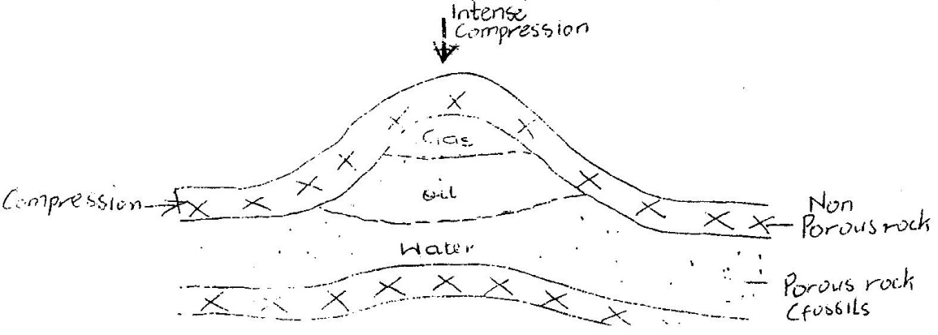
Compression of the remains of flora and fauna due to folding of the layers of rocks.

5. (a) State two reasons why some industries are located near the sources of
raw Materials
- The raw materials may be too bulky and thus expensive to transport
- Some raw materials are perishable so they have to be processed before transportation
- Processing reduces transport costs ( any 2 x 1 = 2 mks)

- Give three characteristics of the cottage industry in India
  - They rely on simple equipment/ machines
  - They are labour intensive
  - They are owned by families
  - They use locally available raw materials
  - They produce mainly for local markets
  - They are widespread in the country (Any 3 x 1 = 3 mks)

6a) ii) They allow ease in comparison interpretation.
They give clear visual impression
They are easy to read
They easily show the trend of the given data.
Easy to draw / construct (Any 2x1 = 2mks)
b) 130,000
- 70,000 60,000 x 100 = 85.7 / 85 (2mks)
60,000 70,000
c) Cool / warm climate / condition. 10ºc to 28ºc throughout the year
High rainfall/ 1000 – 2000 mm per year.
Well distributed rainfall through the year.
Areas the are frost – free
Deep light and well drained soils
Gently sloping / undulating land
Acidic / Volcanic soils / ph of 4 – 6
High altitude / 100 m – 2300m a.s.l (Any 5 x 1 (5mks)
d) Delayed payments / low payments that lowers the morale of the farmers mismanagement / Embezzlement of funds thus farmers are discouraged
Poor feeder roads in the tea growing areas lead to delays in collection / delivery of the green leaf hence wastage.
Adverse weather conditions such as long droughts / hale storms lead to destruction of the crop / lower production.
Fluctuation of prices in the world market makes it difficult for the farmer to plan ahead/ lower morale/ discourages farmers
High production costs due to high prices of farm inputs leads to lower yields since most farmers cannot afford to buy them
Pests/ Fungal diseases destroy crops. Reduce yields ( pests e.g. red spider-mites, weevils and beetles), termites, nematodes.
Inadequate/ unreliable transport facilities delays the collection/ delivery of green leaf reducing the quality.
Labour shortage/ expensive labour leads to low products/quality.. (8mks)
7. (a) (i) What is forestry. (2mks)
It is the science of planting, caring and using trees/ forests and their resources
It is the practice of managing and using trees/ forests associated resources
(ii) Explain three factors that favour the growth of natural forests on the slopes of Mt. Kenya.
- The area receives high rainfall 1000- 22000 mm throughout the year which encourages continuous growth of trees.
- The area has deep fertile volcanic soils that allow the roots to penetrate deep into the ground to support the trees
- The area has well drained soil thus there is no water logging which can choke plants and interfere with their growth
- The area has moderate cool condition/ climate are ideal for the growth of a variety of trees.
- The area is a gazeted forest reserve/ settlement and cultivation are prohibited hence allowing forests to grow without interference
- The steep slopes discourages human activities thus enabling forests to thrive well
Explanation 1 mk Factor 1 mk (6mks)
(iii) State five factors that have led to the reduction of the area under forests on the slopes of Mt Kenya
- The illegal encroachment of human activities
- The illegal cultivation has led to clearing of parts of the forest
- Prolonged droughts have caused drying of some forests
- Plant disease/ pests destroy some trees in the forest
- Outbreak of forest fires/ charcoal burning destroy some trees in the forest
- Over exploitation of certain species of trees. (5mks)

(b) Explain four measures that the government of Kenya is taking to conserve in the country
Registering/ recognizing the efforts of NGOs like the green Belt Movement which have mounted campaigns on planting of trees
Gazeting forested areas to reduce encroachment of the public
Creating public awareness through mass media/ public bazaars on the importance of conserving forest resources
Enacting laws to prohibit the cutting of trees without a license/ protecting indigeous tree species
Establishing NEMA/ ministry of environment and natural resources to coordinate environmental management and conservation activities
Setting aside national tree planting day to encourage people to plant more trees
Advising people to practice agro- forestry so as to avoid cutting trees from the forests
Employing forest guards to protect forests form fires/ other illegal human activities
Encouraging recycling of paers/ wood based products/ use of other sources of energy to reduce demand of trees
Carrying out research through KEFRI and ICRAF in order to come up with ways of controlling diseases/ pests/ develop species suitable for different ecological regions. (8mks)
(c) Give the differences in the exploitation of softwood forests in Kenya and Canada under the following sub- headings
(i) Period of harvesting
Transportation
Kenya Canada
Period of harvesting is done throughout the year Harvesting is in winter and Early spring (2mks)
Transportation mainly road transport Mainly water transport (2mks)

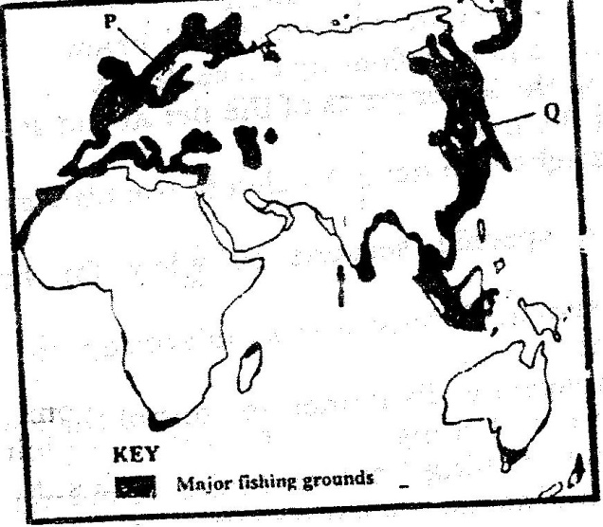
8.(a) (i)

P- Norway Q- Japan. (2mks)
(ii) The area has cool waters which have abundant supply of plantation which is the main food for fish
- The areas have shallow continental shelves which allow light to penetrate to the sea below encouraging the growth of micro- organisms used as food by fish
- The areas experience convergence of warm and cool currents which result in upwelling of ocean waters thus bringing minerals for fish and plankton from the sea bed to the surface
- Most of the coast are indented/ have numerous sheltered bays which provide secure breeding grounds for fish.
- The shelters bays provide suitable sites for building fishing ports/ fish landing sites
- The large population in these area limits agricultural activities thus people turn to fishing as an alternative economic activity/ cold climate also limit agriculture
- Cold climate provides natural preservation of fish. (8mks)
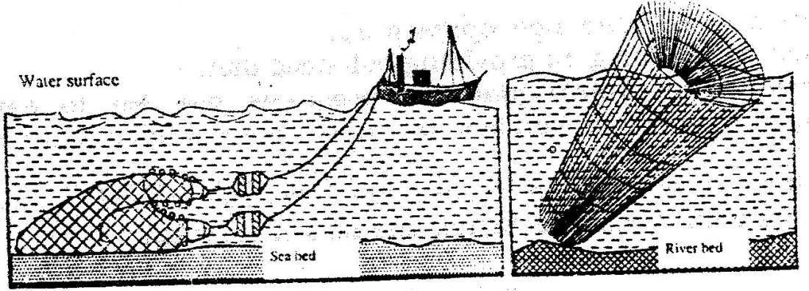
(b)

(iii) R – Trawling S – Basket fishing. (2mks)

(IV)
Basket fishing
- The basket funnel shaped to allow easy entry for fish
- At the mouth there is a non- return valve which restricts the outward/ escape movement of fish once inside the basket it is held in position with tropes/ stones/ sticks to prevent it from being swept downstream
- The basket is left in that position for sometime/ overnight then removed for landing the fish (3mks)
Trawling
- A bag – shaped net is attracted to a ship – trawler
- The nets mouth is kept open by otter boards/ head beam
- The upper part of the net is kept a float by corks/ floats
- Weights are used to keep the lower parts of the net at the seabed
- The trawler drags along the net
- After sufficient fish is caught, the net is hauled to the trawler. (4mks)

(c) Fishing is restricted to specific seasons to allow for breeding and maturing of fish
- The size if the nets used in fishing are standardized to ensure that fingerlings are not caught
- Licenses are issued to prospective fishermen to control their number and to ensure that there is no over fishing
- The law of the sea restricts fishing in the exclusive economic zones/ this ensure the protection of marines fisheries from external exploitation
- Fish farming is being encouraged to ensure that there is sufficient supply of fish from other sources other than the natural fisheries
- There is restriction of the water remain artificial fertilization is carried out is special hatcheries to sustain the supply of fish/ restocking of over fished waters. (6mks)
9.a)i)Tourism is the visiting of places of interest for e recreational purposes (1mk)
ii) The varied relief features.
- Wild animals
- Birds / flamingos
- Hot springs / Geysers / Fumaroles /Geothermal
- Vegetation
- People culture
- Pre- historic sites /Historical sites e.g. Kapenguria
- Mining sites
- Sports tourism e.g. fishing (2mks)
b) The roads leading tourist sites are poorly maintained. Discourages people
from visiting such sites.
- Inadequate local comparing and advertisement of tourist attractions/ special packages leads to low public awareness.
- Familiarity with the tourist attraction among the local people makes them fail to appreciate their beauty and value
- Negative attitude towards local tourism limits the number of people who engage in tourism.
- Insecurity from gangsters/ poachers in national parks and game reserves scare people away from visiting them.
- The high cost of accommodation in the game lodges discourages local tourism / the high cost of hiring tourism vehicles discourages people from touring / low income. (8mks)
c) Illegal hunting / poaching of wild game threatens the conservation efforts leads
to the extinction of some species of animals.
- Overstocking of some wild animals leads to destruction of natural environment through over-grazing.
- Frequent drought experienced in some of the nation parks and reserves leads to loss of animals through starvation and death.
- Staying wild animals from the parks to settlement leads to destruction / high cost of fencing.
- Inadequate capital limits government conservation efforts / over reliance on foreign donor.
- Rapid human population growth leads to the encroachment of games parks and reserve.
- Pollution of the environment leads to death of wild animals.
- Fire outbreaks destroy wildlife. (6mks)
d) Favourable climate; with warm sunny summer which allow swimming and sun bathing and cold winters which encourages winter sports such as skiing.
- The varied scenery consisting of snow – capped mountains, cascading waterfall and glaciated landscape provides varied tourist attraction which are lacking in other parts of Europe make the country easily accessible from the other European countries.
- Political neutrality of Switzerland removes any travel restrictions to the country as a tourist destination.
- Diversity of languages spoken in Switzerland makes it possible for tourist to communicate and move around the area.
- Well- developed transport network tourist sites provide easy accessibility.
- Advanced training in tourist industry enables Switzerland to provide the necessary services to tourist thus attracting more to the country / package tours services offered e.g. hotels.
- Availability of health resorts.
- Inherent hospitality of Swiss people encourage tourist to visit Switzerland.
- Well-developed financial institutions (Banks) have promoted easy transaction, hence encouraging tourist to Switzerland.
- Switzerland is HQ of several international agencies; this has lead to the influx of delegates to the country later turn to tourist. (8mks)
10. a) (i)
- Petroleum /oil
- Natural gas
- Uranium
- Coal/peat (2mks)
(ii)
- Presence of large volume of water from a river /Lake / large catchments area to provide water to drive the turbines
- Regular / constant supply of water to ensure continuous generation of power
- Hard basement rock to provide a firm foundation for the construction of a dam
- Provide space for reservoir
- Non-porous rock to prevent seepage. (8mks)
b)
    - It filters silt to save the other dams which are down stream
    - It provides a fishing ground for the local communities
    - It provides water for domestic use.
    - It is a tourist attraction/reaction
    - The dam provides a link role river Tana.
    - Water for irrigation
    - Provides employment
    - Non-exhaustible/ renewable.
    - Lean to use / non-pollutant
    - Relatively heap
    - Easy to use
    - Adjustable to any fraction of energy using transformers
    - Convenient to use in a variety of ways. (3mks)
c)
      - It would encourage setting up of industries in the rural areas thus stimulating decentralization of industries.
      - It would reduce the cutting down of trees and electricity would be available for domestic use
      - It would attract/improve social amenities in rural areas reducing the need for people to move to urban areas.
      - Most people would invest in the rural areas, which would lead to higher standards of living.
      - It would encourage development of horticultural farming / to have ideal storage of perishable of products. (6mks)
d)
- It leads to closure of some industries
- It led to unemployment /redundancy/early retirement of workers.
- It led to an increase in the cost of electricity / purchase and use of generators
- It led to power rationing. Which slowed down rate of production. (2X3=6mks)

