LONDIANI SUB-COUNTY MOCK.
312/2 FORM 4 GEOGRAPHY PAPER 2 SEPT 2022 TIME: 2$\frac{3}{4}$ HRS
NAME……………………….………………………………ADMIN NO……….CLASS……
INSTRUCTIONS
- The paper comprises of two sections A & B
- Attempt all the questions in Section A
- In Section B answer question 6 and any other Two questions.
- Use separate foolscap to answer questions.
SCORE SHEET

SECTION A

QUESTION 6

QUESTION 7

QUESTION 8

QUESTION 9

QUESTION 10

TOTAL

SECTION A
Answer all questions in this section
- (a) What is a derelict land? (2 mks)
(b) State three causes of land dereliction. (3 mks)
- (a) State three problems facing coffee in Kenya. (3 mks)
(b) Outline two benefits of coffee farming in Brazil. (2mks)
3. a) Name two exotic breeds of dairy cattle reared in Kenya. (2mks)
b) State three physical conditions that favor dairy farming in Denmark. (3mks)
4. The table below shows petroleum production in thousand barrels per day for countries in the Middle East in April 2006. Use it to answer question (a)

Country | Production in ‘000”  Barrels
Iran  Kuwait  Qatar  Saudi Arabia  United Arab Emirates  Iraq | 3800  2550  800  9600  2500  1900

a) (i) What is the difference in production between the highest and the
lowest producer (1mk)
(ii) What is the total amount of petroleum produced in April 2006 in
the region? (1mk)
b) State three conditions that are necessary for the formation of petroleum. (3mks)
5. (a) State two reasons why some industries are located near the sources of
raw materials. (2mks)
(b) Give three characteristics of the cottage industry in India. (3mks)

SECTION B
Answer question 6 and any other Two questions from this section
6. The table below shows four principal crops produced in Kenya in the years 2000 - 2001. Use it to answer question(a) and (b).
CROP | AMOUNT IN | METRIC TONS
 | 2000 | 2001
Wheat | 70,000 | 130,000
Maize | 200,000 | 370,000
Coffee | 98,000 | 55,000
Tea | 240,000 | 295,000
Source: Central Bureau of statistics
a) (i) Using a scale of 1 cm to represent 50,000 metric tons, draw a
simple comparative bar graph based on the data above. (8mks)
(ii) State two advantages of using comparative bar graphs (2mks)
b) Calculate the percentage increase in wheat production between the years 2000 and 2001. (2mks)
c) State five physical conditions required for the growing of tea in Kenya. (5mks)
d) Explain four problems experienced in small scale tea farming in Kenya. (8mks)
7. a) i) What is forestry? (2mks)
ii) Explain three factors that favor the growth of natural forests on the slopes of Mt. Kenya. (6mks)
iii) State five factors that have led to the reduction of the area under forest on the slopes of Mt Kenya. (5mks)
b) Explain four measures that the government of Kenya is taking to conserve forests in the country. (8mks)
c) Give the differences in the exploitation of softwood forests in Kenya and Canada under the following sub-headings;
i) Period of harvesting; (2mks)
ii) Transportation (2mks)

- The map below shows some major fishing grounds in the world. Use it to answer question (a)
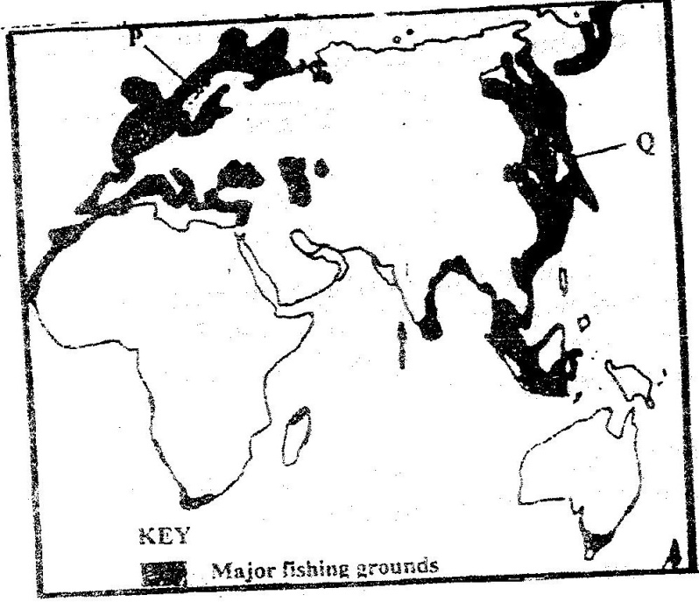

(a) (i) Name the countries marked P and Q. (2mks)
(ii) Explain four conditions that favor fishing in the shaded coastal waters. (8mks)
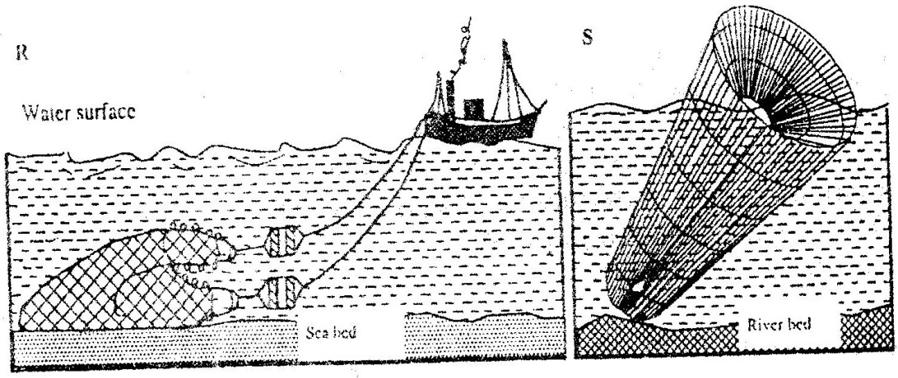
(b) The diagrams below represent some fishing methods

(i) Name the methods R and S. (2mks)
(ii) Describe how each of the two methods is used in fishing. (7mks)
(c) Explain three measures used to conserve fish in Kenya. (6mks)

9.a) (i) Define the term tourism. (1mk)
(ii) Name two tourist attraction found in the Rift valley province of Kenya. (2mks)
b) Explain four factors which hindered the development of domestic tourism in Kenya. (8mks)
c) Explain three problems experienced by the Kenya government in its effort to conserve wildlife. (6mks)
d) Explain four factors which have made Switzerland a major tourist destination in Europe. (8mks)
10. a(i) Name two non – renewable sources of energy. (2mks)
(ii) Explain four physical factors that influence the location of a hydroelectric power station. (8mks)
b) A part from generating H.E.), give three other benefits that have resulted
from the construction of Masinga Dam. (3mks)
c) Explain three benefits that would result from rural electrification in Kenya. (6mks)
d) In what three ways did the power shortages resulting from the
drought of the years 1999 and 2000 affect the industrial sector in Kenya. (6mks)

