312/2
ENGLISH
PAPER 2
MARKING SCHEME
MARCH 2021

THE KENYA NATIONAL EXAMINATION COUNCIL
KENYA CERTIFICATE OF SECONDARY EDUCATION
GEOGRAPHY
PAPER 2

COORDINATED MARKING SCHEME
(CONFIDENTIAL)

QUESTI  ON  ITEM | QUESTION | POSSIBLE RESPONSES | JUSTIFICAT  ION FOR  RESPONSES
1.(a) | What is dairy farming | Dairy farming is the practice of keeping animals for milk  | Award if  cattle
(b) | State two physical conditions that favour dairy farming in Kenya | High to moderate rainfall of about 500-2500mm per year or constant supply of water from rivers   Deep well drained fertile volcanic loamy soils for pasture growth   Cool/warm to moderately hot conditions with temperatures ranging between 10-29⁰c  Continuous availability of natural pastures   Gently sloping landscape which can be adulating 
2(a) | Differentiate between fishing and fisheries | Fishing is the exploitation of water resources while fisheries are water bodies that contain fish and other resources of interest that merit fishing  
2b | Give reasons why fishing is being encouraged in Kenya | Create job opportunities within the fishing sector and other related sectors like filleting industry, fertilizer making transport   Farmers sell fish from the farms to earn income  Fish farming is one way of diversifying the countries economies cushioning it from economic shock waves  Fish farming utilizes small space of land leaving land for other economic activities, suitable for ever reducing land sizes due to population increase   Fish farms are owned by individuals therefore practiced under proper land tenure systems this prevents territorial conflicts   Fish farms provide fish that is quality animal protein with low cholesterol preferred by many.   Fish from fish farms are exported to earn the country foreign exchange   Fishing activities on farms have promoted other related industries like net making, transportation Hotels   In malaria prone areas, fish farming is encouraged since it feeds on mosquito larvae, stopping lifecycle of malaria  It’s the best way of using waterlogged swampy areas which would otherwise be useless   Large fish farms allow sport fishing   Majority of food leftovers in the homes, can be feed to fish this minimises food wastage   Timing or monitoring of fish maturity, can be done, there estimated time for harvesting can be determined 
3a | Apart from coal name two other nonrenewable source of energy | Natural gas   Petroleum/crude oil   uranium 
3b | Give three reasons why use of coal as an industrial fuel has declined | Coal is not eco-friendly, dirty and sooty   During its use, it produces greenhouse gases against the  Kyoto protocol leading to climate change   Industries are adopting new technology with engines which are more fuel efficient, lowering cost of production  Its continuous use completely depletes it, since very few countries has it   Its difficult and expensive to mine since mines are getting deeper 
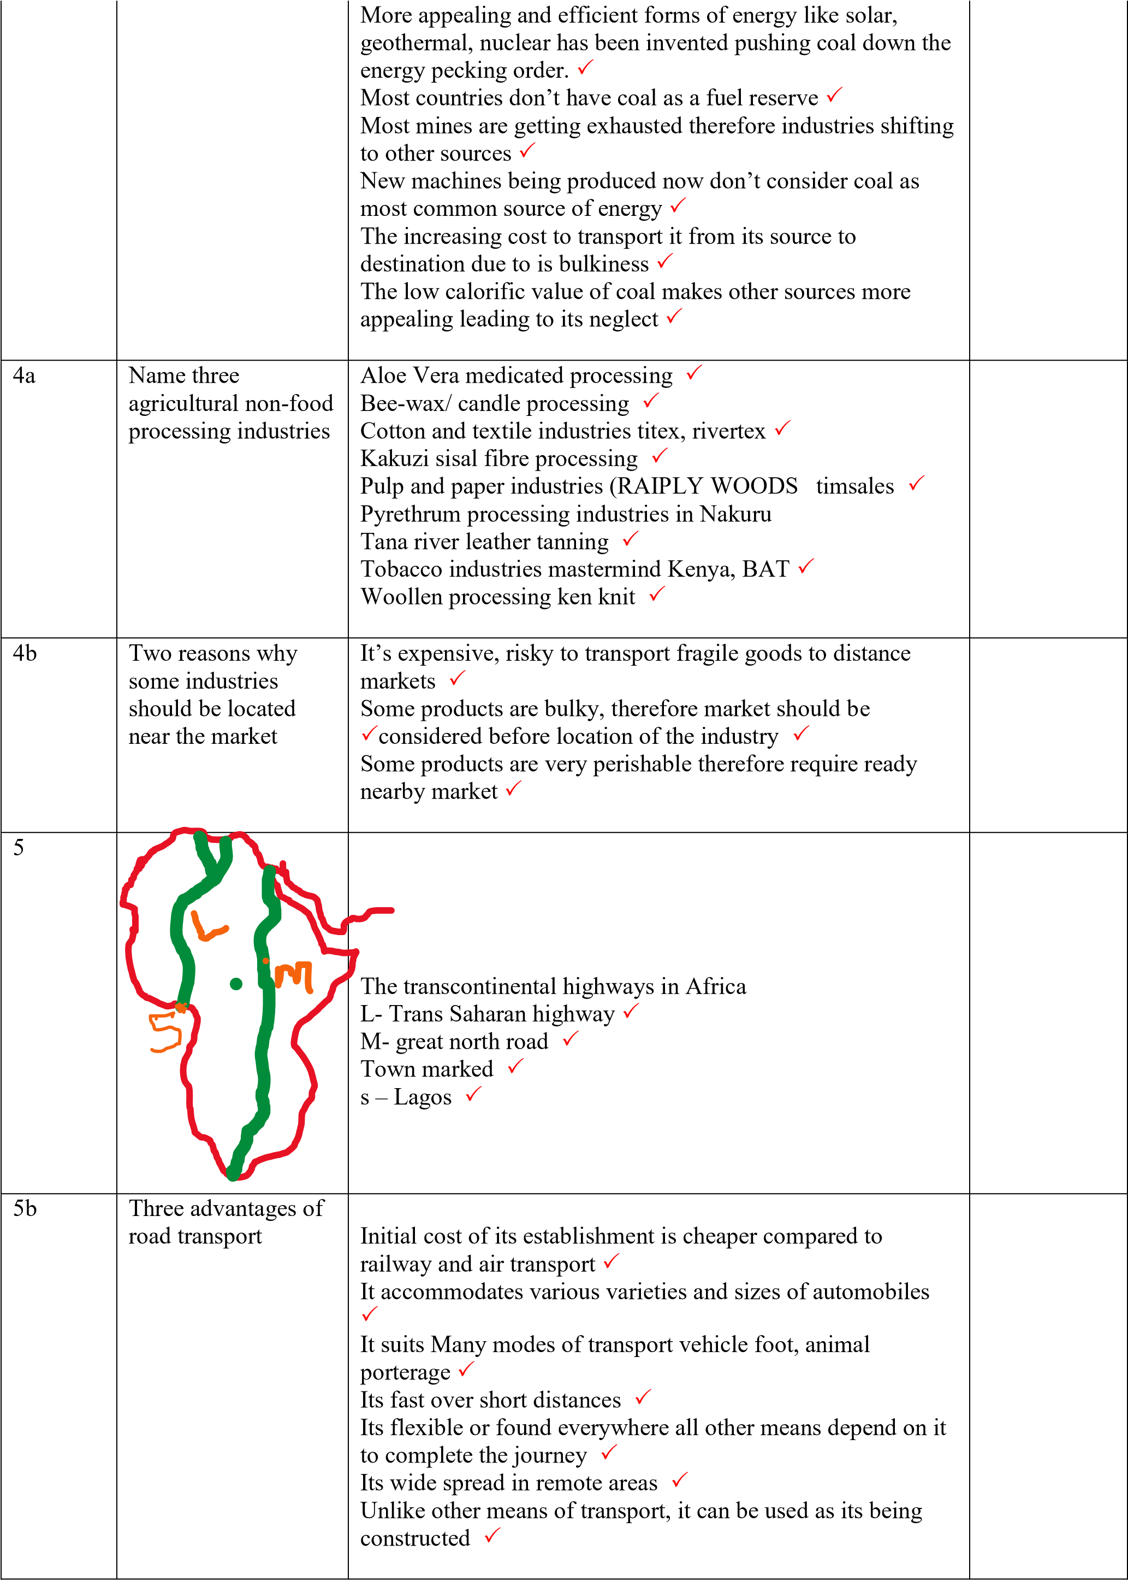
6a I) | The table below shows estimated production of selected crops in  Kenya
 |  | Crop |  | Producti on  number  of bags |  |  |  | Workings |  | Crop | Production number of bags | WORKINGS | workings
 |  | Maize |  | 3890000  0
 |  |  |  |  |  |  |  |  |  | Maize | 38900000 | 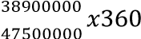 | 294.8211⁰  
 |  | Beans |  | 6100000
 |  |  |  |  |  |  |  |  |  | Beans | 6100000 | 6100000  47500000  𝑥  360 | 46.23158⁰  
 |  | Sorghu m |  | 1800000
 |  |  |  |  |  |  |  |  |  | Sorghum | 1800000 | 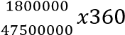 | 13.64211⁰  
 |  | Millet |  | 700,000
 |  |  |  |  |  |  |  |  |  | Millet | 700,000 | 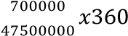 | 5.305263⁰  
 |  |  |  |  |  |  |  |  |  |  | 47500000
TITLE IMK CALCULATIONS
4MK
CORRECT SEGMENT
4MK
 |  |  |  |  |  |  |  |  | ESTIMATED PRODUCTION OF SELECTED CROPS IN KENYS IN 2013    294.8210526  46.23157895  13.64210526  5.305263158 |  |  |  |  |  | TITLE IMK CALCULATIONS  4MK  CORRECT SEGMENT  4MK
6(ii) | Apart from pie chart name two other statistical methods that can be used to represent the data |  |  |  |  |  |  | Compound bar graph  Divided rectangle  Proportional circles   Simple bar graph
6b | State the disadvantages of using pie charts to represent statistical data |  |  |  |  |  |  | From the pie chart its difficult to extract exact value of commodity if the total is not shown  Involves a lot of calculations taking time which could be used for answering other questions   Its difficult for a pie chart to show the changed in the trend of production   Its difficult to measure and represent small angles with decimal points 
It works on the agreed belief that any circle should be 360º which is a mathematical concept without giving reasons why its so 
Its only suitable when few segments are to be drawn but may be impossible to represent if they are very many The reasons are not given why the circle should be 5cm radius when other measurements are used segments are the same
6c | Explain how the following social factors influence agriculture |  |  |  |  |  |  |  |  |  |  |  |  |  | Rules invented by societies to regulate behaviour /property rights
 | Land tenure system |  |  |  |  |  |  | Community owned land has many restrictions in what the land should be used for, all set traditions must be followed  Land is used as security or collateral to loans to be used in farming which can only happen on fully owned land Land which if fully owned with title deeds can influence establishment of long-term farming projects like irrigation schemes, which cannot take place on land which is not fully owned   Land which is not fully owned most cases are poorly maintained in terms of soils fertility leading to low productions   Some land tenure systems prevent land subdivisions like leaseholds 
 | Traditions |  |  |  |  |  |  | Disasters like locust’s drought are believed to be traditionally castigated therefore traditional remedy is sort  It’s a taboo to plant some crops and rare some animals It’s a taboo to sell food stuffs you will be termed an outcast It’s a tradition to have many wives and children purely for labour  Some communities rely on animal labour during ploughing which may hinder when some are sick   Some traditional crops encourage monoculture   Some traditional festivals require certain foodstuffs which must be planted that year
 | Religious beliefs |  |  |  |  |  |  | Muslims belief that the pigs is unclean animal therefore its not reared or eaten   Muslims regard a cow as sacred therefore it is kept for this purpose not meat and milk  Some days of the week are holy days for some religions its set aside for worshiping not farm work this has delayed timely administration of agricultural practices like SDA,  MUSLIMS and protectants   Some religions are known to favour soya beans to replace tea because of its addictive nature   Some religious groups are vegetarians   There is a belief that crops do well not because of proper farming practices but because of the hand of GOD, this has necessitated giving tithes in some churches for farm produce  
6d | Give five problems facing plantation farming in Kenya |  |  |  |  |  |  | Common pests feed on crops lowering yields   Countries enjoying comparative advantage in production of some plantation crops export cheap products to Kenya local industries can’t compete   Diseased attack crops completely destroying them Fertile soils on which plantations grow encourages rapid growth of weeds which takes away nutrients High or excess rainfall/drought lowers yields Inadequate financial capital hinders important farm operations   Muddy impassable roads make transporting of products to the factory expensive   Plantation farming takes long on the farm using same nutrients year in year out exhausting the soil  Plantations like sugarcane are affected by fire outbreaks during dry seasons   Some plantations are attacked by frost in some seasons Some trade agreements in some regional trading blocks allows conditions that makes it difficult for some firms to make profit   Unstable conditions on the world market like price, terms of trade affect proper planning
7a) | Differentiate between forest and |  |  |  |  |  |  | Forest is continuous growth of trees and undergrowth covering large tract of land while forestry is the practice of developing and managing forest 
7a) |  | forestry
7b | Explain four factors influencing distribution of natural forest in  Kenya  8mks |  |  |  |  |  |  | Areas that receive high rainfall have continuous forest cover than areas receiving low intermittent rainfall which have scattered trees  Areas which are gazetted are heavily forested since trees grow without much human interference   Cool to warm moderate temperature conditions favour many forest tree species  Deep fertile well drained soils support growth of many tree species since they allow roots to penetrate deep into the ground than thin sandy soils   High demand for wood, timber posts has led to massive deforestation   Increase in population is putting more pressure on the amount o0fr land that should be cultivated for food and general settlement  Natural forest fires caused by lightening, honey harvesters destroy forests   Prolonged drought sometimes trees fail to completely recover when rain season resumes   Saline soils support very few tree species because of complicated physiographic process like the mangroves  Very steep slopes are covered by trees since steep slopes don’t support human settlement   Wild animals too, are heavy consumers of trees they break them down for food, this deplete s trees  |  |  |  |  |  |  | Give all factor ranging from physical human,  cultural
7b) | Name three hard woods |  |  |  | types | of ks |  | Angiosperms   Deciduous  Evergreen  |  |  |  |  |  |  | Unless the questions asked students to
7b) |  |  |  |  | 2mar |  |  |  |  |  |  |  |  |  | Unless the questions asked students to
 |  |  |  |  |  |  |  |  |  |  |  |  |  |  | give examples
 | Examples |  |  |  |  |  |  | Bamboo   Camphor   Coconut   Ebony   Elgon teak   Eucalyptus   Jacaranda   Mangrove   Meru oak   Mohagony   Nandi flame   Rosewood   Sapele   Umbrella tree 
7c | Give four characteristics of coniferous forests |  |  |  |  |  |  | Majority of the trees are softwoods   Mature trees produce cones with waxy barks   Most of the trees are evergreen few deciduous   Most trees have straight trunks   Most trees have very shallow roots   Species occur in pure stands   The general shape of the trees is conical shape   The trees have narrow needle like leaves   The trees have thick barks   Tree have no undergrowth due to resin   Trees take long to mature   Trunks and branches are flexible to allow snow fall |  |  |  |  |  |  | 1x4
7d | Explain four factors that have led to decline of the area under forest cover in  Kenya |  |  |  |  |  |  | Elephants are heavy feeders their increase in population can clear substantial part of forest   Emerging new diseases which require alternative drugs and management strategies   Government policy of gazettement has allowed settlement and cultivation in the forested area  Human population pressure on land and forest resource has led to decline of this area   Illegal logging of trees has led to clearing some parts of forest  Overexploitations for firewood and timber has led to extinction of some species   Prolonged drought makes trees to die 
8(a) | Define the term wildlife |  |  |  |  |  |  | These are plants and animals existing in its natural habitat  
8(ii) | Name three animals that are members of the big five in Kenya |  |  |  |  |  |  | Buffalo  Elephant  Leopard  Lion  Rhino
8(b) | Explain ways in which human  activities interfere with wildlife |  |  |  |  |  |  | Clearing of bushes, burning reduces wild animal pasture making most of them to starve to death  Excess water stored for irrigation interferes with natural flow and wildlife downstream
Excessive exploitation of fisheries resources interferes with growth of fish some extinct 
Forests is often cleared for settlement and agriculture Game parks allow domestic grazing which often depletes pasture meant for wild species 
Industries use rivers to dispose industrial wastes often pollute aquatic environment killing majority of water-based animals
Mining activities are known to destroy soils and vegetation
Overfishing may extract young fish which leads to depletion of some marine river ponds and lacustrine fish resources Vegetation is destroyed through cutting of trees for timber or wood 

8c | Explain three effects of adverse climatic conditions on wildlife in Kenya |  |  |  |  |  |  | Climate change leads to flooding which destroys river lake and marine habitats aquatic animals are displaced takes time to stabilize   Climatic change in temperature levels makes some plants to completely shift altitude-wise where they re-establish themselves   Fire outbreaks caused by lightening destroys thousands of hectors of vegetation displacing birds, killing animals.  Flash flood in desert region are know to cause massive erosion than buries animals in sand  Hailstone occurrence are known to destroy leaves, kill thousands of birds and small animals  Persisted temperature inversion in valley’s causes frost which interferes with growth of trees  Prolonged drought lead to acute shortage of pasture some animals die while others migrate to other safer areas  Prolonged drought makes some plants to die some fail to recover leading to their extinction  Strong winds like harmattans are known to break and uproot trees 
8d | Explain four ways in which wild animals are of significant to the economy if  Kenya |  |  |  |  |  |  | Desire for proper accessibility in our wildlife areas has led to massive construction of roads airstrips which have opened up the interior  Park entry fees is a source of revenue to county and national governments   Some wildlife products like wood, skin bones are important raw materials for industries   Wild animals are major tourist attractions which earns the country foreign exchange this raises living standards Wild life in privately owned game ranges are slaughtered for game meat, at times exported, and sold in hotels to earn income   Wild life related tourist activities promote other sectors of the economy like sportfishing, agricultural sector due to demand for food   Wildlife provides avenues for scientific research which  improve the knowledge sphere on wildlife  Wildlife provides the best alternative use of would otherwise be waste marginal land profitably
9(a) (i) | Name three imports to Kenya |  |  |  |  |  |  | Crude oil  Electronics 
Fertilizers 
Foot ware/shoes
Furniture 
Iron and steel
Machinery and machines 
Motor vehicles 
Paper 
Pharmaceuticals
Rubber/tyres 
Textiles 
9(a)ii | Give measures Kenya has taken to reduce unfavourable balance of trade |  |  |  |  |  |  | Adopt ISO standardization procedures on goods earmarked for exports   Carry out massive import substitution processes Create more avenues foe invisible trade like tourism technology and service industry   Create new trade partners that massively complement each other’s disparity in resources   Establish commercial attachés on external to carry out massive campaign, and advertisement in search of new markets for Kenyan products   Establish export processing zones  Improve efficiency, in the transportation networks to cut down in the cost of production internally  Insist on importation of capital goods   Insist on manufacturing of quality exports products that withstand competition on world market   Intensify diversification of economic avenues of export producing industries   Limit importation of luxury products that don’t add value in the production chain, impose high tax.   Massive integration of technology like computerised run systems, robots for 24hr nonstop labour free production Reduce taxation on raw materials to make goods oriented export market   Venture in the production of goods that our country enjoys massive comparative advantage in their production 
9(b) | Explain three factors that influence  internal trade in  Kenya |  |  |  |  |  |  | Agro-based trade is heavily affected by weather conditions which breaks down chain of distribution   Culture insists on production of same goods for cultural satisfaction neglecting other goods this reduces market diversity   Global pandemics like corona outbreak limits internal travelling and purchasing power, and closure of some business   Government based stimulus packages, provision of per sector-interest free loan facilities more often boost trade  Low purchasing power of Kenyan population limits production of some goods   Making available all forms of capital, financial, human, technological, and mechanical on local market   Similarity in goods produced induces competition leaving the market potential un-utilized   Transportation networks may limit or enhance movement of goods to and from the market, this narrows the market 
 |  |  |  |  |  |  |  | Various government policies like 100% tax submission and declaration, long process of acquiring business permits hinder trade 
9(c)(i) | Identify two countries in east Africa that are  members of common market for eastern  and southern Africa  (COMESA) |  |  |  |  |  |  | Kenya   Uganda 
9(c)(ii) | State four objectives of economic community of west  African states  (ECOWAS) |  |  |  |  |  |  | Develop and promote transport and communication links like roads railways to facilitate movement of goods and people   Harmonize economic and financial policies Promote social political interactions and mutual development  To coordinate matters meaningful research and adopt sustainable policies   To create economic and monetary union   To eliminate useless traded barriers and regulate sustainable ones   To promote developments and social integration  To promote trade among member states 
9(d) | Explain three ways in which member states have benefited from formations of regional trading blocs in Africa |  |  |  |  |  |  | Agro based trade has really benefited from ready market of agricultural products this has boosted agriculture sector Common market created within the trading blocs have provides access to variety of good which would otherwise be unavailable   Enhanced trade among member states expanding markets for locally produced goods   It has helped to reduce tariffs on goods produced by member states.   Promoted industrial development by availing raw materials and market for finished good  Trading blocs has allowed countries to specialize depending of who enjoys the highest comparative advantage 
10 | Use the map of east Africa below to answer questions (a)i and a(ii)
(a)(i) | 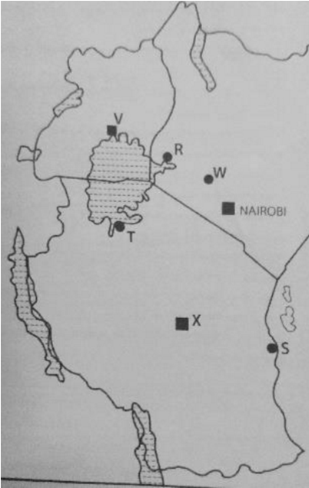 |  |  |  |  |  |  | The ports marked RS and D  R-Kisumu  - Dar-es Salam   - Mwanza
(a) (ii) | Towns marked VWX |  |  |  |  |  |  | V-Kampala w- Nakuru x -Dodoma 
10 b | State five functions of Thika town |  |  |  |  |  |  | Administrative centre   Agricultural collection centre 
It an industrial centre 
It’s a religious centre 
It’s a residential town
It’s a transportation and communication centre 
It’s an educational centre
Recreational centre 
Trading and commercial centre 
10c | Explain three ways in which the port of Mombasa is similar to Rotterdam |  |  |  |  |  |  | Both handle containerized cargo which ensures that good s have temper proof seals  Both ports are characterised by rich extensive hinterland which help countries collect a lot of revenue   Both ports are located on deep natural harbours suitable for large vessels   Both ports have modern facilities with spacious harbour that enables it to handle large quantities of exports and imports  Mombasa port is located at the mouth river Mwachi, while Rotterdam is located at the mouth of river rhine for fresh salt less water  The warm north Atlantic drift current, and the warm Mozambique current ensures the both ports are ice free therefore used all year round  Unique features in both ports provide tourist attraction avenues making them tourist destinations 
10d | Explain the positive effects of urbanization to a country |  |  |  |  |  |  | Create employment opportunities through trading  It provides market for industrial goods   People of different tribes’ nationalities meet at a point this boosts national interaction   Trading activities in urban centres help generate national revenue, and income to people   Transport routes constructed improve national accessibility from one town to another  Urban centres are markets for industrial good and agricultural goods   Urban centres develop social amenities which improves living standards 

