PHYSICS FORM THREE ASSIGNMENT
DECEMBER 2022
TOPIC 1
LINEAR MOTION
1. Sketch a velocity- time graph showing the motion of a ball vertically upwards with an initial velocity of u.
2. Calculate the acceleration shown by the tickers-tape that was made using a ticker timer vibrating at 50HZ.

A B C D E

3. What is the difference between speed and velocity?
4.A mass is projected horizontally from height of 5m above the ground with a velocity of 30m/s. Calculate:
a) The time taken to reach the ground
b) The horizontal distance traveled before hitting the ground
c) The vertical velocity with which the mass hits the ground
5. The data in the table below represents the motion over a period of 7 seconds

Time s | 0 | 1 | 2 | 3 | 4 | 5 | 6 | 7
D is m | 0 | 20 | 40 | 60 | 80 | 95 | 105 | 110
a) Plot on graph paper a graph of displacement (y-axis) against time.
b) Describe the motion of the vehicle for the first 4 seconds.
c) Determine the velocities at 4.5s and 6.5 s. Hence or otherwise determine the average acceleration of the vehicle over this time interval.
6. a) A body accelerates uniformly from initial velocity, U to the final velocity
V, in time t, the distance traveled during this time interval is S. If the acceleration is shown by the letter a, show that;
i) V= U + at ii) s= ut + ½ at² iii) V² =U² + 2 as
b) A body initially moving at 50m/s decelerates uniformly at 2m/s until it come to rest. What distance does it cover from the time it started to decelerate?
7. An object dropped from a height h attains a velocity of 6m/s just before hitting the ground, find the value of h.
8 The figure shows a speed-time graph for part of the journey of a motorcar.
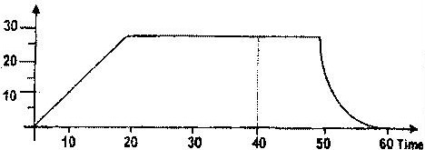

Determine the distance the car travels in the first 40 second
9. a) The figure below shows the displacement time graph of the motion of a
particle.
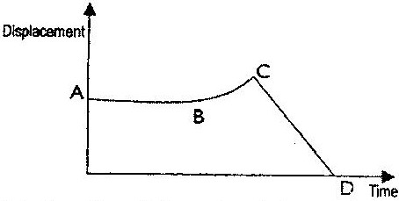

State the nature of the motion of the particle between:
i) A and B
ii) B and C
iii) C and D
Determine the total distance moved by the body. (3mks)
10 An airplane is flying horizontally over a camp at 250m/s and drops a pack. How far from the camp will the pack land if the plane was flying 300m above the ground
SECTION B
- An object is projected vertically upwards at a speed of 15ms⁻¹. How long will it take to return to the same level of projection? (2MKS)
- A bullet is fired horizontally from a cliff at a velocity 100ms-1. It takes 10 seconds to hit the ground.
- Sketch the graph of height against time for the motion (2mks)
- Calculate the height of the cliff (2mks)
- What is the horizontal distance moved form the cliff when the bullet hits the groun (3mks)
- Determine the velocity and direction with which the bullet hits the ground (2mks)
- The pattern below shows oil leakage on a path at the rate of 10drops per second form a lorry.

4m
0.5m

- Calculate the initial and final velocity (3mks)
- Calculate the acceleration of the lorry (3mks)
- Give one difference between limiting and dynamic forces of friction (1mk)
- The figure 7 below shows two blocks of masses M₁=1.5kg and M₂ = 2.0kg which are in contact with frictionless table surface.

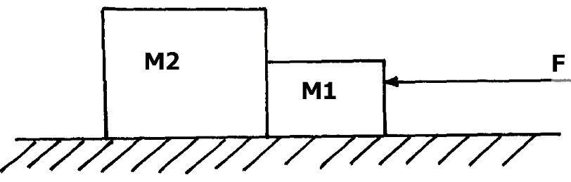

A force F=7N acts on the bodies, determine the force on mass M₂ (3mks)
- Distinguish between the terms ‘uniform velocity’ and ‘uniform acceleration’ (2mks)

- The figure below shows a section of a ticker tape. The dots were made at a frequency of 50 Hz.
Determine the acceleration of the trolley pulling the tape. (3mks)
- A bullet of mass 150g moving at an initial velocity of 80m/s strikes a suspended block of mass 2.5kg

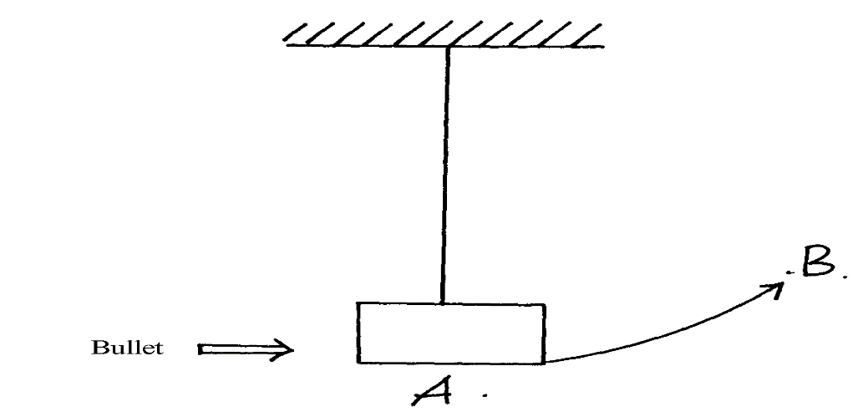

- If block swings from point A to B. Determine the vertical displacement between A and B (2mks)
- What observations are you likely to observe on the block after collision? (2mks)
- The figure below shows a car with a dummy driver before and after a collision test.
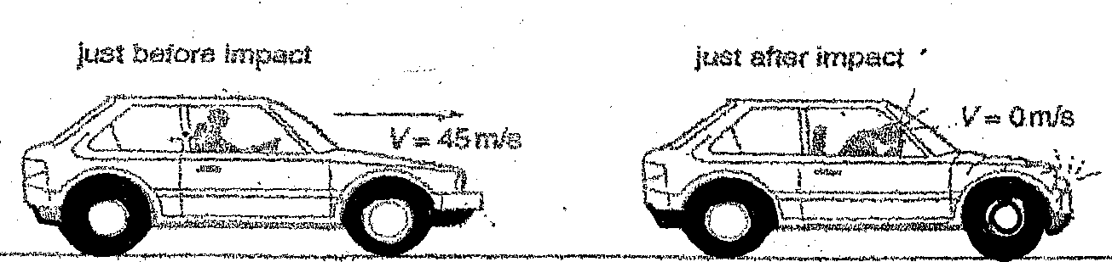

- The mass of the dummy driver is 90kg. The impact time to reduce the dummy’s speed from 45ms⁻¹ to zero is 1.2 seconds: (3mks)
- Calculate the average force on the dummy during impact. (3mks)
- State the main energy transformation during the collision . (3mks)
- Calculate how much of the dummy’s energy is transformed during the collision (3mks)

