FORM THREE
BIOLOGY
TIME: 1 HOUR.
NAME: ………………………………………………………………………
ADM NUMBER: ……………………………
Answer ALL the questions in the spaces provided.(30 marks)
1. Which two classes of phylum arthropoda have their head fused with the thorax? (2 marks)
……………………………………………………………………………………………………………………………………………………………………………………………………………………………………………………………………………………………………………………..
2. State three features that a grasshopper, a crab, a spider and a millipede have in common.
(3 mark)
………………………………………………………………………………………………………………………………………………………………………………………………………………………………………………………………………………………………………………………………………………………………………………………………………………………………
3. State two characteristics of Eukaryotes. (2 marks)
………………………………………………………………………………………………………………………………………………………………………………………………………………………………………………………………………………………………………………………
4. The diagram below represents a fern.
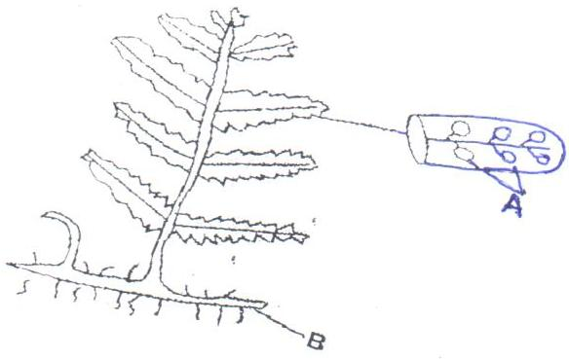

- Name parts labelled A and B. (2mks)
………………………………………………………………………………………………………………………………………………………………………………………………………………
- In which division does the plant belong? (1mk)
………………………………………………………………………………………………………
- State the function of the part labelled A. (1mk)
………………………………………………………………………………………………………

5. What is the importance of the following in an ecosystem? (2marks)
- Decomposers
…………………………………………………………………………………………………..
- Predation
………………………………………………………………………………………………………
6. (a) State two functions of bile juice in the digestion of food. (2marks)
………………………………………………………………………………………………………………………………………………………………………………………………………………………………………………………………………………………………………………………………………………
(b) How does substrate concentration affect the rate of enzyme action? (1mark)
………………………………………………………………………………………………………………………………………………………………………………………………………….
7. Name the features that increase the surface area of small intestines. (2marks)
………………………………………………………………………………………………………………………………………………………………………………………………………………………………………………………………………………………………………………………
8. (a) Define the following terms. (2marks)
- Population
………………………………………………………………………………………………………………………………………………………………………………………………………………
- Community
………………………………………………………………………………………………………………………………………………………………………………………………………………
(b) Name a method that could be used to estimate the population size of the following organisms.
- Fish in a pond. (1mark)
………………………………………………………………………………………………………
- Black jack in a garden (1mark)
………………………………………………………………………………………………………
9.Giving a reason in each case, name the class to which each of the following organisms belong: (4marks)
Pea plant
………………………………………………………………………………………………………
Reason
………………………………………………………………………………………........................
Bat
………………………………………………………………………………………………………
Reason
………………………………………………………………………………………………………
10.The diagram below represents a member of the kingdom Animalia.
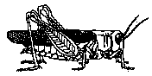
- Name the phylum to which the organism belongs. (1mark)
………………………………………………………………………………………………………
ii).Using observable features in the diagram, give three reasons for the answer in (i) above.(3marks)
………………………………………………………………………………………………………………………………………………………………………………………………………………………………………………………………………………………………………………………………………………………………………………………………………………………………

