GEOGRAPHY EXAM MID TERM
FORM THREE
TERM ONE 2021
NAME:…………………………………………………………………………
ADM NO…………………… CLASS………………………
- The table below shows the number of visitors in ‘000 to selected national parks in Kenya for the years 2006-2008.Use it to answer the questions that follows;
PARK/YR | 2006 | 2007 | 2008
Nairobi | 102 | 093 | 092
Amboseli | 153 | 156 | 082
Tsavo | 354 | 372 | 182
Lake Nakuru | 327 | 347 | 138
Total | 946 | 968 | 497
a)What is the difference in the number of visitors who visited the parks in 2006 and those in 2007?(1mk)

b) Calculate the percentage increase in the number of visitors who visited lake nakuru national park between 2006 and 2007.(2mks)

c) Draw a compound bar graph to represent the number of visitors to selected national parks in kenya. Use the scale of 1cm to represent 100,000 visitors. (10mks)

d) State two advantages of using compound bar graphs to represent geographical data (2mks)

- The table below shows the approximate population of four districts in central province in 1999.Use it to answer questions that follow.
District | population
Murang’a | 350,000
Maragua | 390,000
Nyandarua | 470,000
Thika | 650,000
Total | 1,860,000

- Using a radius of 5cm draw a pie chat to represent the data above (10mks)

B) Apart from pie charts, name two other statistical methods that can be used to represent data in the table (2mks)

C) Give three advantages of using a pie chart to represent data (3mks)

- What is forestry?(2mks)

- Explain four measures that the government of Kenya is taking to conserve forests in the country.(8mks)

- Use the map below to answer questions (a) and (b)
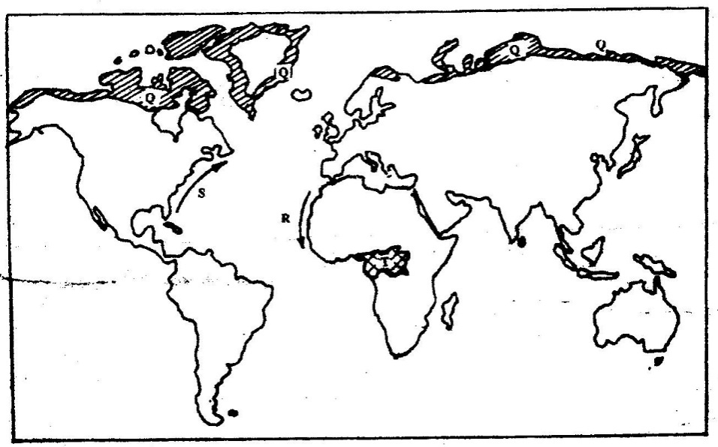

(a) Name:
(i) The type of climate found in the shaded area marked Q (1mk)

(b) (ii) Describe the characteristics of the type of climate found in the shaded area marked (9mks)

