**PANGANI POST MOCK EXAMINATION**

**2022**

**NAME:** ……………………………………..**ADM NO.:**………**CLASS** ………

**SIGNATURE**:…………………...**DATE**:………………TEACHER…………..

***121 /1***

***MATHEMATICS ALT A C .***

***C***

***TIME:***  ***HRS***

***Instructions to candidates***

1. *Write your* ***name*** *and* ***index*** *in the spaces provided above.*
2. *Sign and write the date of the examination in the spaces provided above.*
3. *The paper contains* ***TWO*** *Sections:* ***Section I*** *and* ***Section II.***
4. *Answer* ***ALL*** *the questions in Section I and* ***Only five*** *questions from* ***Section II****.*
5. *All answers and working must be written on the question paper in the spaces provided below each question.*
6. ***Show all the steps in your calculations, giving your answers at each stage in the spaces below each question.***
7. *Marks may be given for correct working even if the answer is wrong.*
8. ***Non-programmable*** *silent electronic calculators and KNEC Mathematical tables may be used except where stated otherwise.*
9. *This paper consists of* ***15*** *printed pages.*
10. ***Candidates should check the question paper to ascertain that all the pages are printed as indicated and that no questions are missing.***
11. *Answer all the questions in English.*

***FOR EXAMINER’S USE ONLY***

***SECTION I***

|  |  |  |  |  |  |  |  |  |  |  |  |  |  |  |  |  |
| --- | --- | --- | --- | --- | --- | --- | --- | --- | --- | --- | --- | --- | --- | --- | --- | --- |
| ***1*** | ***2*** | ***3*** | ***4*** | ***5*** | ***6*** | ***7*** | ***8*** | ***9*** | ***10*** | ***11*** | ***12*** | ***13*** | ***14*** | ***15*** | ***16*** | ***Total*** |
|  |  |  |  |  |  |  |  |  |  |  |  |  |  |  |  |  |

|  |
| --- |
|  |

|  |  |  |  |  |  |  |  |  |
| --- | --- | --- | --- | --- | --- | --- | --- | --- |
| ***17*** | ***18*** | ***19*** | ***20*** | ***21*** | ***22*** | ***23*** | ***24*** | ***Total*** |
|  |  |  |  |  |  |  |  |  |

***SECTION II***

***Grand***

***Total***

**SECTION I** (50 marks)

*Answer* ***all*** *questions in this section in the spaces provided*

1. All odd numbers from  are arranged in descending order to form a number.

(a)(i) Write the number (1 mark)

(ii) Write the total value of the second digit of the number formed in (a) (i) (1 mark)

(iii) Express the value of the number in (a) (ii) as a product of its prime factors in power form.

(2 marks)

1. A shopkeeper bought a bag of sugar. He intends to repack the sugar in ,  and . Determine the least mass in grams of sugar that was in the bag. (3 marks)
2. Given that  and  without using tables or calculator find  correct to 4 significant figures. (3 marks)
3. Evaluate  (3 marks)
4. Using the grid provided below, solve the simultaneous equation (3 marks)

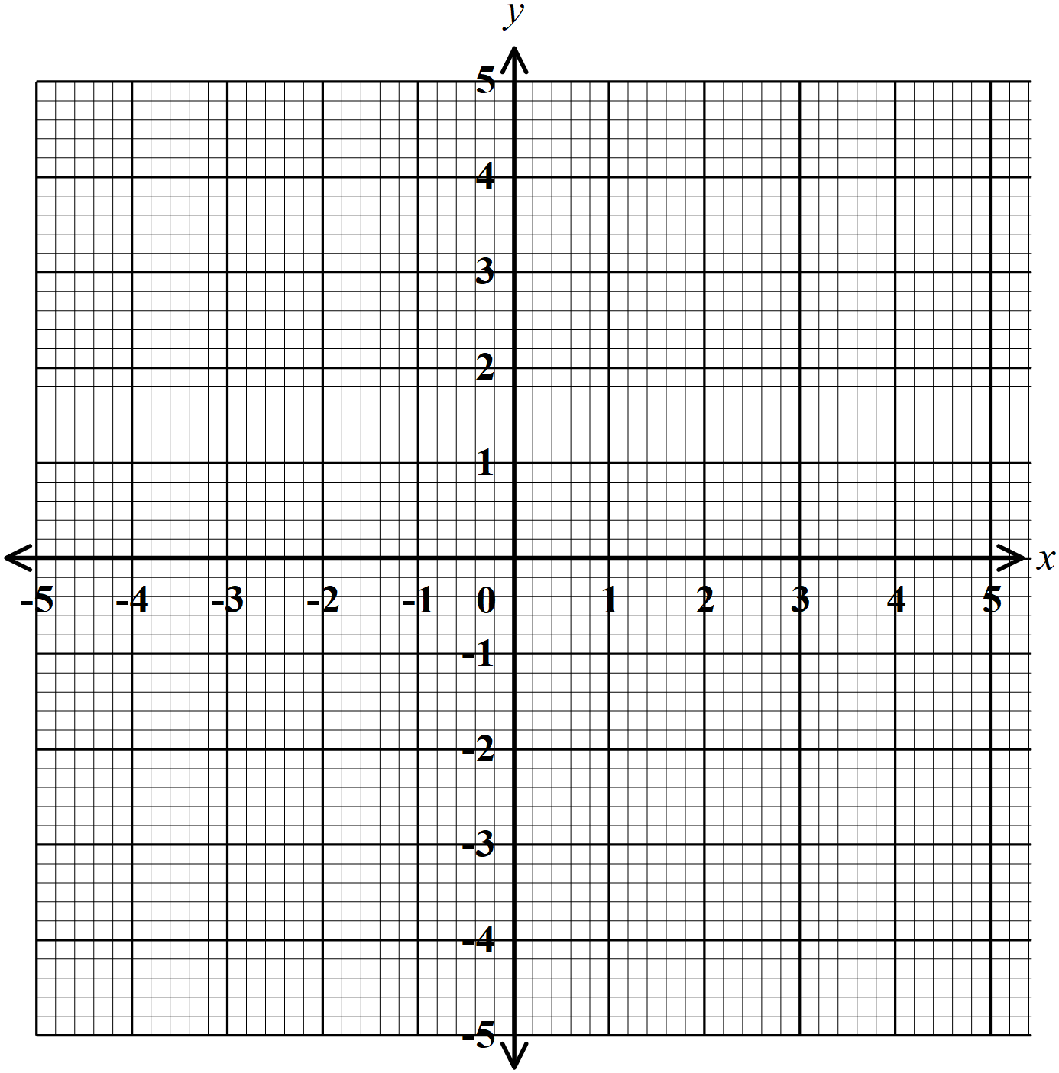

1. Given that a chord of length subtends an angle of  at the circumference of the circle. Calculate the radius of the circle. (3 marks)
2. When a shopkeeper sells articles at , he makes a  profit on the cost price. During a sale, he reduced the price of each article to . Calculate the percentage profit on an article sold at the sale price. (3 marks)
3. The size of one interior angle of an irregular polygon is . Each of the other interior angles is . Find the number of sides of the polygon. (3 marks)
4. Simplify  (2 marks)
5. Given the inequalities 

(a)Solve the inequality (3 marks)

(b)Represent on a number line (1 mark)

1. The diagram below represents a right rectangular based pyramid of 5 cm by 4 cm. The slant edge of the pyramid is 6 cm. Draw and label the net of the pyramid. (3 marks)

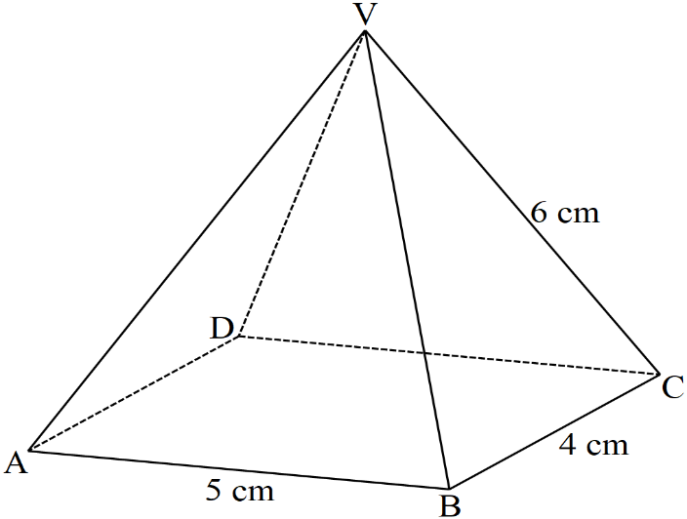

1. Vectors ,  and . Show that points A, B and C are collinear.

(3 marks)

1. Find the period , amplitude and phase angle of the function  (3 marks)
2. Simplify  (3 marks)
3. Write the following ratios in ascending order , ,  ,  (3 marks)
4. Under an enlargement, the image of the points  and  are  and . Find the centre and scale factor of enlargement. (4 marks)

**SECTION II** (50 marks)

*Answer* ***only five*** *questions in this section in spaces provided*

1. A straight line passes through  and .

(a)Find the length of line  (2 marks)

(b) Find the equation of the perpendicular bisector of line , leaving the equation in the form

 (4 marks)

(c) Determine the equation of line parallel to line  and passes through point , leaving

your answer in double intercept form. Hence state the  intercept. (4 marks)

1. The marks scored by 30 students in test were recorded as follows



1. Starting with the class , make a frequency distribution table for the data. (2 marks)
2. Using the frequency distribution in (a) above calculate :

(i) the mean (2 marks)

(ii) the median (3 marks)

1. Draw a frequency polygon to represent the data. (3 marks)

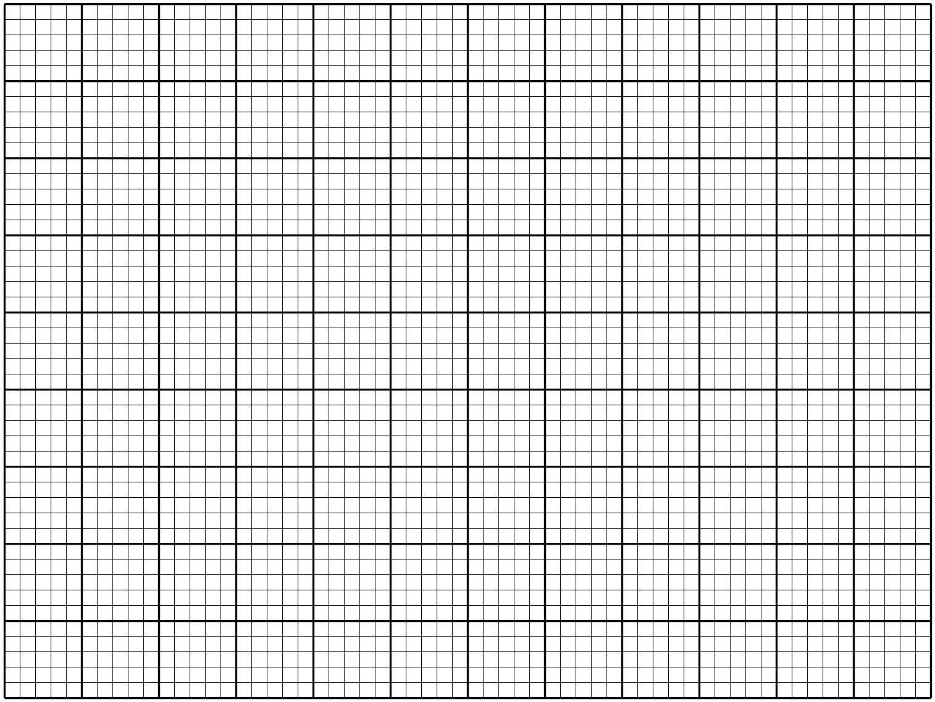

1. The solid below is made up of hemispherical part and a frustum of cone. The top and bottom radius of the frustum are  and  respectively. The vertical height of the frustum is .

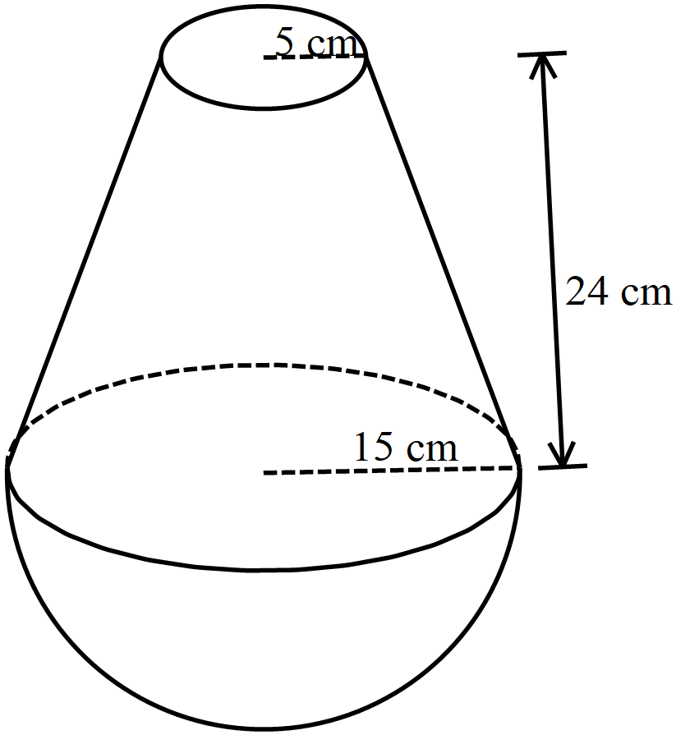

1. Determine the vertical height of the cone from which the frustum was cut. (2 marks)
2. Calculate
3. The volume of the solid correct to 2 decimal places (3 marks)
4. The surface area of the solid correct to 2 decimal places (5 marks)
5. (a) (i) Draw the graph of the function  for  (5 marks)



(ii) Use the graph to solve the equation (1 mark)

(b) Use the graph to solve the simultaneous equation  and  (3 marks)

(c) Write down the quadratic equation which the line  is solving. (1 marks)

1. The diagram below shows the speed time graph for a bus travelling between two stations, the bus starts from rest and accelerates uniformly for 75 seconds. It then travels at constant speed for 150 seconds and finally decelerates uniformly for 100 seconds.

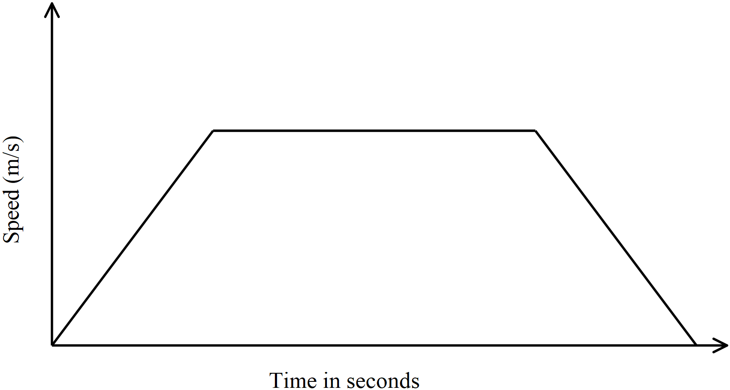

(a) Given that the distance between the two stations is . Calculate

(i) maximum speed in attained by the bus. (3 marks)

(ii) the acceleration of the bus (2 marks)

1. A van left Nairobi at 8.30 a.m and travelled towards Mombasa at an average speed of

. At 8.30 am a car left Nairobi and travelled along the same road at an average

speed of .

(i) Calculate the distance covered by the car to catch up with the van. (4 marks)

(ii) Find the time of the day when the car caught up with van. (1 mark)

1. On the Cartesian plane below, triangle PQR has vertices P(2, 3), Q(1, 2) and R(4, 1) while triangle P’’Q’’R’’ has vertices P’’(-2, 3), Q’’(-1, 2) and R’’(-4, 1).

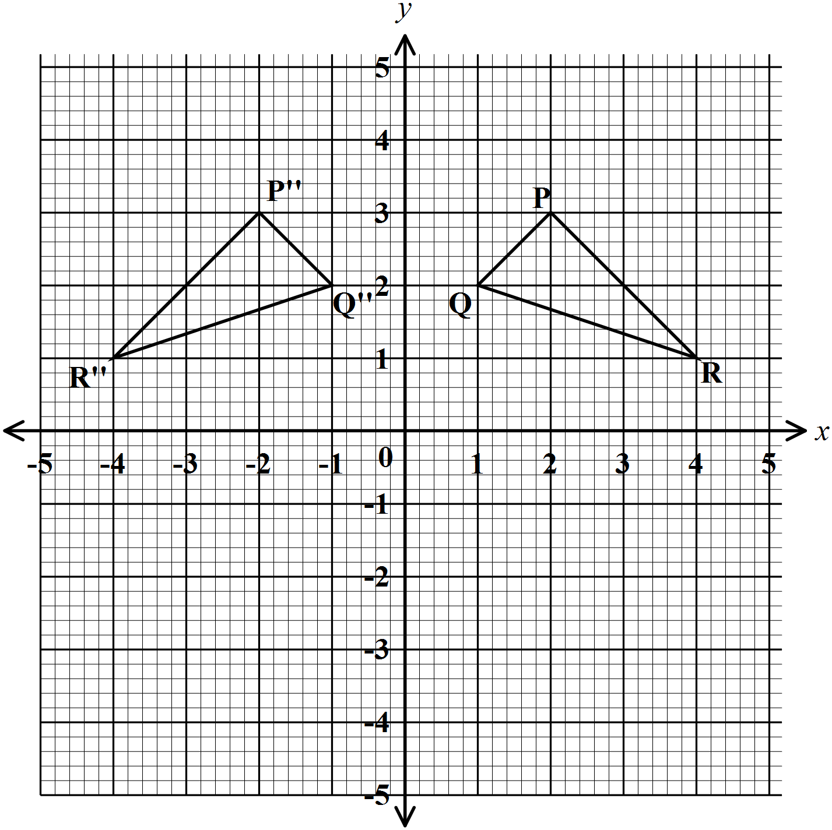

1. Describe fully the transformation which maps triangle PQR onto triangle P’’Q’’R’’.

(1 mark)

1. On the same plane, draw triangle P’Q’R’, the image of triangle PQR under a reflection in the line  (2 marks)
2. Describe fully a single transformation which maps triangle P’Q’R’ onto triangle P’’Q’’R’’ (2 marks)
3. Draw triangle P’’’Q’’’R’’’ such that it can be mapped onto triangle PQR by a positive quarter turn about (0, 0) (3 marks)

1. State a pair of triangles that is

i) oppositely congruent (1 mark)

ii) directly congruent (1 mark)

1. The equation of the curve is 

(a) Determine

(i) the stationary points (4 marks)

(ii) the nature of the stationary points in (a) (i) above (2 marks)

(b) Determine

(i) the equation of the tangent to the curve at  (2 marks)

(ii) the equation of the normal to the curve at  (2 marks)

1. The boundaries of ranch, ,  and  are straight lines such that is  from  and a distance of.  is due east of  and a bearing of  from .  is due south of and a distance of .

(a) Using a scale of **1 cm** to represent **10 km.** show the relative positions of .

(3 marks)

(b) From the scale drawing, determine

(i) the distance in kilometres between  and  (2 marks)

(ii) the bearing of  from  (2 marks)

(iii) the shortest distance from  to border  (1 mark)

(c) Calculate the area of the ranch in square kilometer. (2 marks)