PANGANI POST MOCK EXAMINATION
2022
MARKING SCHEME

PHYSICS
Paper 2
Time: 2 Hours

Instruction to Candidates
- Write your name, index number in the spaces provided above.
- Sign and write the date of examination in the spaces provided above.
- This paper consists of two sections: A and B.
- Answer all the questions in sections A and B in the spaces provided.
- All working must be clearly shown.
- Silent non-programmable electronic calculators may be used.
- Candidates should answer the questions in English.

For Examiners Use Only

Section | Question | Maximum Score | Candidate’s  Score
A | 1 – 12 | 25
B | 13 | 12
 | 14 | 12
 | 15 | 12
 | 16 | 9
 | 17 | 10
Total Score |  | 80

This paper consists of 12 printed pages, candidate should check the questions to ascertain that all pages are printed as indicated and that no questions are missing

SECTION A 25 MARKS
Answer all the questions in the spaces provided.
- The figure below shows a ray of light incident on a mirror at an angle of 45º. Another mirror is placed at an angle of 45º to the first one as shown. Sketch the path of the ray until it emerges. (2 marks)
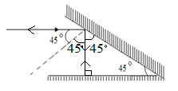
1 mark for all angles
1 mark for all correct rays and direction
- The figure below shows a transverse stationary wave along a string.

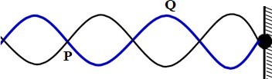
Name P and Q and explain how each is formed. (3 marks)
P – Node Q – Antinode
Nodes are formed due to destructive interference while antinodes are formed due to constructive interference.
- The diagrams below show a positively charged acetate strip and a negatively charged polythene strip freely suspended and isolated.

Two rods X and Y are brought up in turn to these strips. X attracts the acetate strip but repels the polythene strip. Rod X does not repel either the acetate or the polythene. State the type of charge on
each rod.
X Negative charges (1 mark)
Y Neutral (1 mark)

- The figure below shows how magnets are stored in pairs with keepers at the end. Explain how this method of storing helps in retaining magnetism longer (1 mark)

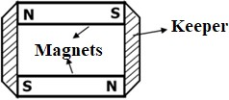
Keepers are magnetized through induction creating magnets with opposite polarity. These creates loops through which magnetic field flows.
- The diagram below shows waves generated from a tuning fork. If the wave takes 0.1 second to move from point A to B. determine the frequency of the wave. (3 marks)

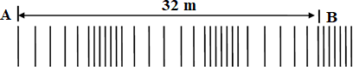
2.5 = 32
1 = $\frac{1×32}{2.5}$
$$λ=12.8m$$
V= $\frac{32}{0.1}=320m/s$
f = $\frac{V}{λ}=320×\frac{2.5}{32}$=25Hz

- In the figure 9 and 10 below, sketch a graph for each to show the variation of voltage with time as displayed on a CRO screen. (2 marks)
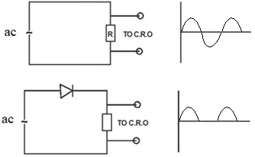
The gaps must be equal
- Other than current state two other factors that affect the magnitude of force on a current carrying conductor placed in a magnetic field. (2 marks)

Length of the conductor within the magnetic field
Magnetic field strength
Angle between the conductor and magnetic field lines

- Concave mirrors are used by dentists to examine teeth. By use of a ray diagram show how this is achieved. (2 marks)
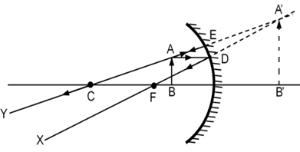

1 mark for all correct rays and direction
1 mark for the virtual image.
- A student connected the set up below in the laboratory. Explain the observation made on the bulb when the set-up below is taken to a dark room (2 marks)
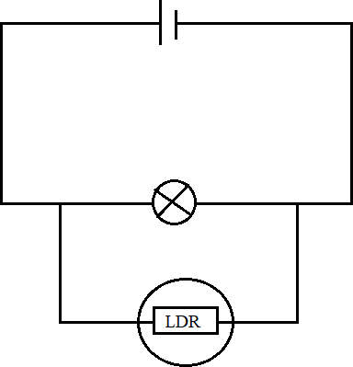
Brightness of the bulb increases.
The resistance of the LDR increases when the intensity of the light increases this causse more current to flow through the bulb.

- The figure below shows a fully charged capacitor
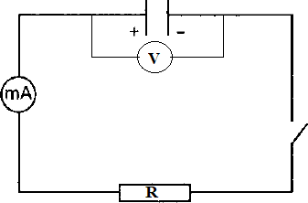
  - State the observation made on the voltmeter when the switch is closed. (1 mark)
The reading decreases to zero.

  - State the function of resistor R (1 mark)
To increasing the time discharging. To slow down the rate of discharging by reducing the amount of current flowing
- Calculate the maximum number of 100W bulbs that can be safely connected to 240V in a circuit fitted with 13A fuse. (2 marks)
Power = VI
= 240×13
No. Of bulbs = $\frac{240×13}{100}$
= 31.20
= 31 bulbs

- The figure below part of electromagnetic spectrum.

Identify radiation A and state its source. (2 marks)
Microwaves – Magnetrons/ Maser

SECTION B 55 MARKS
Answer all the questions in this section in the spaces provided.
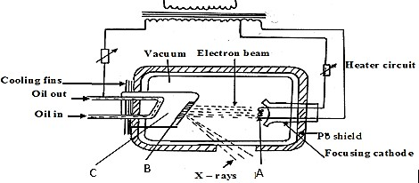
- (a) The figure below shows a modern X-ray tube
  - Name the part labelled C (1 mark)
Anode / copper anode (deny copper)
  - State the property of the material labelled B on the diagram which makes it suitable for use in the X-ray tube. (1 marks)
High melting point
  - Why is C inclined at an angle of 45º? (1 mark)
To direct x rays out of the tube through the window
  - State the adjustment that can be made to vary
    - The quality of X-rays (1 mark)
Varying the accelerating voltage (increasing / decreasing the accelerating voltage)
    - The quantity of the X-rays. (1 mark)
Increasing or decreasing (varying) the heating current at the cathode
  - Given that 99% of the energy of the electrons is converted into heat while the rest is converted into x-rays, determine the frequency of the x-rays produced given that the accelerating potential is 100KV (Plank’s constant = 6.63 x 10 ⁻³⁴ Js, e = 1.6x 10⁻¹⁹C)
(3 marks)
k.e = eV =hf
= 100000 × 1.6 × ${10}^{-19}$
= 1.6 × ${10}^{-14}$ J
$f=$2.413 ×${10}^{19}$Hz

- In a CRO, waveform given below was displayed on the screen when Y-shift was set at The sensitivity at the Y plate was10V/cm and time base set at 20 milliseconds/cm.
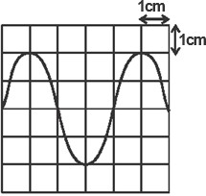

Determine:
  - peak voltage (2 marks)
= y- gain ×no. of divisions
=10v/cm…× 2cm
= 20V
  - frequency of the signal (2 marks)
T. base $= 4×20$
$$=80ms$$
$$=0.08$$
f$= \frac{1}{0.08}$
=12.5 Hz
86

- a)
88
226 𝑅𝑎
decays into 222 𝑅𝑛 by emission of an alpha particle. Write a nuclear equation

for the decay (1 marks)

${}_{88}^{238}{Ra }{}_{86}^{222}{Rn+}{}_{2}^{4}{He}$

b)
- What do you understand by the term half-life of a radioactive substance? (1 mark)

Time taken by radioactive substance to decay to/by half of its original mass.

- A G.M tube registers 20 counts. When a radioactive source is brought close to it, it registers 3220 counts and 120 counts 30 hours later. What is the half-life of this substance? (3 marks)
$$Initial = 3220-20$$
$$Final = 120-20$$
$$100=3200{\left(\frac{1}{2}\right)}^{\frac{30}{t}}$$
$${\left(\frac{1}{2}\right)}^{5}={\left(\frac{1}{2}\right)}^{\frac{30}{t}}$$
$$5=\frac{30}{t}$$
$$t=6 Hours$$
c) The figure below shows a G.M tube.

Anode Aluminium casing

Mica window

Argon gas mixed with little bromine

Scalar or ratemeter

- What is the purpose of the mica window? (1 mark)
To allow all radiations to penetrate

- Explain the purpose of the bromine (2 mark)

To absorb k.e of the ions hence preventing secondary ionisation

- Why should argon gas be kept at low pressure (1 mark)

For easier ionization / for faster ionization

- What is meant by the term “dead time” as used in GM tube (1 mark)

Time taken by positive ions to move from anode to cathode

- Briefly explain how GM tube works. (2 marks)

When the radiations enters through the mica window, argon gas is ionized and the positive ions move to the walls (cathode) as negative ions move to the anode. As the ions accelerate, they cause further ionization (secondary ionization) leading to avalanche of electrons which enables pulse current to flow and pulse voltage is registered across resistor R

- (a) State the Ohms Law (1 mark)
Current flowing through a conductor is directly proportional to the p.d across its end and provided that temperature and other physical conditions are kept constant.

- You are provided a rheostat, 2 cell, a voltmeter, an ammeter, a switch and a fixed resistor.
  - Draw a circuit diagram that can be used to verify Ohms law. (2 marks)

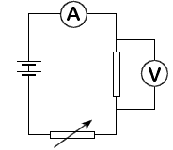

  - Describe how the above set up can be used to determine Ohms law. (4 marks)
  - Vary the voltage using the variable resistor and record the corresponding values of voltage and current
  - Repeat for several values of current and voltage and tabulate
  - Plot a graph of P.d against current.
  - The graph is a straight line with positive gradient. Showing that current through a conductor is directly proportional to the P.d across it.
- Study the circuit diagram below and answer the questions that follow.
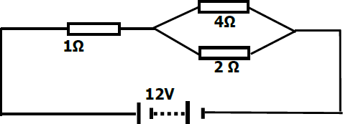
Calculate
- Determine the total resistance in the circuit. (2 marks)
$$R_{T}=R_{1}+\frac{R_{2}R_{1}}{R_{2}+R_{1}}$$

= 1+ $\frac{8}{6}$
= 2.333 Ω

- The current through the 4Ω resistor (3 marks)
$I_{T}$= $\frac{12}{2.333}$ = 5.150A
P.D = IR=6.849V
$I_{4Ω}=\frac{V}{R}\frac{6.849}{4}$ = 1.712A

- a) State Snell’s law (1mark)
The ratio of sine of angle of incidence to that of sine of angle of refraction is constant for a given pair of medium
- A ray of light travelling from water to glass makes an angle of incident of 30⁰. Find the angle of refraction in the glass. Refractive index of water = 4⁄3. Refractive index of glass

= 3⁄2
(3 marks)

$\frac{\sin{i}}{\sin{r}}$ = _{w}n_{g}
$\frac{\sin{30}}{\sin{r}}$ =$\frac{3}{2}$ × $\frac{3}{4}$
$\frac{0.5}{\sin{r}}$= $\frac{9}{8}$
Sin r =0.5$×\frac{8}{9}$
r = ${26.39}^{0}$

- State the necessary and sufficient conditions for total internal reflection to occur.
(2 marks)

- Light must move from an optically denser to optically less dense medium.
- The incidence angle in an optically denser medium must be greater than the critical angle

- The figure below shows a human eye defect.

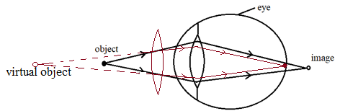
  - State one possible cause of this defect. (1 mark)

Longer focal length
Shorter eyeball

  - On the diagram, show how the defect is corrected. (2 mark)

- (a) State the Lenz’s law of electromagnetic induction. (1 mark)
The direction of induced e.m.f is such that the induced current that it causes to flow produces a magnetic effect which opposes the charge producing it

- A bar magnet is moved into a coil of an insulated copper wire connected to a zero centre galvanometer as shown below
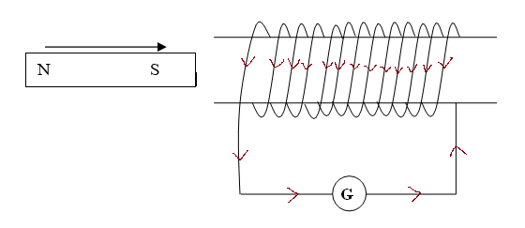
  - Show on the figure above the direction of the induced current in the coil
(1 mark)

  - State and explain what is observed on the galvanometer when the south pole of the magnet is moved into and then withdrawn from the coil. (2 marks)

The pointer deflects in one direction and comes back to zero. When magnetic fields cut through the conductor, emf is induced which makes the current to flow and the pointer deflect but comes back to zero when there is no relative motion between the coil and the magnet
- A transformer has 800 turns in the primary and 40 turns in the secondary winding.
The alternating voltage connected to the primary is 240V and current of 0.5.A. If 10% of the power is dissipated as heat within the transformer, determine the current in the secondary coil.
(3 marks)
$$\frac{N_{G}}{N_{P}}=\frac{V_{S}}{V_{P}}$$
$\frac{40}{800}$ = $\frac{V_{S}}{240}$
$V_{S}$ = $\frac{40+240}{800}$ = 12V
$\frac{V_{S}I_{S}}{V_{P}I_{P}}$ × 100 = 90
$I_{S}$ = $\frac{0.9 ×240 ×0.5}{12}$ = 9 A

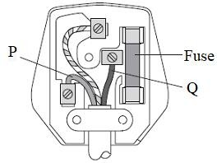
- The diagram below shows a three-pin plug.

- Name the colour of conductors P and Q (2 marks) P - Blue / Black
Q – Red / Brown

- Why is the earth pin longer than the rest in the three-pin plug shown above?
(1 mark)
To open the blinds
To earth the appliance before current start flowing

