COMPUTER STUDIES
PAPER 1
(THEORY)
2 ½ hours
SECTION A (40 MARKS)
1. What is meant by
a) Analogue data

b) Digital data (4mks)

2. Distinguish between transcription and transposition types of errors and give an
example of each (4mks)

3. a) what are peripheral devices? (1mk)

b) Give two examples of peripheral devices (1mk)

4 a) What meant by the term user-friendly as used in software development?
(1mk)

b) Distinguish between the terms single-tasking and multi-user as used in
operating systems (2mks)
5. What actions should be taken in case of a fire outbreak in the computer
laboratory? (4mks)

6 a) What is an Internet Service Provider? (1mk)

b) An employee in a business company is charged with the responsibility of
putting the company advertisements on the Internet.
- State the professional title of the employee. (1mk)

ii) Give an example of software used by this employee to carry out
the above task. (1mk)

7. Differentiate between COM ports and LPT ports (2mks)

8. Explain two ways in which ICT can enhance commerce. (2mks)

9. Explain the following software terms:
a) Portability (1 mk)

b) Modularity (1 mk)

10. a) State two application areas of a desktop publishing software. (2mks)

b) Explain the following graphic terms:
i) Rotate (1 mk)

(ii)Crop (1mk)

12. a) List two arithmetic operations that can be performed on a row of numeric
data in a word processing table. (1 mk)

b) In each case of (a) above, write the expression used. (2mks)

13. List two methods of gathering information during system development process.(2mks)

14. Name three types of optical disks. (3mks)

15. The diagram below shows a formatted plate surface of a storage disk.

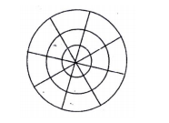
Shade and label:
(a)one sector ( 1mk)

b) One block

SECTION B (60 MKS)
Answer question 16 and any other three questions from this section in the space
provided
16. Study the flowchart below and answer the questions that follow
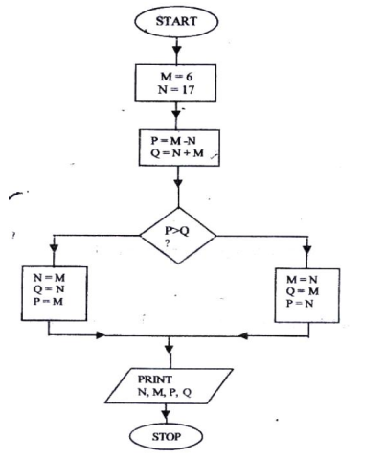

- Name the control structures used in the flowchart (2mks)

- Determine the values of M, N, P and Q. (4 mks)
M…………………………. N………………………...
P …………………………. Q ………………………
- Write the pseudo code for the flowchart (7mks)

b) List four functions of an assembler (2 mks

17. (a) Distinguish between the following sets of terms as used in spreadsheets.
(2mks)
- Worksheet and workbook

- Filtering and sorting

b) State one way in which a user may reverse the last action taken in a
spreadsheet package. (1 mk)

c) The following is a sample of a payroll. The worksheet row and column
headings are marked 1, 2, 3, and A, B, C. respectively
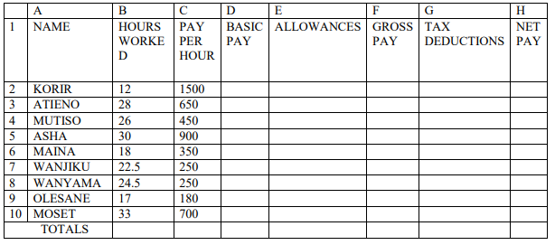

Use the following expressions to answer the questions that follow:
• Basic pay = hours worked x pay per hour

• Allowances are allocated at 10% of basic pay

• Gross pay = basic pay + allowances

• Tax deductions are calculated at 20% of gross pay

• Net pay = Gross pay – tax deductions.

Write formulae using cell references for the following cells;(5mks)
(i)D2

ii) E4

(iii)F10

(iv)G7

v) H5

d) i) State three ways of moving round the page in a Desktop Publishing
window. (3mks)

ii) State two ways on how information & Communication Technology (ICT)
can be used to reduce the spread of HIV/AIDS (2mks)

18.a) Describe the following terms with reference to security of data: (2mk)
(i) Log files

(ii)Firewalls

b) A student‟ database comprises of students‟ details table and fees received
table as shown below:
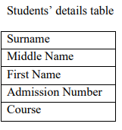

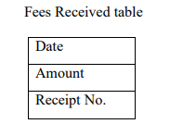

(i)State the primary key field for each table. (2mks)

(ii)State the field, which should serve as the linking field for the two tables

c) Describe the following terms with respect to computer security:
i) Logic bombs (2mks)

(ii)Physical security (2mks)

(iii)Tapping (2mks)

d) List three functions of antivirus software. (3mks

19. Define the following web related terms:
i) Web browser (1mk)

(ii)Hyperlink (1mk)

(iii)Hypertext document (1mk)

b) List six activities performed on the web (3mks)

c) Below is an email address:
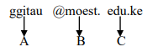
Name the parts labeled:
- A

- B

iii) C

20. A computer C directory has folders for form 1, form 2, Form 3 and form 4. Each
class has student‟s folders labeled according to their number. The students create
their own folder for the subject the are studying based on the table shown below
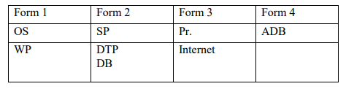
a) Assuming there is one student per class, draw the corresponding directory
tree structure. (6mks)

b) i) a form four student wants to create a folder to store her project.
State the path for that project folder. (2 mks)

(ii)Suggest how the student can ensure that

- Work is not lost in case the hard disk fails. (1mk)

- The project is not copied by other students. (1mk)

c) i). Other than I/O devices, list other three devices under the control of the operating system. (3mks)

ii) Explain any one of the devices named in C (i) above (1mk)

d) Define the term trouble shooting (1mk)

c) State and explain three ways that can be followed to replace the current
system (6mks

