NAME: ______________________________________ ADM NO: ____________CLASS:__________
DATE: ______________________________ SIGN: ______________________TARGET___________
AGRICULTURE
FORM 3
MID-TERM EXAM
TERM 1, 2024

INSTRUCTIONS: Answer all questions in the spaces provided (50 mks) TIME: 1 ¹/₂ HOURS

- State two methods of stocking a beehive. (2 mks)

- What term is used to describe a case where during parturition the hind legs come out first? (1mk)

- Give the two breeding system used in livestock improvement. (2 mks)

- Give any four advantages of artificial insemination. (2mks)

- State four methods of identification in livestock. (2mks)

- Define the following terms.
  - Flushing (1mk)

  - Crutching (1mk)

  - Ringing (1mk)

  - Raddling (1mk)

- State three methods of dehorning. (3 mks)

- State four uses of a crush in livestock production. (2mks)

- State three functions of the worker bee in a bee colony. (3mks)

- Give three methods of selection. ( 3mks)

- The diagram below illustrates a breeding management practice.

a) Identify the practice. (1mk)

b) Outline two reasons for carrying out this practice. (2mks)

- Define hybrid vigour as used in livestock production (1mk)

- Outline three disadvantages of artificial insemination in cattle management (3mks)

- Give any three reasons why bees swarm from a hive ( 3mks)

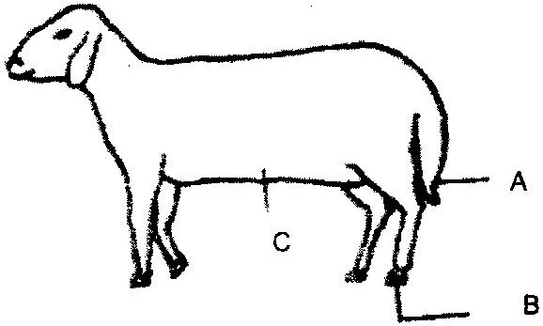
- Below is a diagram of a sheep with some parts labeled A, B, and C. Study the diagram and answer the questions that follow.

- What operation is usually carried out on the part labeled A during a sheep’s early stages of life? (1mk)

- Why is it necessary to carry out the operation in (i) above? (2mks)

- Which operation is usually carried out on part labeled B (1mk)

- Give four signs which indicate that a sow is about to farrow (2mks)

- State any four benefits of steaming up in livestock (2mks)

- Name four reasons for castrating male calves (2mks)

19. The diagram below shows a certain practice carried on pigs.
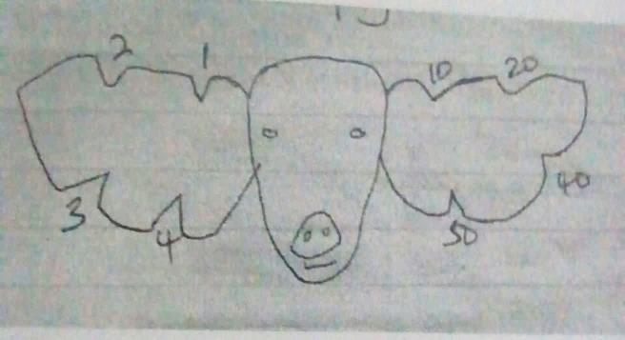
- Identify the practice (1mk)

- Name the tool used to carry out the practice above (1mk)

- State any other two methods of identifying piglets (1mk)

- State the number represented on the ears (1mk)

- Draw a sketch to represent an animal number 95 (2mks)

