NAME: ______________________________________ ADM NO: ____________CLASS:__________
DATE: ______________________________ SIGN: _________________TARGET________________
BIOLOGY
FORM 1
MID-TERM EXAM
TERM 1, 2024

INSTRUCTIONS: (Answer all questions in the spaces provided) TIME: (1 hour)

- Define the term biology 1mrk

- List and define the two major branches of Biology. 4mrks

- Give four importance of studying biology. 4mrks

- State the eight characteristics of living organisms 8 mrks

- How does nutrition differ in plants and animals? 2mrks

- The photograph below illustrates living organisms. Study it and answer the question that follow.
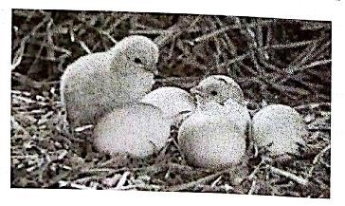
State two characteristics of living organisms illustrated in the 2mrks
Photograph

- Name the characteristic of living organisms illustrated by dressing heavily- 1mrk

- State five main differences between plants and animals. 10 mrks

Animals | Plants

- What is a hand lens? 1mrk

- List three use of the energy obtained from the process of respiration. 3mrks

- Motor vehicles move, use energy and produce carbon dioxide and water. Similar
characteristics occur in living organisms yet motor vehicles are not classified as
living. List other characteristics of living things that do NOT occur in motor
vehicles. 3mrks

- Give the functions of the following apparatus as used in biology. 6mrks
- Fish net;
- Pooter ;
- Bait trap;
- Pitfall trap;
- Pair of forceps;
- Specimen bottles;
- What do you understand by the term specimen 2mrks

- List three precautions made during collection and observation of specimen.
3mrks

