NAME: ______________________________________ ADM NO: ____________CLASS:__________
DATE: ______________________________ SIGN: _____________TARGET__________
BIOLOGY
FORM 2
MID-TERM EXAM
TERM 1, 2024

INSTRUCTIONS: Answer all questions in the spaces provided (50 marks) TIME: 1 ¹/₂ HOURS
- The diagram below represents a transverse section through a plant organ.

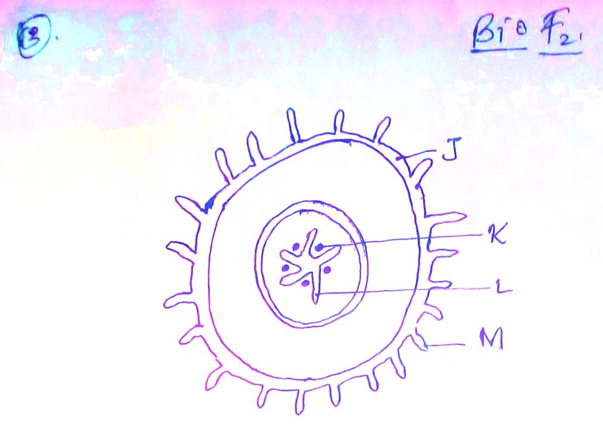

- From which plant organ was the section obtained. (1mark)

- Give two reasons for your answer in (a) above (2marks)

- Name the parts labeled J, K and L. (3marks)

- State two functions of the part labeled M. (2marks)

- Name the tissues in plants responsible for: (2marks)
- Transport of water and mineral salts

- Transport of manufactured carbohydrates

- State one adaptation of xylem vessels to their functions (1mark)

- State two ways in which the root hairs are adapted to their function. (2marks)

- State two primary roles of the stem (2marks)

- State the name given to the study of (2 marks)
(a) Micro-organisms ………………………………………………………………………………

(b) Classification …………………………………………………………………………...........

- State factors that affect the rate of transpiration in terrestrial plants.
(4 marks)

- Name three types of transpiration (3marks)

- State four forces that are involved in the transportation of water and mineral salts (4marks)

- Give three reasons why transpiration is significant in plants (3marks)

- Name the physiological process that requires energy and aids in absorption of mineral salts to the root cells (1mark)

- Name one tissue that is strengthened by : (2marks)
- Lignin
- Cellulose
- Name the organelle in plants that supports plant cells and is strengthened by cellulose (1mark)

- Draw and label a cross section of a dicotyledonous stem (5mks)

- How does leaf fall help to lower the rate of transpiration (2 marks)

- Name the process by which transport of substances take place in unicellular organisms (1mark)

- Name the two main functions of the root (2marks)
- What is the function of parenchyma tissue in plants (2mks)

- Form two students from Hightower Boys observed that the smell from a decomposing animal carcass was stronger at mid-day than early in the morning.
- Name the physiological process by which the smell reached the students (1mark)

- Give a reason for their observation (2marks)

