**NAME: _________________________________ADM NO: ________CLASS:__________**

**DATE: ______________________________ SIGN: _______________TARGET________**

**BIOLOGY**

**FORM THREE**

**MID-TERM EXAM**

**TERM 1, 2024**

**INSTRUCTIONS: (ANSWER ALL QUESTIONS) TIME: (1HR 30MIN)**

(1) Define the following terms used in ecology (4mks)

*(i)* Biosphere

*(ii)* Population

*(iii)* Synecology

*(iv)* Carrying capacity

2) Name the two main components of an ecosystem (2 mks)

3.In an attempt to estimate the numbers of weaver birds in small woodland 435 were captured, marked and released. Three days later, 620 were captured 75 of which were marked.

*a)* What is the name of the sampling method described above? (1mk)

*b)* Calculate the approximate size of the weaver bird population in the woodland.(2mks)

*c)* Give one disadvantage of this method. (1mk)

(4) state five abiotic factors affecting plants (5 marks)

(5) The following chart shows a feeding relationship in ecosystem.

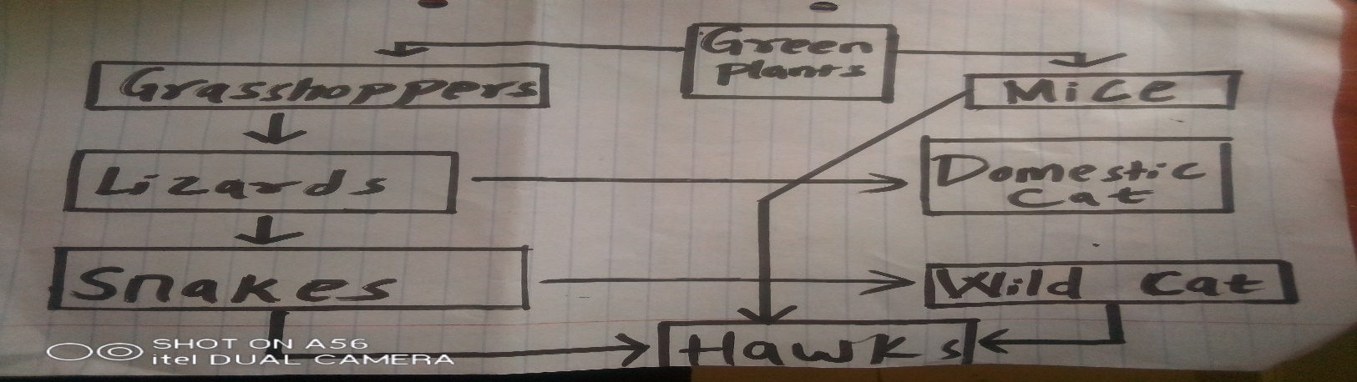

1. Construct two food chains ending with a tertiary consumer in each case. (2mks)
2. Which organism has the largest variety of predator in food web? (1mk)
3. Suggest three ways in which the ecosystem would be affected if there was prolonged drought. (3mks)

6)During an ecological study of a lake, a group of students recorded the following observations.

*(i)* Planktonic crustaceans feed on planktonic algae;

*(ii)* Small fish feed on planktonic crustaceans, worms and insect larvae;

*(iii)* Worms feed on insect larvae;

*(iv)* A bird species feeds on small fish, planktonic crustaceans, worms and large fish;

*(v)* Insect larvae feed on planktonic algae;

*(vi)* Large fish feed on small fish.

1. From this record of observations, construct a food web. (4 marks)

*(b)* From the food web, isolate and write down a food chain that ends with:-

*(i)* Bird species as a secondary consumer. (1 mark)

*(ii)* Large fish as a tertiary consumer. (1 mark)

1. Using the food web, identify three pairs of organisms that compete for food in the lake and for each case, name the food being competed for. (6 marks)
2. (i) State three ways by which human beings may interfere with this lake ecosystem.(3 marks)

6) Below is an example of a food chain.

Nappier grass Mouse Snake Hawk

*(a)* Identify the trophic level occupied by:

*(i)* Nappier grass (1mk)

*(ii)* Hawk (1mk)

1. What would happen if snakes are removed from the food chain? (2mks)

(7) i) The diagram below represents a simplified Nitrogen cycle

i) Name the following process A, B, C and E. (4mks)

ii) Name the organisms presented in I above (2mk)

(iii) Differentiate between food web and food chain. (2mks)

iv) Name the group of plants which promote process A take place (1mk)

v) State the part of the plant where process A take place (1mk