**NAME: ______________________________________ ADM NO: ____________CLASS:__________**

**DATE: ______________________________ SIGN: _____________TARGET__________**

**BIOLOGY**

**FORM FOUR**

**MID-TERM EXAM**

**TERM 1, 2024**

INSTRUCTIONS: (Answer all questions in the spaces provided) TIME: (1 Hour)

1. The diagram below shows a phenomenon which occurs during cell division. (3mrks)

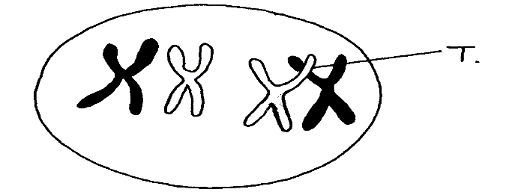

1. Name the part labeled T.

1. i) State the biological importance of the part labelled T.

ii) Identify the type of cell division in which this phenomenon occurs.

1. The calyx cells of a certain plant have 22 chromosomes.

State the number of chromosome present in the plant’s

i) Endosperm.

ii) Ovule cell. (2mrks)

1. Part of one strand of a DNA molecule was found to have the following base sequence.

G – T – C – A – G – T

1. What is the sequence on ; (2mrks)
2. complimentary DNA strand

1. m-RNA strand copied from this DNA portion?

(b) State two roles of DNA molecule. 2mrks

1. State three structural differences between ribonucleic acid (RNA) and deoxyribonucleic acid ( DNA) 3marks

|  |  |
| --- | --- |
| DNA | RNA |
|  |  |
|  |  |
|  |  |

1. Differentiate between;
2. Continuous and discontinuous variations. (2mrks)
3. Complete and incomplete dominance. (2mrks)
4. Members of the same species of organism tend to differ due to variation.

State three causes of variation in organisms. (3mrks)

1. In an experiment, a variety of garden peas having a smooth seed oat was crossed with a variety with a wrinkled seed coat. All the seeds obtained in the F1 had a smooth seed coat. The F1 generation was selfed. The total number of F2 generation was 7324.

Using appropriate letter symbols, work out the genotype of the F1 generation.

(4 mrks)

* 1. From the information above, work out the following for the F2 generation

|  |  |
| --- | --- |
| (i) Genotype ratio | ( 2 marks) |
|  |  |
| (ii) Phenotype ratio | ( 1 mark) |
|  |  |
|  |  |
| (iii) Wrinkled number | ( 1 mark) |
|  |  |

1. Describe the following chromosomal mutations . (2mrks)
   * + - 1. Inversion.
         2. Translocation
2. In human couples the sex of a baby is determined by the man. Explain this statement.

(1mrks)

1. What is meant by the term ; (2mrks)
2. Allele
3. Mutation
4. The table below is a representation of a chromatid with genes along its length. It undergoes

mutation to appear as shown below:

|  |  |  |  |  |  |  |
| --- | --- | --- | --- | --- | --- | --- |
| Before mutation | L | M | N | O | P | Q |
| After mutation | L | O | N | M | P | Q |

a) Name the type of chromosomal mutation represented . (1mrk)

b) Name one mutagenic agent. (1mrk)

1. Study the genetic chart below showing the inheritance of the gene responsible for haemophilia in a family.

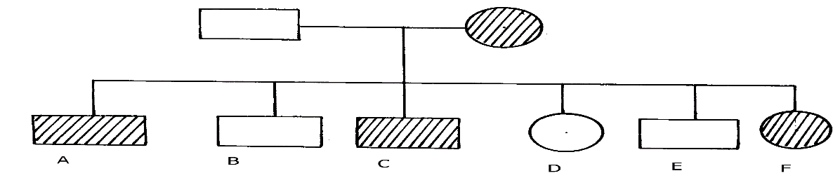

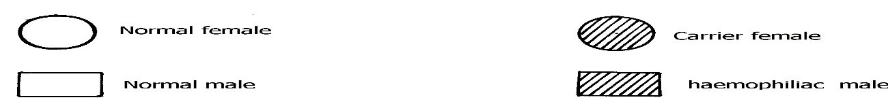

a) Write the genotype of individuals A, B, F 3mrks

b) A member of this family labelled F marries a haemophiliac male. What will be the phenotypic ratio of the offspring? Show your workings 5mrks

c) Other than the condition stated above, state any other two common genetic disorders that result from gene mutation. 2mrks

1. In man blood group inheritance is controlled by multiple alleles in which allele A is co dominant to allele B. a woman heterozygous for blood group A married a man heterozygous for blood group B. Using a punnet square, show the genotypes of F1 generation . (4mrks)

1. (i) What is non— disjunction? (1mrk)

(ii) Give one example of a genetic disorder associated with non-disjunction. (1mrk)