**BIOLOGY**

**FORM FOUR**

**MID-TERM EXAM**

**TERM 1, 2024**

**MARKING SCHEME**

1. **The diagram below shows a phenomenon which occurs during cell division. (3mrks)**

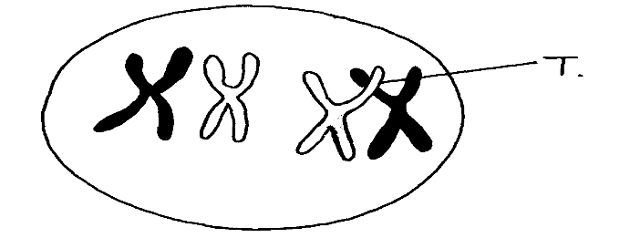

1. **Name the part labeled T.**

chiasma

1. **i) State the biological importance of the part labelled T.**

Leads to exchange of genetic information;hence variation

**ii) Identify the type of cell division in which this phenomenon occurs.**

meiosis

1. **The calyx cells of a certain plant has 22 chromosomes.**

**State the number of chromosome present in the plant’s**

**i) Endosperm** 33

**ii) Ovule cell** 11 **2mrks**

1. **Part of one strand of a DNA molecule was found to have the following base sequence.**

**G – T – C – A – G – T**

1. **What is the sequence on; 2mrks**
2. **complimentary DNA strand**

C-A-G-T-C-A

1. **m-RNA strand copied from this DNA portion?**

C-A – G – U – C - A ;

**(b) State two roles of DNA molecule. 2mrks**

Stores genetic information (in a coded form);

Enables transfer of genetic information unchanged to daughter cells through replication;

Translates genetic information into characteristic of an organism through protein synthesis;

1. **State three structural differences between ribonucleic acid ( RNA) and deoxyribonucleic acid ( DNA) 3marks**

|  |  |
| --- | --- |
| DNA | RNA |
| Double stranded | Single stranded |
| Has deoxyribose sugar | Has ribose sugar |
| Has thymine as one of the nitrogenous bases | Thymine is replaced by uracil |

1. **Differentiate between ;**
2. **continuous and discontinuous variations 2mrks**

continuous variation shows gradation in characteristic with intermediate from one extreme end to another; discontinuous shows distinct characteristics between organisms with no intermediate groupings;

1. **complete and incomplete dominance 2mrks**

Complete dominance is when an allele completely suppresses/masks the expression of another allele;

Incomplete dominance is when heterozygous organisms show an intermediate trait phenotypically;

1. **Members of the same species of organism tend to differ due to variation.**

**State three causes of variation in organisms 3mrks**

Genetic recombination’s of alleles reading to variations;

Independent assortment of chromosomes;

Random fusion of gametes; mutations;

Environment (may either enhance or suppress expression of a gene);

1. **In an experiment, a variety of garden peas having a smooth seed oat was crossed with a variety with a wrinkled seed coat. All the seeds obtained in the F1 had a smooth seed coat. The F1 generation was selfed. The total number of F2 generation was 7324.**
2. **Using appropriate letter symbols, work out the genotype of the F1** **generation.**

let s to represent gene for seed coat ( 4mrks)

Parental phenotypes smooth seed coat wrinkled seed coat

Parental genotype SS x ss

Gametes MUST BE CIRCLED

Fusion FUSION LINES MUST BE CONTINOUS

Offspring genotypes All Ss

1. **From the information above, work out the following for the F2 generation**

|  |  |
| --- | --- |
| **i) Genotype ratio** | **( 2 mrks)** |
| SS; 2 Ss; ss |  |
| **ii) Phenotype ratio** | **( 1 mrk)** |
| 3:1 |  |
| **iii) Wrinkled number** | **( 1 mrk)** |
| **¼ x7324= 1834 wrinkled seeds** |  |
|  |  |
|  |  |

1. **Describe the following chromosomal mutations . (2mrks)**
2. **Inversion;** is a type of chromosomal mutation where a chromosome break s at two places rotates1800 and rejoins**.**
3. **Translocation**when a section of one chromatid break off and becomes attached to another chromatid but of non- homologous pair
4. **In human couples the sex of a baby is determined by the man. Explain this statement.**

(1mrks)

The male gamete carries both the y-chromosome and the X-chromosomewhich combine with the X-chromosome from the female gamete to form XY (boy)or XX(girl)

1. **What is meant by the term; (2mrks)**
2. **Allele** Alternative form of a gene.
3. **Mutation** spontenous change in genetic make up of organism.
4. **The table below is a representation of a chromatid with genes along its length. It undergoes**

**mutation to appear as shown below:**

|  |  |  |  |  |  |  |
| --- | --- | --- | --- | --- | --- | --- |
| **Before mutation** | **L** | **M** | **N** | **O** | **P** | **Q** |
| **After mutation** | **L** | **O** | **N** | **M** | **P** | **Q** |

**a) Name the type of chromosomal mutation represented . (1mrk)**

Inversion ;

**b) Name one mutagenic agent. (1mrk)**

* Mustard gas;
* ionizing radiation;
* gamma rays;
* X- rays ;

1. **Study the genetic chart below showing the inheritance of the gene responsible for haemophilia**

**in a family.**

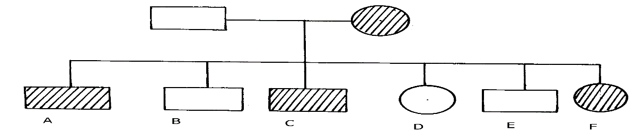

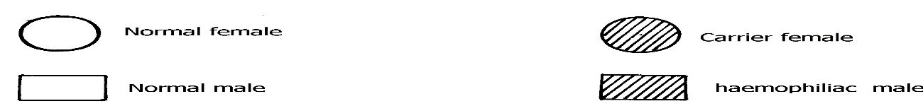

**a) Write the genotype of individuals A, B, F 3mrks**

A – XhY;

B – XHY;

F – XHXh;

**b) A member of this family labelled F marries a haemophiliac male. What will be the phenotypic ratio of the offspring? Show your workings 5mrks**

XHXh ; X XhY;

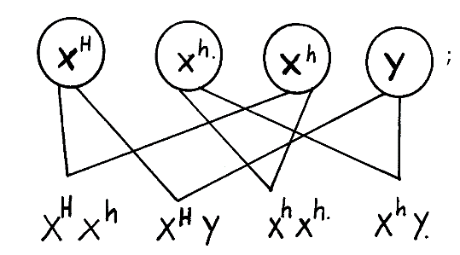

**c) Other than the condition stated above, state any other two common genetic disorders that result from gene mutation. 2mrks**

Albinism; sickle cell anaemia; colour blindness; chondrodystrophic dwarfism;

1. **In man blood group inheritance is controlled by multiple alleles in which allele A is co dominant to allele B. a woman heterozygous for blood group A married a man heterozygous for blood group B. Using a punnet square, show the genotypes of F1 generation . (4mrks)**

parental phenotypes woman blood group A Man blood group B

parental genotypes AO X BO

Gametes

|  |  |  |
| --- | --- | --- |
| Gametes | A | O |
| B | AB | BO |
| O | AO | OO |

Offspring genotypes AB,AO,BO,OO

1. **(i) what is non— disjunction? (1mrk)**

Type of chromosome abnormalitythat leads to addition or loss of one or more chromosomes.

**(ii) Give one example of a genetic disorder associated with non-disjunction. (1mrk)**

Klinefelter”s; Down”s syndrome