NAME: ______________________________________ ADM NO: ____________CLASS:__________
DATE: ______________________________ SIGN: _________________TARGET____________
CHEMISTRY
FORM 1
MID-TERM EXAM
TERM 1, 2024

INSTRUCTIONS: (insert instructions) TIME: (Insert time here)
- Define the following terms:
- Chemistry (2mks)

- Matter (1mk)

- Drug abuse (1mk)

- Name four career opportunities open to a chemist. (4mks)

- Name three frequently abused drugs. (3mks)

- Explain why most laboratory apparatus are made of glass. (2mks)

- Name three apparatus used for measuring volumes. (3mks)

- Name the function of the following apparatus. (2mks)
- Conical flask

- Boiling tube

- Draw a well labeled diagram of a Bunsen burner. (4mks)

- Give four differences between a luminous and non-luminous flame. (4mks)
Luminous flame | Non-luminous flame

- Name two safety rules in the laboratory. (2mks)

- Define:
- Sublimation (1mk)

- Chromatography (1mk)

11 (a). The following are laboratory apparatus used in Chemistry. Name them and give their uses.
Apparatus | Use
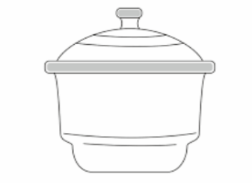 | 1mk
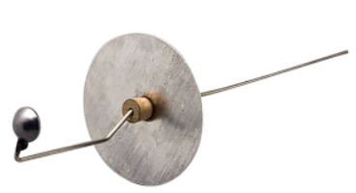 | 1mk

(b). Give two reasons why most laboratory apparatus are made of transparent glass. (2mks)

(b) Give the method used in separating the following mixtures (3mks)
- Sand and water…………………………………………….
- Petroleum from crude oil…………………………………
- Oil from groundnuts seeds……………………………….
12 (i) What is a flame? (1mk)

(ii). The following diagram represent a type of flame produced by a Bunsen burner.
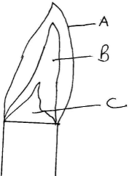

- Name the type of flame (1mk)

(b). The flame should be put off immediately after use or adjusted to another type of flame. Explain (2mks)

(iii). A wooden splint slipped through region B of the above flame laboratory. The splint was burnt as shown in the diagram below.
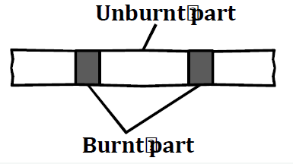
Explain why the splint was burnt the way it is shown in the diagram. (2mks)

13.(a)State two branches of chemistry (2mks)

(b)Define each of the following term (1mks) ii) Conductor

14.(a)Differentiate between a pure substance and a mixture (2Mks)

(b)State two factors that determine the choice of the method of separation of mixtures (2mks)

