NAME: ____________________________________ ADM NO: _________CLASS:________
DATE: ______________________________ SIGN: _______________________
CHEMISTRY
FORM TWO
MID-TERM EXAM
TERM 1, 2024

TIME: (1h 30min)

INSTRUCTIONS:
- Write your name and other details on the space provided above
- Answer all the questions in the spaces provided for each question.

- In the laboratory, there are two types of flames; with reasons, state which flame is used for:
- Heating………………………………………………………………………………………………………………………………………………………………………………………………………………………………………………… (1 mark)
- Lighting………………………………………………………………………………………………………………………………………………………………………………………………………………………………………………… (1 mark)
- Define the term drug abuse. (1 mark)
………………………………………………………………………………………………………………………………………………………………………………………………………………
- Shanty accidentally mixed iron fillings, iron (III) chloride crystals and sulphur powder. Describe how she would obtain each of the substances separately. (3 marks)
……………………………………………………………………………………………………………………………………………………………………………………………………………………………………………………………………………………………………………………………………………………………………………………………………………………………………………………………….
- Classify the following as either chemical or physical changes. (5 marks)
Process | Type of change
Electrical conductivity by copper wire
Rusting of an iron nail
Sublimation of iodine
Burning candle wax
Attraction of iron filings by a magnet
- Matter exists in three states. Describe how particles behave in each state according to kinetic theory of matter.
(a) Solid state: (1 marks)
………………………………………………………………………………………………………………………………………………………………………………………………………………
- Liquid state: (1 marks)
………………………………………………………………………………………………………………………………………………………………………………………………………………
- Gaseous state: (1 marks)
………………………………………………………………………………………………………………………………………………………………………………………………………………
- Solutions may be classified as strongly basic, weakly basic, neutral, weakly acid, or strongly acidic. The information below gives solutions and their pH values. Study it and answer the questions that follow.

Solution | pH value | Nature of solution
B | 0.5
C | 6
Classify the solutions in the table using the stated classifications. (2 Marks)

- Zinc reacts with dilute sulphuric (VI) acid to produce a colourless gas. Write an equation for the reaction. (1 mark)
………………………………………………………………………………………………………
(b) Describe a test for the colourless gas. (2 marks)
………………………………………………………………………………………………………………………………………………………………………………………………………………………………………………………………………………………………………………………
- (a) Name one natural source of water for a chemical industry. (1 mark)
………………………………………………………………………………………………………
(b) Kerosene is a hydrocarbon. Name the product of burning kerosene that is a liquid at room temperature. …………………………………………………………………… (1 mark)
(c) Metal Y can displace metal X from its oxide. Hydrogen can reduce the oxide of metal X. Metal X does not react with water, while metal Y reacts with water moderately. Metal Z reacts with explosively with water. Arrange the metals and hydrogen from the most reactive. (1 mark)
………………………………………………………………………………………………………
- The set-up below was used to prepare a gas Q.
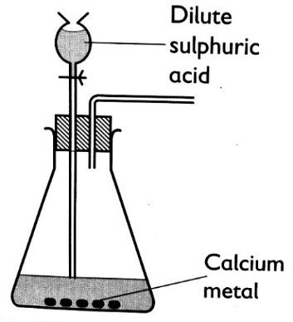
- Complete the diagram to show how a dry sample of gas Q may be collected. (2 marks)
- Give a reason why calcium is not the most appropriate metal for use in this preparation. (1 mark)
………………………………………………………………………………………………………
- Write an equation for the reaction for the formation of gas Q. (1 mark)
………………………………………………………………………………………………………
- Complete the key shown below for sub atomic particles.
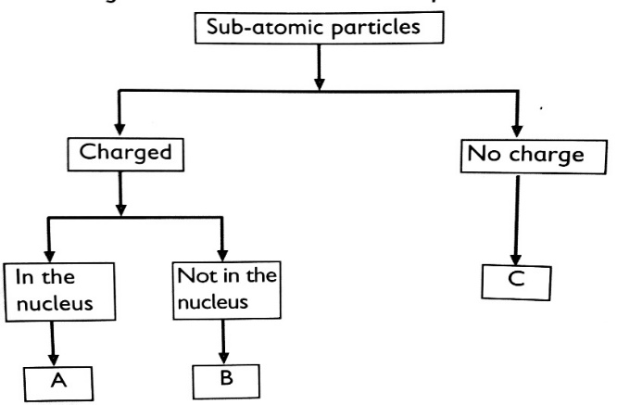
(3 marks)
Key
A …………………………………
B…………………………………
C …………………………………

- The relative atomic mass of element Y which consists of the isotopes ²⁰Y and ²²Y is 20.2. Calculate the percentage of the atoms in the isotopic mixture. (3 marks)

- The electronic arrangement of the ions of Q and R are given as follows: Q²⁺ = 2,8,8 and R⁻ = 2,8.
- Complete the table below: (2 marks)
Element | Group | Period
Q
R
- Write the formula of the product formed when Q and R react. (1 mark)
………………………………………………………………………………………………………
- The halogens are a group of non-metals in Group VII of the Periodic Table.
- Describe an experiment which shows that chlorine is more reactive than iodine. Include an equation in your answer. (3 marks)
………………………………………………………………………………………………………………………………………………………………………………………………………………………………………………………………………………………………………………………………………………
- State two observations made when warm sodium metal in a deflagrating spoon is lowered in a gas jar full of chlorine gas? (2 marks)
……………………………………………………………………………………………………………………………………………………………………………………………………………
- Write an equation for the reaction in (b) above. (1 mark)
………………………………………………………………………………………………………
- The following table gives the number of protons in the nucleus of some elements. The letters do not represent the actual symbols of elements. Use it to answer the questions that follow.
Element | E | F | G | H | I | J | K | L
Number of protons | 3 | 12 | 6 | 17 | 10 | 19 | 14 | 35
- Which elements belong to the same group of the periodic table? (2 marks)
………………………………………………………………………………………………………
- How will the reactivity of element F compare with that of element K? Explain. (2 marks)
………………………………………………………………………………………………………………………………………………………………………………………………………………
- The atomic numbers of elements X and W are 11 and 16 respectively.
- Write the electronic arrangements of the elements. (1 mark)
Element X……………………………………
Element W…………………………………
- Predict the type of bonding in the product formed if elements W and X were to be reacted. Give the formula of the resulting compound. (2 marks)
Type of bond……………………………………
Formula of compound ………………………
- The table below show the physical properties of some substances. Use it to answer the questions that follow.
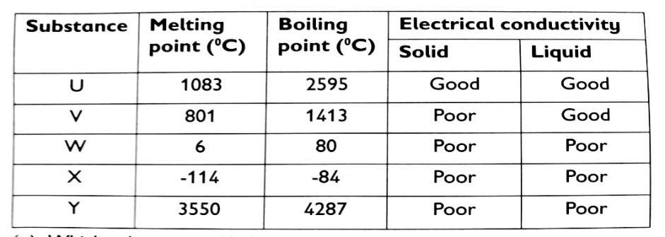
- Which substance is likely to be; (1 mark)
- An element ……………………………
- (ii) A liquid at 22ºC ………………………….
- Which substance is likely to have the following structures? (3 marks)
- Simple molecular structure …………………………………………………………….
- Giant ionic structure ………………………………………………………………………
- Giant atomic structure ……………………………………………………………………

