**NAME: ______________________________________ ADM NO: ____________CLASS: __________**

**DATE: ______________________________ SIGN: ___________________TARGET______________**

**CHEMISTRY**

**FORM 3**

**MID-TERM EXAM**

**TERM 1, 2024**

**INSTRUCTIONS: (Answer all the questions) TIME: (1h 30 mins)**

1. The diagram below shows a Bunsen burner when in use.

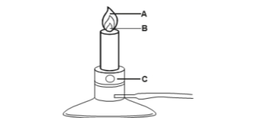

1. Name the region labelled A and B (2 mks)

b. State the function of the part labelled C. (1mk)

2. a.) Complete the table by writing the formula and naming the structure of the chlorides of the elements.

|  |  |  |  |  |
| --- | --- | --- | --- | --- |
| Element | sodium | magnesium | silicon | phosphorus |
| Formula of chloride |  |  |  |  |
| Name of the structure of the chloride |  |  |  |  |

(2mks)

b.) Select from the table an acidic chloride and write the equation for the reaction with water. (2mks)

3. A student set up the apparatus below to prepare and collect a dry sample of carbon (IV) oxide.



Giving reasons, state any three mistakes made in the set up above. (3mks)

4. Distinguish between efflorescent and hygroscopic salts. (2mks)

5. a.) Write an expression to show the relationship between temperature and volume of an ideal gas at constant pressure. (1mk)

b.) A fixed mass of a gas occupies a volume of 150cm3 at room temperature and pressure. What volume would the gas occupy if the temperature of the gas tripled at 680 mmHg? (2mks)

6.A student accidentally mixed potassium chloride with white sand in the laboratory. Briefly describe how the mixture can be separated. (3mks)

7.A compound X is made of carbon, hydrogen and oxygen whose percentage composition by mass are 62.1%, 10.3% and the rest oxygen respectively. The relative molecular mass of X is 58 (H = 1, O = 16, C = 12) Determine the molecular formula of the compound. (3 mks)

8.(a)State Graham’s law of diffusion. (2mks)

(b) 50cm3 of Carbon (IV) Oxide diffuses through a porous plate in 15 seconds. Calculate the time taken by 75cm3 of Nitrogen (IV) Oxide to diffuse through the same plate under similar conditions. (C = 12, 0 = 16, N = 14) (3mks)

9. 12.0cm3 of 0.05m hydrochloric acid reacted with calcium hydrogen carbonate to form calcium chloride, water and carbon IV oxide.

(a)Write the chemical equation for the reaction. (1mk)

(b)Calculate the number of moles of hydrochloric acid used. (2mks)

(c)Determine the number of moles of calcium hydrogen carbonate used. (1mk)

10.Give two reasons why a luminous flame is not used for heating purposes (2mks)

11.Dry carbon (II) oxide gas reacts with heated lead (II) oxide as shown in the equation below.

PbO(s) + CO(g) Pb (s) + CO2 (g)

1. a.) Name the process undergone by the lead (II) oxide. (1mk)

b.) Give a reason for your answer in (a) above. (1mk)

1. c.) Name another gas that can be used to perform the same function as carbon (II) oxide. (1mk)

12.When magnesium metal is burnt in air, it reacts with both oxygen and nitrogen gases giving a white ash. Write two equations for the reactions that take place. (2mks)

13. The diagram shows the structures of two allotropes of carbon. Study them and answer the questions that follow.



* 1. a.) Name allotrope A and B [2 mks]
  2. b.) Give two uses of allotrope B [2 mks]
  3. c.) Which allotrope conducts electricity? Explain. [2 mks]

14. Study the following part of periodic table chart and use it to answer the questions that

follow. The letters are not the actual symbols of the elements.

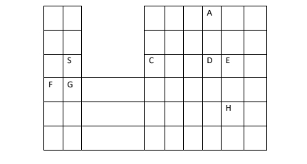

1. Which elements form ions with charge of -2? Explain (2mks)
2. If the oxides of S and D are separately dissolved in water, what effect will their aqueous solution have on litmus. (2mks)
3. How would you expect the ionic radius of C and E to compare? Explain (2mks)
4. Write the formula of the compounds formed between elements G and H (1mk)
5. Write an equation to show the action of heat on the carbonates with element G (1mk)