**NAME: ____________________________________ ADM NO: _________CLASS:________**

**DATE: ______________________________ SIGN: ___________________TARGET_______**

**CHEMISTRY**

**FORM FOUR**

**MID-TERM EXAM**

**TERM 1, 2024**

**TIME: (1h 30min)**

1. The diagram below shows the set-up of the apparatus used by a student to determine the enthalpy change of combustion of ethanol. The heat produced by burning fuel warms a known mass of water.

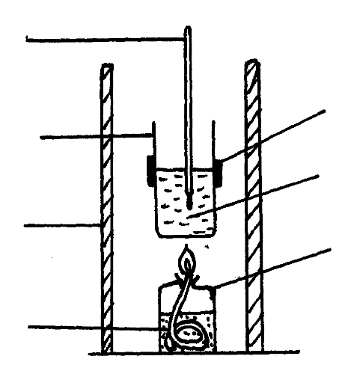

**Thermometer**

**Metal calorimeter**

**Clamp**

**Spirit burner**

**Water**

**Draught shield**

**Liquid fuel**

Results

Volume of water in the beaker = 500 cm3

Initial temperature of water= 120C

Final temperature of water = 31.50C

Mass of ethanol burnt = 1.50g

Density of water = 1 g/cm3

Specific heat capacity = 4.2 Jg-1K-1

1. Define molar heat of combustion. *(1 mark)*

……………………………………………………………………………………………….......…

……………………………………………………………………………………………………...

1. (i) Calculate the heat required to raise the temperature of the water from 120C to 31.50C. *(2 marks)*

(ii) Find the molar enthalpy of combustion of ethanol. *(2 marks)*

$$(C=12, H=1, O=16)$$

1. An accurate value for ΔHC of ethanol is -1368 kJmol-1. State **two** sources of errors for the low figure obtained. *(2 marks)*

……………………………………………………………………………………………….......…

……………………………………………………………………………………………………...

1. Draw an energy level diagram for the combustion of ethanol. *(2 marks)*
2. Calculate the heating value of ethanol from the above experiment.

$(C = 12, H = 1, O = 16)$*(2 marks)*

1. State one factor that one may consider when choosing kerosene as a fuel in Eldoret town. *(1 mark)*

……………………………………………………………………………………………….......…

……………………………………………………………………………………………………...

1. (a) Define solubility. *(1 mark)*

……………………………………………………………………………………………….......…

……………………………………………………………………………………………………...

……………………………………………………………………………………………………...

(b) The table below shows solubility of two salts X and Y at varying temperatures.

|  |  |  |  |  |  |  |  |  |  |
| --- | --- | --- | --- | --- | --- | --- | --- | --- | --- |
| Temperature (0C) | 10 | 20 | 30 | 40 | 50 | 60 | 70 | 80 | 90 |
| Solubility of Y (g/100g water) | 70.0 | 66.0 | 63.0 | 60.0 | 59.0 | 56.5 | 54.5 | 53 | 51 |
| Solubility of X (g/100g water) | 12.0 | 18.0 | 24.0 | 31.0 | 38.0 | 48.0 | 51.0 | 74.0 | 88.0 |

1. Draw the graph of solubility against temperature. *(3 mark)*
   * 1. At what temperature is the solubility of both X and Y the same? *(1 mark)*

……………………………………………………………………………………………….......…

* + 1. Which of the substances X and Y is likely to be a gas? Explain. *(2 marks)* ……………………………………………………………………………………………….......…

……………………………………………………………………………………………………...

* + 1. What is the mass of Y that would dissolve in 50g of water at 480C? *(1 mark)*

* + 1. Determine the solubility of salt X at 550C? *(2 marks)*

……………………………………………………………………………………………….......…

……………………………………………………………………………………………………...

* + 1. State ***one*** application of solubility. *(1 mark)*

……………………………………………………………………………………………….......…

1. (a) (i) What is meant by isomerism? *(1 mark)* ……………………………………………………………………………………………….......…

……………………………………………………………………………………………………...

……………………………………………………………………………………………………...

(ii) A hydrocarbon sample is found to contain 83.3% carbon and 16.7%

hydrogen. If the relative molecular mass of the compound is 72.0, determine its molecular formula. $(C=12, H=1)$*(3 marks)*

(iii) Draw the structural formula and name the compound whose molecular formula is in (a) (ii) above.  *(2 marks)*

1. Study the chemical equation below and answer the questions that follow.

CH3CH2COOH + CH3OH CH3CH2COOCH3 + H2O

**R W**

1. Name the type of reaction represented by the above equation. *(1 mark)*

……………………………………………………………………………………………….........

1. State two conditions in the reaction above. *(2 marks)*

……………………………………………………………………………………………….......…

……………………………………………………………………………………………………...

1. Write an equation for the reaction between the compound labelled **R** and potassium hydroxide solution. *(1 mark)*

……………………………………………………………………………………………….......…

……………………………………………………………………………………………………...

1. Name the type of reaction in b (iii) above. *(1 mark)*

……………………………………………………………………………………………….......…

1. Give three differences between the reactions named in b (i) and b (iv) above.

(3 *marks*)

……………………………………………………………………………………………….......…

……………………………………………………………………………………………………...

……………………………………………………………………………………………………...

1. 4 grams of methanol $\left({CH}_{3}OH\right)$ requires 93.5 kJ of heat to vaporise completely. Calculate the heat required to vaporise one mole of methanol completely.

$(C = 12.0, H = 1.0, O = 16.0)$*(2 marks)*