NAME: ______________________________________ ADM NO: ____________CLASS:__________
DATE: ______________________________ SIGN: _______________________
GEOGRAPHY
FORM TWO
MID-TERM EXAM
TERM 1, 2024

INSTRUCTIONS: ATTEMPT ALL QUESTIONS TIME: 1 HOUR
1. Students of Apple High school conducted a field study on a farm near their school. Identify four objectives of the study. (4mks)

2. Highlight some of the problems that students may have encountered in question one above. (5mks)

3. Give three uses of Soda Ash extracted from Trona as mineral mined at lake Magadi. (3mks)

4. Define the term earth movements. (2mks)

5. Identify two types of earth movements. (2mks)

6. Give four causes of Earth movements. (4mks)

7. Identify any five resultant features of vertical Earth Movements. (5mks)

8. What are the evidences supporting Continental Drift Theory? (5mks)

9. State types of plate tectonic boundaries. (3mks)

10. List any five major plates. (5mks)

11. The diagram below shows type of Fold. Name the part marked A, B and C. (3Marks)
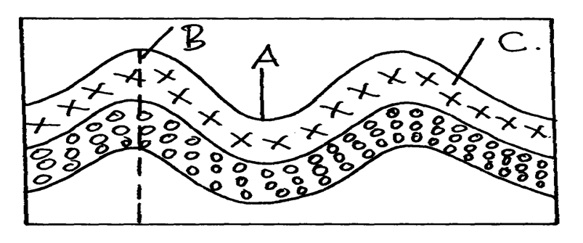

12. What is Folding ? (2mks)

13. Identify four examples of Tectonic forces. (4mks)

14. Identify any three types of Folds. (3mks)

