GEOGRAPHY FORM TWO
MID-TERM EXAM TERM 1, 2024
MARKING SCHEME
1. Students of Apple High school conducted a field study on a farm near their school. Identify four objectives of the study. (4mks)
To identify the types of crops grown
To find out the number of plantings
To establish number of workers on the farm
To find out problems farmers face
2. Highlight some of the problems that students may have encountered in question one above. (5mks)
May fall sick
Respondents may be uncooperative
Language barrier
Transport problems
Environmental constraints
Dishonest respondents
Financial constraints
3. Give three uses of Soda Ash extracted from Trona as mineral mined at lake Magadi. (3mks)
Glass manufacturing Soaps and detergents
Softening water in paper making Oil refining
Textile industry

4. Define the term earth movements. (2mks)
Movements of crustal rocks caused by forces originating and operating in the interior of the earth.
5. Identify two types of earth movements. (2mks)
Horizontal Vertical
6. Give four causes of Earth movements. (4mks)
Magma movement Gravitational force
Convectional currents in the mantle Isostatic adjustment
7. Identify any five resultant features of vertical Earth Movements. (5mks)
Raised cliffs
Tilt blocks
Rift valleys
Fault scarps/escarpments
Plateaus
Basins
8. What are the evidences supporting Continental Drift Theory? (5mks)
Jigsaw fit Geological structure
Distribution of ancient glacial deposits Palaeontological evidences
Mid atlantic ridge Palaeomagnetic studies
Sea floor spreading Climatology

9. State types of plate tectonic boundaries. (3mks)
Extension / constructive margins
Compressional / destructive margins
Transform faults / conservative margins
10. List any five major plates. (5mks)
Eurasian N.America S.America
Pacific Australian
African Antarctic

11. The diagram below shows type of Fold. Name the part marked A, B and C. (3Marks)
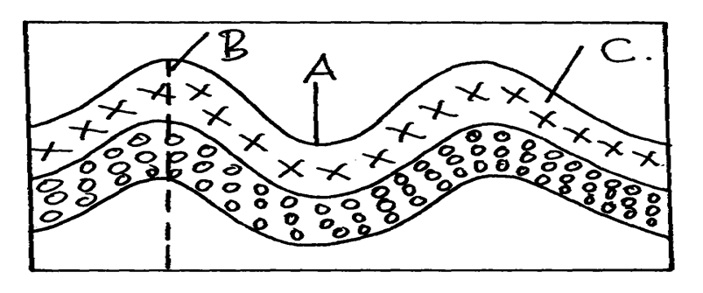
A-axis B-syncline C-limb of a fold
12. What is Folding ? (2mks)
This is the process of Crustal rocks distortion that causes rocks to bend upwards and downwards due to compressional forces.
13. Identify four examples of Tectonic forces. (4mks)
Tensional
Compressional
Shear Gravitational
14. Identify any three types of Folds. (3mks)
Simple Symmetrical Fold •
Asymmetrical Fold •
Overthrust /nappe Fold •
Isoclinal Fold •
Recumbent Fold.
Anticlinorium / synclinorium complex

