NAME: _________________________________ ADM NO: __________CLASS:__________
DATE: ______________________________ SIGN: _________________TARGET_________
FORM TWO
PHYSICS
MID-TERM EXAM
TERM 1, 2024

INSTRUCTIONS: (Answer all the questions) TIME: (1 ½ HOURS)
- State any two modes of heat transfer. (2mk)

- Give a reason why water is not suitable for use as a barometric liquid. (1mk)

- Give a reason why heat transfer by radiation is faster than heat transfer by conduction. 1mk

- State the number of images formed when an object is between two plane mirrors placed in parallel. (1mk)

- Explain why the image formed in a pin hole camera gets blurred when the hole is enlaged. (2mk)

- State the law of electrostatic charges. (1mk)

- Two mirrors are inclining at 60⁰ to each other. Determine the number of images observed and state one application of this arrangement. (3mk)

- State two factors that determine the kind of image formed by a pinhole camera. (2mk)

- A pinhole camera forms an image of size 10cm. The object is 5m tall and 20m away from the pinhole. Find the length of the pinhole camera. (3mk)

- Figure below shows a ray of light being incident on a mirror. (2MKS)
48⁰

- A sharp point of a pin is held in the bare hands and brought near the cap of a positive charged electroscope. State and explain the observation made on the electroscope. (2 mk)

- State two uses of a gold leaf electroscope (2mk)

- Two identical spheres A and B each standing on an insulating base are in contact. A negatively charged rod is brought near sphere A as shown below.
A
B
Insulating rods
-
-
-
-
-

In what way will A differ from B if separated while the rod is near? Explain. 2mk

- An uncharged metal rod brought close to but not touching the cap of a charged electroscope caused decrease in the divergence of the leaf. Explain this observation. (1 mk)

- Distinguish between electromotive force and potential difference (2mks
.

- The figure below shows a simple cell made of copper and zinc electrodes dipped in dilute sulphuric acid.
Bulb
DilH₂SO₄

Zinc plate

Copper plate

a) Identify the cathode and the anode. (2 mks)
Cathode ………………………..
Anode ………………………..
b) State the two common defects in a simple cell. (2 mks)

c) Explain how the defects in b) are minimized (2mk)

- State two properties of magnets. (2mk)

- Give a reason why attraction in magnetism is not regarded as a reliable method of testing for polarity. (1mk)

- In an attempt to make a magnet, a student used the double stroke method as shown below.
Magnetic material
Magnetic material
Y
X
N
S
S
N

State the polarity at end X and Y. (2mk)

- State the principle of moments. (1mk)

- A uniform meter rule is pivoted at the 30cm mark by a force of 16N placed at the 0cm mark.
30cm
16N
0
100cm

Calculate the weight of the meter rule. (3mk)

22. A micrometer screw gauge has a zero error of 0. 12mm.Sketch the reading of the micrometer screw gauge when used to measure the size of a ball of diameter 3.44mm. (2 mark)

23. In figure 2 ammonia gas and an acid gas diffuse and react to form a white deposit on the walls of the glass tube. Explain why the white deposit forms nearer end B than A. (3mark)

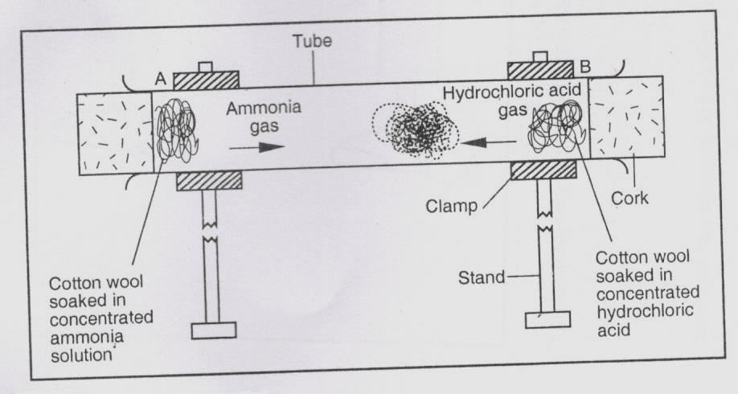

8. Figure 3 shows a uniform bar of mass 0.8kg supported by a spring balance at its centre and the bar is at equilibrium.
////////////////////// support

Spring balance

0.8m 0.6m

XN 24N

Figure 3
Determine the:
(a) value of X (3 marks)

