**Term 1 - 2025**

**AGRICULTURE (443)**

**FORM TWO**

**TIME: 2 HOURS**

**Name: …………………………………………………………. Adm No: ……………….**

**School: ……………………………………………………….. Class: …………………..**

**Signature: …………………………………………………….. Date: …………………….**

**SECTION A: 50MARKS**

**Answer all questions in the space provided.**

**1** a) The term agriculture is derived from **two Latin words**, name them and give their meaning (2mks)

**…………………………………………………………………………………………………………………………………………………………………………………………………………………………………………………………………………………………………………………………………………………………………………………………………………………………**

b) What does agriculture involve as art and a science: -

(i)As an art (4mks)

**…………………………………………………………………………………………………………………………………………………………………………………………………………………………………………………………………………………………………………………………………………………………………………………………………………………………**

(ii)As a science (4mks)

**…………………………………………………………………………………………………………………………………………………………………………………………………………………………………………………………………………………………………………………………………………………………………………………………………………………………**

**2** Differentiate between olericulture and pomiculture (2mks)

**………………………………………………………………………………………………………………………………………………………………………………………………………………**

**3**. List **four** livestock farming in Kenya. (4 marks)

**……………………………………………………………………………………………………………………………………………………………………………………………………………………………………………………………………………………………………………………………………………………………………………………………………………………………..**

4. State **four** advantages of shifting cultivation (4marks)

**……………………………………………………………………………………………………………………………………………………………………………………………………………………………………………………………………………………………………………………………………………………………………………………………………………………………..**

**5a**) Name **three** processes of rock weathering. (3mks)

**……………………………………………………………………………………………………………………………………………………………………………………………………………………………………………………………………………………………………………………………………………………………………………………………………………………………..**

b) Differentiate between soil texture and soil structure. (2mks)

**…………………………………………………………………………………………………………………………………………………………………………………………………………………………………………………………………………………………………………………………………………………………………………………………………………………………….**

**6.** State **three** effects of HIV/AIDS on agricultural production (3marks)

**…………………………………………………………………………………………………………………………………………………………………………………………………………………………………………………………………………………………………………………………………………………………………………………………………………………………….**

7.Give **two** roles of macro-organisms in the soil that are beneficial to crops (2mks)

**…………………………………………………………………………………………………………………………………………………………………………………………………………………………………………………………………………………………………………………………………………………………………………………………………………………………….**

8. State four effects of **low temperature** on crop production. (4marks)

**………………………………………………………………………………………………………………………………………………………………………………………………………………………………………………………………………………………………………………………………………………………………………………………………………………………………………………………………………………………………………………………**

**9.** List down the three aspects of rainfall that affect agriculture. (3mks)

**………………………………………………………………………………………………………………………………………………………………………………………………………………………………………………………………………………………………………………………………………………………………………………………………………………………………………………………………………………………………………………………**

10. What’s the meaning of the following terms in agriculture: -

a) Evapotranspiration (1mk)

**………………………………………………………………………………………………………………………………………………………………………………………………………………**

b) Agricultural Economics (1mk)

**………………………………………………………………………………………………………………………………………………………………………………………………………………**

11. Write how the following Human factors influence agriculture: -

a) Level Of Education and Technology (4mks)

**………………………………………………………………………………………………………………………………………………………………………………………………………………………………………………………………………………………………………………………………………………………………………………………………………………………………………………………………………………………………………………………………..**

c) Government policy (4mks)

**………………………………………………………………………………………………………………………………………………………………………………………………………………………………………………………………………………………………………………………………………………………………………………………………………………………………………………………………………………………………………………………………..**

12. State the three factors that influence soil formation (3mks)

**………………………………………………………………………………………………………………………………………………………………………………………………………………………………………………………………………………………………………………………………………………………………………………………………………………………………………………………………………………………………………………………………..**

**SECTION B: 30marks**

**13.** a) List three aspects of light that influence crop growth. (3mks)

**………………………………………………………………………………………………………………………………………………………………………………………………………………………………………………………………………………………………………………………………………………………………………………………………………………………………**

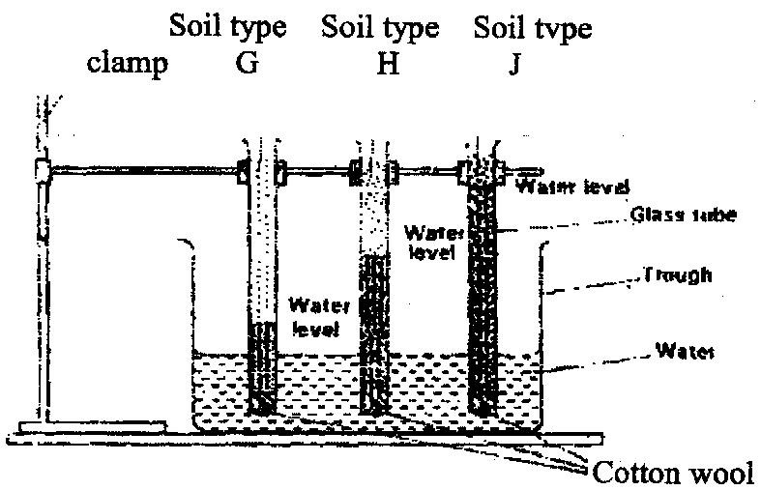b) The diagram below shows an experiment set up using soil types G, H and J and observations made after 24 hours. Study the diagram and answer the questions that follow.

i)What is the experiment represented above designed to study? (1mks)

………………………………………………………………………………………………………………………………………………………………………………………………………………………………………………………………………………………………………………………………………………………………………………………………………………………………………………………………………………..

ii) Name the three soil types G, H and J. (3mks)

G………………………………………………………………………………

H………………………………………………………………………..

J…………………………………………………………………………..

iii) What is the characteristic texture of soil types G and J? (2mks)

G…………………………………………………………………………………………………………………………………………………………………………………………………………………………………………………………………………………………………

J…………………………………………………………………………………………………………………………………………………………………………………………………………………………………………………………………………….

iv) State how a farmer would improve the structure of soil type G. (1mk)

………………………………………………………………………………………………………………………………………………………………………………………………………………………………………………………………………………………………………………………..

14. Study the diagrams S and T and answer the questions that follow.

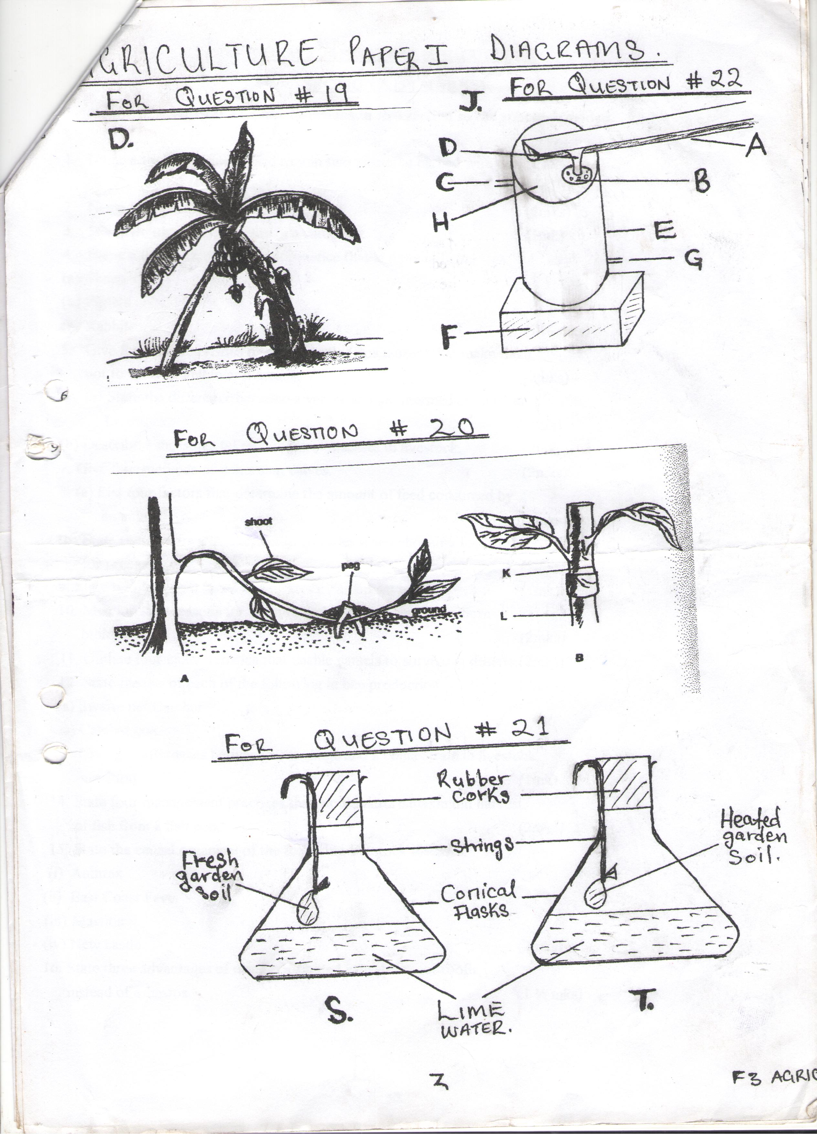

1. What was the aim of setting up the experiment? (1mk)

………………………………………………………………………………………………………

1. Why was the soil in flask strongly heated? (1mk)

…………………………………………………………………………………………………………………………………………………………………………………………………………………………………………………………………………

c) What observations would you make at the end of the experiment in both flasks? (2mks)

……………………………………………………………………………………………………………………………………………………………………………………………………………………………………………………………………………………………………………………………………………………………………………………………………….

d) Explain the result in flask S. (1MK)

……………………………………………………………………………………………………………………………………………………………………………………………………………………………………………………………………………………………………………………………………………………………………………………………………………………………

15.The following are diagrams illustrating a soil profile labeled **A** and **two** types of soil structure labeled **B** and **C**. Use them to answer the questions that follow.

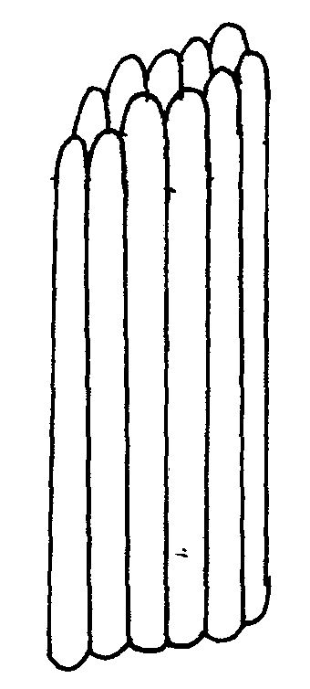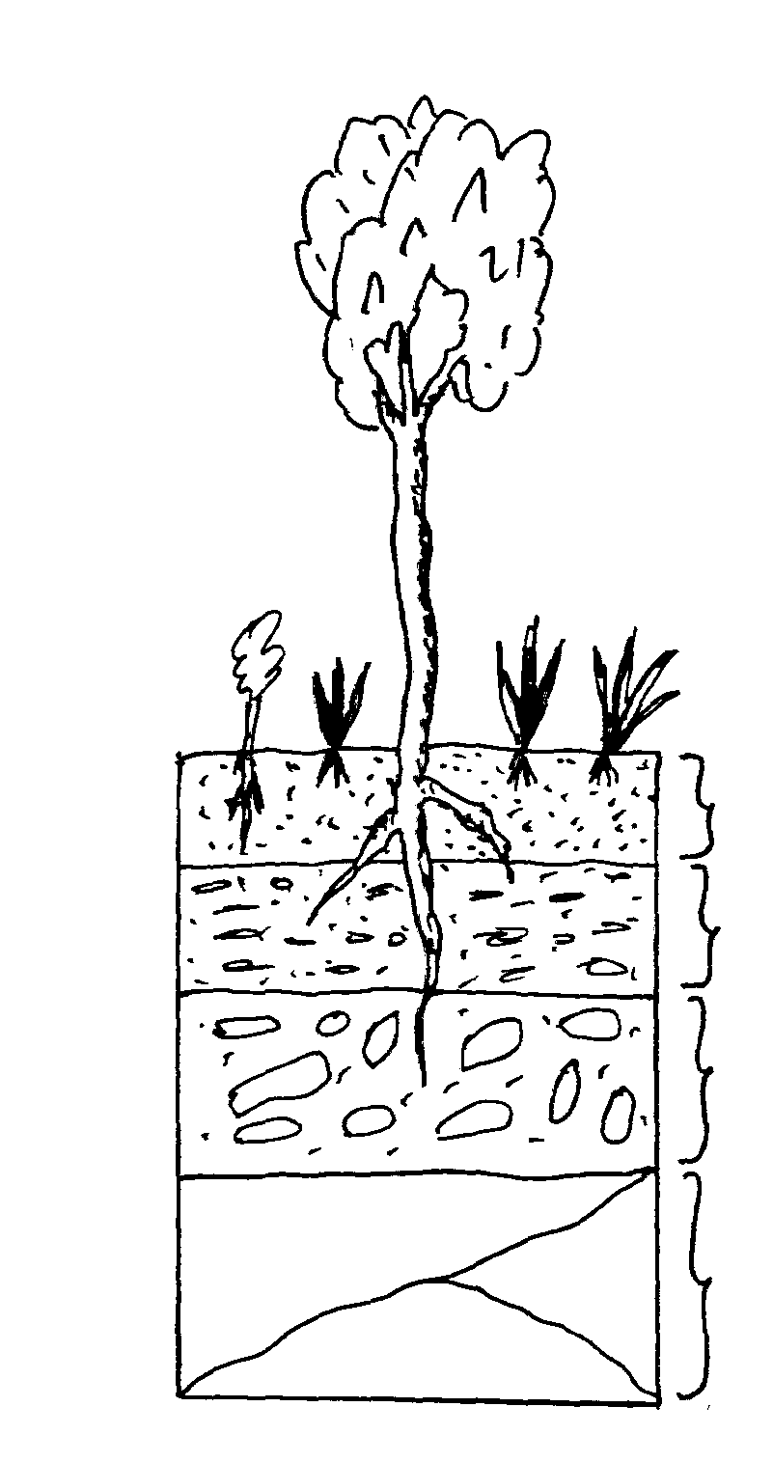

**1**

**2**

**3**

**4**

A B C

1. Identify the strata of the soil profile labeled **1,2, 3** and **4** (4 mks)

**1**………………………………………………

**2**………………………………………………

**3**………………………………………………

**4**………………………………………………

1. Identify the types of soil structure labeled **B** and **C** (2mks)

**B**………………………………………………

**C**……………………………………………

1. Name a natural process that may change soil structure **B** into structure **C** (1 mk)

………………………………………………………………………………………….………………

……………………………………………………………………………………………….…………

1. State **two** limitations of the hard layer of soil that develops in **layer 2** (2mk)

………………………………………………………………………………………….………………

……………………………………………………………………………………………….…………

1. List **two** farming practices that may destroy **structure B** (2mk)

………………………………………………………………………………………….………………

……………………………………………………………………………………………….…………

(f)State **four** characteristics of the soil in the Horizon **labelled 1 (4mks)**

**…………………………………………………………………………………………………………………………………………………………………………………………………………………………………………………………………………………………………………………………………………………………………………………………………………………………………………………………………………………………………………………………………………………………………………………………………………………………………………………………………………………………………………………………………………………………………………………………………………………………………………………………………………………………………………………….**

**SECTION C (10mks)**

**16.**  State and explain **five** roles of agriculture in economic development of Kenya (5marks)

………………………………………………………………………………………………………………………………………………………………………………………………………………………………………………………………………………………………………………………………………………………………………………………………………………………………………………………………………………………………………………………………………………………………………………………………………………………………………………………………………………………………………………………………………………………………………………………………………………………………………………………………

**17.** Explain the **negative** ways in which wind influence crop production: (5mks)

………………………………………………………………………………………………………………………………………………………………………………………………………………………………………………………………………………………………………………………………………………………………………………………………………………………………………………………………………………………………………………………………………………………………………………………………………………………………………………………………………………………………………………………………………………………………………………………………………………………………………………………………