**TERM 1 – 2025**

**MID TERM EXAM**

**ART AND DESIGN (442/1)**

**FORM 3**

**MARKING SCHEME**

**Instructions to candidates**

1. *Write your name and Admin number in the spaces provided above*
2. *Sign and write the date of the examination in the spaces provided above.*
3. *This paper consists of* ***two***  *sections* ***A****, and* ***B***
4. *Answer* ***all*** *questions in bot sections..*
5. *Answers to all the questions must be written in the spaces provided.*
6. *Where drawings and diagrams are appropriate, they should be included within the text of your answers*
7. ***Candidates should check the question paper to ascertain that all the pages are printed as indicated and that no questions are missing.***

________________________________________________________________

**For Examiner’s Use Only**

|  |  |  |  |
| --- | --- | --- | --- |
| **Section** | **Question** | **Maximum score** | **Candidates ‘Score** |
| A | 1 | 25 |  |
| B | 2-6 | 40 |  |

**Total Score: 65**

**SECTION A** (25 marks)

*Answer* ***all*** *the questions in this section in the spaces provided.*

1. *(a)*

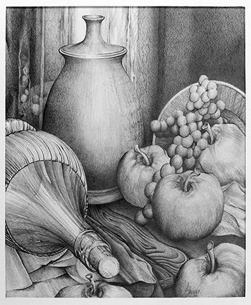

1. Two most outstanding elements and one principle in the art work above (3marks)

Elements……***Tone, Shape***

Principal ***Unity/ harmony***

(ii) Two ways through which depth has been achieved in the composition

***-By overlapping shapes***

***-Closer shapes and parts appear detailed and bigger***

***Use of tone*** (2marks)

(ii)Dominance as a principle and how it is achieved composition

***The principle of art that makes shapes and elements be easily seen/recognized/conspicuous from the rest (2marks***)

1. Below is an identification symbol

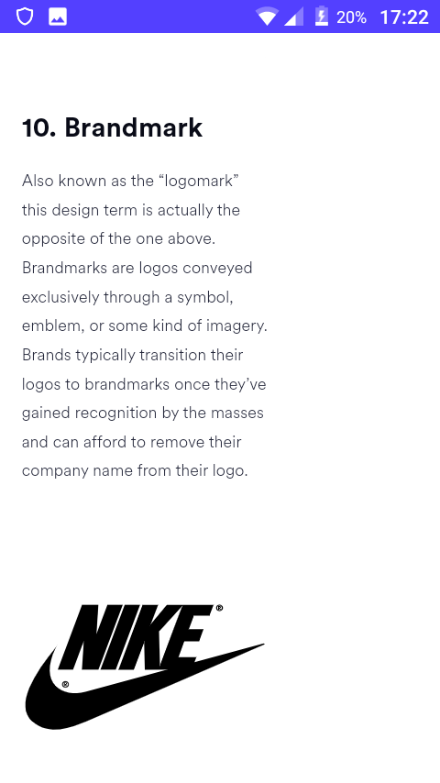

Identify the symbol.-***Trade mark*** (1mark)

(ii)Any other three symbols that are used in the same category as one above (3mks)

***Logos***

***Emblems,***

***Badges,***

1. Below is a colour wheel showing colour temperature

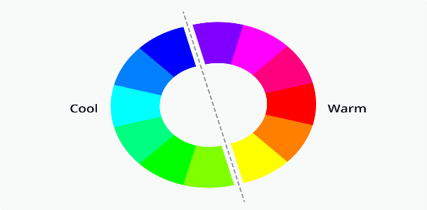

Warm colours

Cool colours

[a] In regard to colour temperature, Identify and label the following: (4mks)

(i)Worm colours

***The colours ion the right hand side of the line-Yellow to pink***

(ii)Cool colours

***Colours on the left side of the line stretching from Green to blue***

[b](i)Identify any two analogous colours (2mks)

***Yellow, red, orange, light blue, green, pink, blue***

(ii) Complimentary colours (2mks)

***Red and green, Yellow and blue, Pink and light green, orange/light blue.***

1. Using illustrations in the space below, explain the difference between **Front, Profile, and ¾ view** in regards to portrait drawing (6mks)

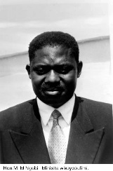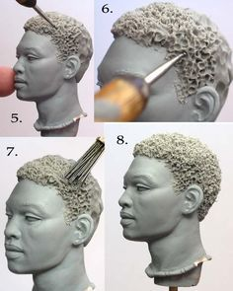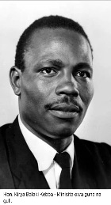

***Front view*** ***Profile/side view*** ***¾ view***

-***Front view-All facial parts-both eyes and ears are directly visible***

***- Profile/side view-Only an ear and an eye are visible***

***-3/4 view-the two eyes and one ear are visible. At a slightly tilted pause***.

**SECTION B (40 marks) Answer All questions in this section**

2(a) Differences btwn mosaic and collage

MOSAIC COLLAGE

***Juxtaposed tesseraes -Superimposed tesseraes***

***2D Art work -3D art work***

***Presence of interstices -Presence of textured surface***

***Colour is the main element*** -***Texture is the main element Any 2=2marks)***

(b) Two similarities of montage and collage artworks

-***Both involve pasting***

***-Both can be done on flat surfaces***

***-elements such as shape, colour and texture are majorly conspicuous***

***-Are multimedia art techniques*** (4 mks)

(3)(i)Any two serigraphy printing techniques.

***Stencil***

***Silk screen printing*** (2marks)

(ii)The difference between a negative and positive space in printing any artwork

Positive space-the area occupied/covered by the art works

Negative space-the area uncovered/unoccupied by the artwork/printed work (4mks)

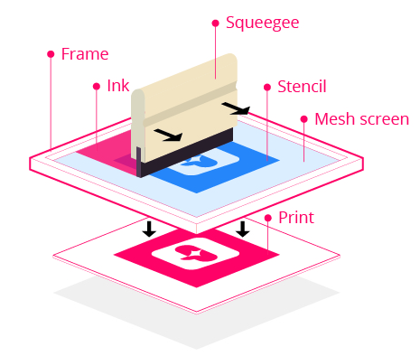

Positive space

Negative space

(b) Using the graphic words below,

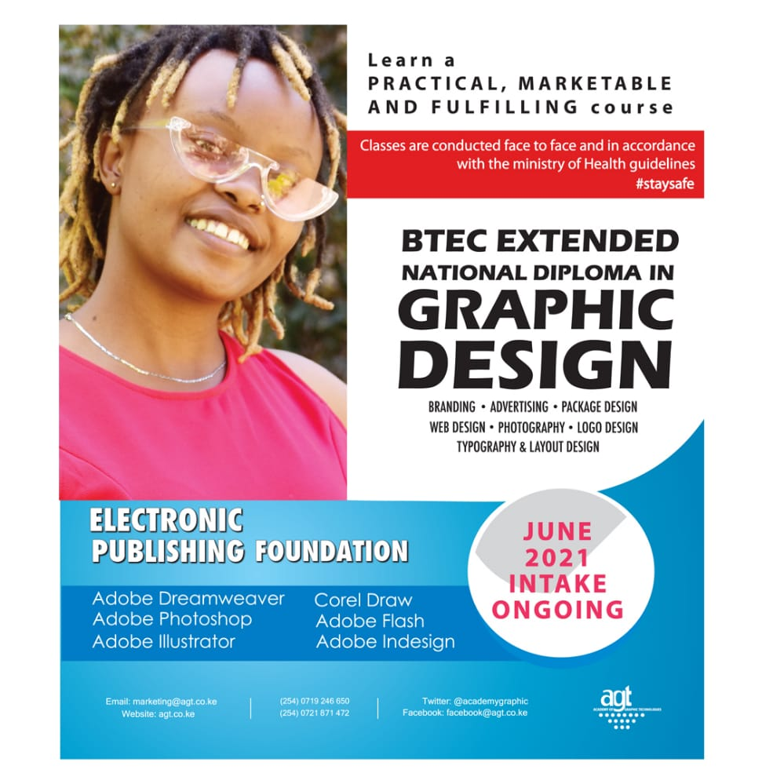

(i)Identify and show the condensed words ***NATIIONAL DIPLOMA***(1mk)

(ii)Expanded words……***GRAPHIC DESIGN***(1mk)

4(a)[i] the type of eye level shown in the illustration below-***Worms eye view*** (2mark)

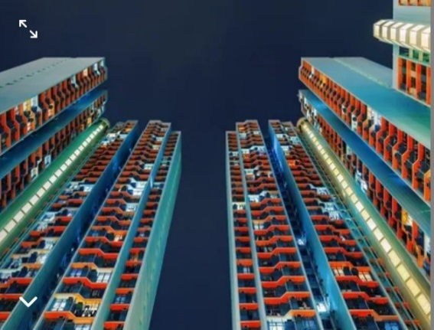

[ii] Name any other two eye levels apart from the one named in 4[i] above (2mks)

***Bird’s eye***

***Normal Eye view/level***

1. Any three painting techniques

***Pallet knife***

***Brush stroke***

***Dry brush***

***Wash out***

***Dabbing***

***Wet in wet (Any 3=3marks)***

1. Study the activity below and answer the questions that follow.

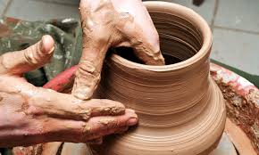

1. The art activity and the technique being used

Activity…***Pottery/making a vase using clay*** (1mark)

Technique…***Throwing*** (1mk)

1. Give any other two hand building techniques apart from the one above (2marks)

***-Pinching, Coiling, Slab, Ball method***

***6.***Using the blank space of the question paper and in an area of 12cm by 8cm, **Either** draw a composition of “**A person resting under a tree shade with one leg foreshortened towards the viewer”** **Or** In Good calligraphic hand witting, Rewrite the extract: “***Art is never finished, it is only abandoned***” **Leonardo Davinci**.(15mks)

Alt A

***-Correct question interpretation/theme/subject matter-2mks***

***-Correct shapes-3mks***

***-Proper show of depth/perspective by foreshortening one of the legs-4mksmks***

***Use of other elements and principles-texture, tone and proportions***

***4mks***

***Execution and finishing-2mks***

***Total 15mks***

***Alt B***

***Lettering 5mks***

***Precision and tidiness, outlines, font styles and consistency-5***

***Media and tool control-3mks***

***Personal quality and finishing 2mks***

***Total15mks***