TERM 1 – 2025

ART AND DESIGN (442/1)

FORM TWO

Time: 2 Hours

MARKING SCHEME

FOR EXAMINER’S USE ONLY

|  |  |  |
| --- | --- | --- |
| SECTION | QUESTIONS | CANDIDATES’ SCORE |
| A | 20 |  |
| B | 60 |  |
| TOTAL SCORE: 80 |  |

1. Definition of Art-*The human ability to make forms creatively and skillfully for aesthetic and utilitarian/ functional purposes* (2 mks)

1. (i)Shape- *An area with well-defined and enclosed boundaries/boarders* (1mks) c(i)Two types of shapes-

*Geometric*

*Organic shapes* [2mk] (ii) examples of each of the shapes named in b (ii) above (3mks)

*Organic-rocks, trees, clouds, stones, generally plant and animal species*

*Geometric-Circles, squares cones, cubes, cuboids, ovals, triangles, trapeziums, etc.*

d) Any 5 design courses in the field or Art.

*Graphic Designer*

*Fashion Designer*

*Web Designer*

*Architectural Designer*

*Interior Designer*

*Product designer*

*Industrial design*

*Etc.* [any 5=5mks]

e (i)Two types balance

*Active=formal=Asymmetrical*

*Passive=informal=symmetrical*

*(*Any 2=2mks)

(ii) Use a diagram to illustrate any one of the types above

(2mks)

*Passive/formal/Symmetrical-illustration should be in a sense that the axis distributes the elements/shapes into identical equivalence and Active/informal/asymmetrical, the elements are balanced with different shapes and variables.*

Any one well illustrated 2mks

f. Tone and illustrate using a shape of cylinder (3mks).

*-The darkness or lightness of a surface/object-1mk*

*Illustration=2mks*

*Total 3mks*

SECTION B (40mks)

[2] A drawing of a hand brushing a shoe [10mks

-*shapes and posture-4mks*

*Shading- texture, and tone 3mks*

*Execution and quality3mks*

(3)Study of the art work bellow

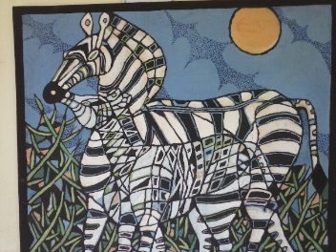

(i).possible suitable theme/topic of the art work above (1mk)

*Mother’s love/parental care/parental love*

(ii)Two most outstanding elements in the art work above (2mks)

*Lines*

*Shape*

4. Line *A continuous mark made on a surface, created by joining dots together* (1mk)

(b) Any six characters of lines

*Wavy,spiral,diagonal,pararell,vertival,horizontal,thick,thin,circular,straight,curved,etc* (Any ½ a mark @ 6=3mks)

5. (a) Colour-*an element of art and design that can be perceived by the sense of sight only in the presence of light*(2mks)

(b) Three major types of colours (3mks)

*Primary, secondary, tertiary*

(c)Fill the missing colours in the colour triangle bellow (4mks)

Orange

Purple

*Between Purple and orange is RED*

*Directly opposite purple =Yellow*

*Opposite Orange is Blue*

*Directly opposite Red=Green*

(d) Name any two sets of complimentary and analogous colours (4mks)

Complementary colours *Red and Green, Purple and Yellow, Blue and orange [*any 2=2mks

*Analogous Red and yellow, Blue and Purple, Yellow and orange, Blue and green, purple and red.[any set of two/three*=3mks

[6]Texture-*The surface quality of an object/the roughness or smoothness of a surface/object [*2mks] (b) Two types of texture: *Visual and tactile texture (*2mks)

c) Using any Illustrations of your choice, Show any three techniques of shading that creates texture of a surface/object (6mks)

*Any well illustrated diagram with any three of the following shading techniques*: *Hatching, Crosshatching, Stippling/Dot shading/ pointillism, block shading, scribbling (Any 3 well illustrated=6mks)*

7. Dominance is a *principal of art and design that shows the state of being conspicuous, easily seen and noticeable/standing out of the rest*. (1mk)

(b) *Any well illustrated diagram showing any of the techniques accredited to show dominance (as answered below*)= (3mks)

(b) ii Two ways/ techniques of achieving the principal of dominance- Use of differing *shapes, colours, sizes, e.g. big one and small ones or vice versa, etc. any 2=(2mks)*

8. Identify and name the techniques of shading illustrated below (2ms) 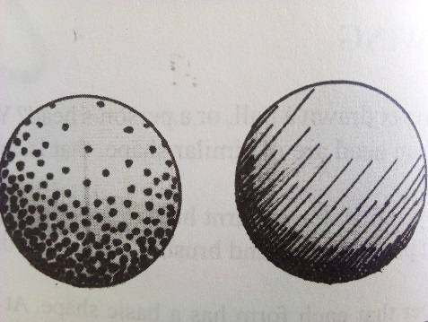

Hatching

Stippling

(ii) The element of tone shown in *the two illustrations above Has been achieved by drawing/appling the lines in hatching and dots in stippling too close togather where light hits less and spacing them where there”s too much light impact* (2mks)

9.“Perspective,as a *techique in drawing-The technique applied in drawing where illusion of depth is created on shapes as a result of distance,such that objects /shapes close appear big and clear and faintin the further ends*?(2mks)

(ii)The other name for aerial perspective-*Atmospheric perspective*(2mks)

(ii) Using relevant drawings in the space below,Illustrate any other two types of perspective apart from the one named in 9ii) above*-Any two well drawn Illustrations showing Linear-One point and two-point perspectives=6mks*

10. (i)balance-*The state of equillibrium between the elements on a composition/visual weight created by the elements of art and desigh on a working surface/composition.(*1mk)

(ii) Using relevant drawings/illustrations,Name and explain three types nof balance Any of the three rellevant drawings *showing Symetrical-Line of exis cuts through the elements to create identical shapes.,Assymetrical-line of symetry/axis devides the shapes but not identical on both sides and Radial, the balancing is focused towards the center either radiating/diverging or converging(9mks)*