TERM 1 – 2025

ART AND DESIGN (442/1)

FORM TWO

Time: 2 Hours

Name: …………………………………………………………. Adm No: ……………….

School: ……………………………………………………….. Class: …………………..

Signature: …………………………………………………….. Date: …………………...

Instructions:

* This paper consists of two sections, A and B

\**Answer all questions in both sections.*

*\*Write your name and admin No clearly in the spaces provided above.*

*\*Use relevant illustrators and drawings where required.*

FOR EXAMINER’S USE ONLY

|  |  |  |
| --- | --- | --- |
| SECTION | QUESTIONS | CANDIDATES’ SCORE |
| A | 20 |  |
| B | 70 |  |
| TOTAL SCORE: 90 |  |

(a) Define Art (2 mks)

……………………………………………………………………………………………………………….

……………………………………………………………………………………………………………….

………………………………………………………………………………………………………….

(b) What do you understand by the term shape (1mks?)

c. Name two types of shapes [2mk] ………………………………………………………………………….…… ………………………………………………………………………………………………………………………………………………………………………………

(ii) Give 3 examples of each of the shapes name in c (ii) above (3mks) ………………………………………………………………………………….. ………………………………………………………………………………….. ……………………………………………………………………………………

d) List any 5 design courses in the field or Art (5mks)……………………………………………………… ..………………………………………………………………………………………………………………………………………………...………………………………………………………….…………………………………………………

………………………………………………………

e (i)Give the bother name for active and passive balance(2mks)

…………………………………………………………

…………………………………………………………

(ii) Use a diagram to illustrate any one of the types above (2mks)

f. Define tone and illustrate using the shape of a cylinder (3mks).

SECTION B (60mks)

[2] Using the space bellow, draw a hand brushing a shoe [10mks]

(3)Study the art work bellow

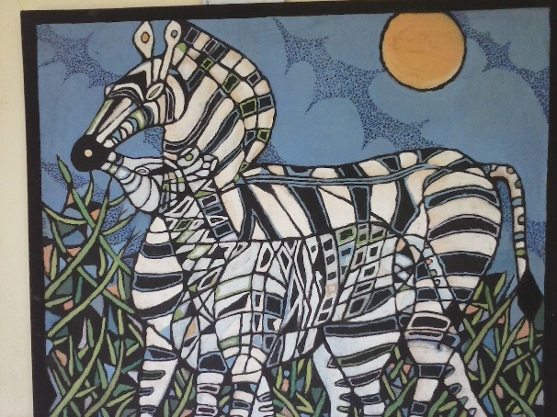

(i). Give the possible suitable theme/topic of the art work above (1mk)

………………………………………………………………………………………

(ii)Give two most outstanding elements in the art work above (2mks)

…………………………………………… ………………………………………

4. Define a line (1mk)

(b) Name any six characters of lines (3mks)

5. (a) Define colour as an element of art and design (2mks)

……………………………………………………………………………………………………………… ………………………………………………………………………………………………………………

(b) Name three major types of colours (3mks)

…………………………………….

…………………………………….

…………………………………….

(c)Fill the missing colours in the colour triangle bellow (4mks)

Orange

Purple

(d) Name any two sets of complimentary and analogous colours (4mks)

Complementary………………………………….. ,………………………………

…………………………………., …………………………………

Analogous ……………………………………………………………………….

……………………………………………………………………….

[6]Define texture [2mks] ………………………………………………………………………………………………………………………………………………………………………………………………………………………………………………………………………………………………….. (b) Name two types of texture (2mks)

c) Using any Illustrations of your choice, Show any three techniques of shading that creates texture of a surface/object (6mks)

7. Define dominance as a principal of art and design. (1mk)

(b) In the space below, illustrate the above principal (3mks)

(b) ii Give any two ways/ techniques of achieving the principal of dominance(2mks)

8. Identify and name the techniques of shading illustrated below (2ms) 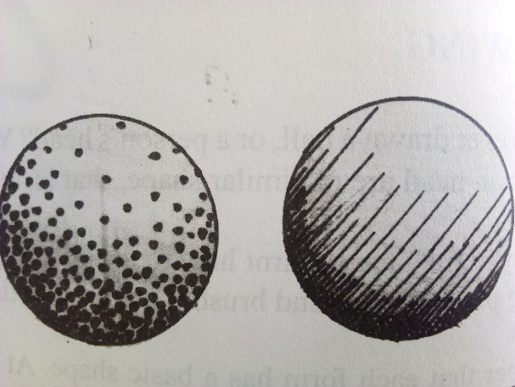

(ii) How is the element of tone shown in the two illustrations above?(2mks)

9.What do you understand by the term “Perspective,as a techique in drawing?(2mks)

(ii) What is the other name for aerial perspective?(2mks)

(ii) Using relevant drawings in the space below,Illustrate any other two types of perspective apart from the one named in 9ii) above(6mks)

10. (i) Define balance(1mk) ……………………………………………………………………………………………………………………………………………………………………………………………………………………………………………………………………………………………………………………………………………………………………………..

(ii) Using relevant drawings/illustrations,Name and explain three types nof balance(9mks)……………………………………………………………………………………………………………...(a)…………………………………………………………………………………………………………………………………………………………………………………………………………………………………………………………

(b)……………………………………………………………………………………………………………………………………………………………………………………………………………………………………………………………………………………………………………………………………………………………………………….

(c)………………………………………………………………………………………………………………………………………………………………………………………………………………………………………………………………………………………………………………………………………………………………………………………